](https://www.nsc.org/road/distracted-driving-awareness-month/ddam-materials?)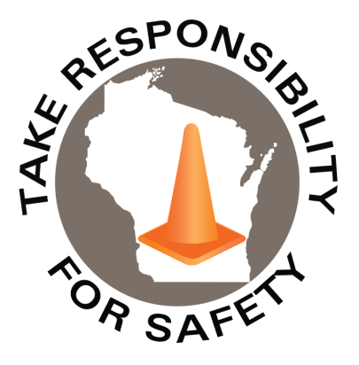

In This Issue:

**Distracted Driving Awareness Month**

**Tornado & Severe Weather Awareness Week**

Volume 11, Number 4

April 2024

|  |
| --- |
| Safety Net(work)  Produced by Department of Administration Bureau of State Risk Management  Produced by Department of Administration Bureau of State Risk Management |

Safety Spotlight:

[Distracted Driving Awareness Month](https://www.nsc.org/pages/ddam/ddam-materials)

[Severe Weather and Tornado Safety](https://readywisconsin.wi.gov/be-informed/tornadoes/)

|  |  |
| --- | --- |
| |  | | --- | | **April is Distracted Driving Awareness Month**  Each April, the National Safety Council, USDOT and others observe Distracted Driving Awareness Month to bring attention to the dangers of distracted driving and share simple steps drivers can take to avoid it. This year, [NSC is offering a variety of free resources](https://www.nsc.org/road/distracted-driving-awareness-month/ddam-materials?) to help keep yourself and others safe on the road, including:   * [**A participant guide**](https://secure-web.cisco.com/1pRJhw-CkSc137BA1hcpcUI1ufUaFavH9pftNvZy17ZSys6CcpKBGn71YbV3RkE7fGGcwouk3IVh2QRPE0_ZhPgBVrO5qeASAiLIelb28iX41bCkXSiVBYkOKUJ44tDw0Pl-9m8fpLgXEFPfjZbf13qmKLtoP508ma_vGKneunAo-g61Qkpz716rvKD0OynlnRAsgug7nD9ZiQ7UqyCLOLDj-JZ7wA0x_vpjTpCmRZgA5RPjX8_N-KvzYmhta10EF_03BvmKZlK7u89QCrkjwgEeh5ri4jrEHinsVlI2H8bpK1mSfXuaQflikjkUxZWJq3hKicmnrHMyqyzR2XP2kXg/https%3A%2F%2Fclick.safe.nsc.org%2F%3Fqs%3Dcce4c29f3bf335da11a6e017073b1ba31e4328b6495cd111acaea7f78bf5784312888eb8986992cff9f04fd95117fbb76b03b69f3706d87e1542ef2637e8ef3d) to help make your plan for the month * [**The Just Drive pledge**](https://secure-web.cisco.com/1xDgWk9ooDAgwHLXqntQjcs8YCyzXjXpUo7CZHiU5eag1KxO2Dve3_ITqYKympmyAdF9OjttNPTkA7dqsZnUlTn6OK8n1RLrsaLiaiTcm0IS-h3ZskUiKGl70SdoDwCzzBQ1PFaaWlIeRdB6IKGIF9NicfaAbkh9WhysbicB-n-58lY9yYSTIkZYmUhbbviOZp5oPSfl6xscq62ZMGP92ZM7vua9cVMM9ZmEvZ_d-t8d58ONOZ6wHZfxMwAiSgtJylXaafytfswLSnaoIsUyg2Zmn2E07s6cIVOoueESwxuF29SoP-olduJzf_V9eGsfz0zRYNVQ3gjAFit2n67G-7Q/https%3A%2F%2Fclick.safe.nsc.org%2F%3Fqs%3Dcce4c29f3bf335da623c5d5491008824f4f4cb741a3ef5ebe3035c511756013c5c35551930ef577e27428f357e2023c0146ba4e7509ca77f511c396b54290f84) to drive distraction-free * Posters, videos and articles on how to prevent distractions, and more   You can also [**register for this Distracted Driving Awareness Month webinar,**](https://secure-web.cisco.com/1gs0Awxjp1t_QIi4rD-MxY2ZqnnD7F2fkSSxN1HxZVUOuAhvNFHyffoTrnF4SpkJWxA25Q6xySC799MKtvmW7riB8z97N7QRcmbSyEZIM31fJVhw4SjlkRsCGWEikIc-A3rk39s7VCo7qA09GrkVke-crK4q5cB7BL2NljQQnYEnfSc6fF_bi0EcKkp50tAr8-uDzDkbdBdvjtzQuq1Np8z3jQiQTxXSGamV7tu8rK7d6q1ms_cYVYE4BUQ7nC-LwjboutT5K8ygdrpjDbqZKjtF5ClMykcEYeMHkyaWpZRTgQTxcXZcwXiFumihd8TC6TKIzfeR6O5cMHagrgJqkoQ/https%3A%2F%2Fclick.safe.nsc.org%2F%3Fqs%3Dcce4c29f3bf335da163d9bb0d32ee2884f2739c8d6179400d31a9c2b95e9b87c393808aab146480df35e77e549a8a34af3a33f5421843641c36665ade885ad7e) hosted in partnership with the Road to Zero Coalition and featuring a panel of experts. Thousands of people are killed and hundreds of thousands more are seriously injured in distracted driving crashes each year. Join NSC in this year’s observance to help protect your workforce on and off the job, reinforce your commitment to safety in your community, and help create safer roads for us all. Visit [**nsc.org/JustDrive**](https://secure-web.cisco.com/1Q1zfWv_Au3FNjasUdnx_zqatX_OxVlP2b6aMdAot__kHuLoJeXikPzK0NmOyWATeXTcbhaFtPeuWy3HKdMYwwDCR6S5b6rHgK-V_FL6vLa1P_5iuXz1BbdI73zckbLGFjfWXtubjmkvImk84zmMZU08a-DD9r07TieonHKkiUSQqSxACBrk9gPzxUs4eoFh6ayxbYMxcdTIW1yRo1THw4Mpelo2Xb-E1MP8HiVetLtCd_3pWENrdjEz8aoQ4wfh6TcSNC7bT6iHWVD6litPewUNSccDjJhSrB5YwR-csP6z9M-MFO3ddp4AHnh9PUbDH5PXKA6iYfsTZDNOV3lef5g/https%3A%2F%2Fclick.safe.nsc.org%2F%3Fqs%3Dcce4c29f3bf335da785d3487ecb1ca80485512ceeef072643442089b7c793b8f827dc779fe2a88bb5a8f0da975bd0c0977c1d4e3d2cad8363d99b8e655f4fcef) to get started. | |

Survivor, Carlos Rosario, Florida State Trooper asks you to **PLEASE put your phone away while driving** (Ctrl Click Image to Play Video from NSC web site):

<https://www.nsc.org/road/resources/distracted-driving-survivors-network/carlos-rosario>

This month, and any month, please make use of the many distracted driving prevention resources available such as from the [Network of Employers for Traffic Safety](https://r20.rs6.net/tn.jsp?f=001lA_Er2Vph8VPaAZuoqGAxPb_3UWw0hhlk7nO0OXxPVJ-wOTxi_ihQJXn6uI41sTi8GTp_g3vHyYAeBA0gdK4MTQXt4AR8uxDLLPfe5o94xBY3C5HdS68_t_JFgJxs4GF_9p1FoX1rYVRMTcqR5wkFt27qZMmmuK2Nk0wnTo0khVJx8eVNnPoNlzbhZ73nRM7xOfo11spwP8Eyfm_w7zsBg==&c=Ukexv6-BX6jsQUdC44KLCBGdTjjHTRBJVnct4U4YGu8W_m18lBJr4Q==&ch=xqa9LndACibAAxZlQwe0JCqOXqVjuimVnTObUwzmlwOrgDuANXgjcA==)  or the [National Safety Council](https://www.nsc.org/road/distracted-driving-awareness-month/ddam-materials?).

**Distracted Driving**

[**3,522**](https://crashstats.nhtsa.dot.gov/Api/Public/ViewPublication/813443)

**NUMBER OF PEOPLE KILLED BY DISTRACTED DRIVING IN 2021**

(+368 More than in 2020)

381

1,487

Claims

FY24 YTD

Workers Comp

Alarming Statistics:

Five Minutes for Safety:

345

Claims

FY23 YTD YTD

Lost Time

FY24 YTD

Lost Time

FY23 YTD

1,487

**Tornado & Severe Weather Awareness Week**

Our partners at Wisconsin Emergency Management would like to announce that Tornado and Severe Weather Awareness Week in Wisconsin will take place April 8-12 this year. This annual campaign encourages everyone in Wisconsin to prepare for the tornadoes and severe storms in the state that may develop during the spring and summer months. This is also a good opportunity for all to review their severe weather safety procedures by participating in statewide tornado drills at 1:45 p.m. and 6:45 p.m. on Thursday, April 11th. For more information regarding the 2024 Wisconsin statewide tornado drill, click on the link below!

***Click on the link for more information on the 2024 Wisconsin statewide tornado drill!*** <https://wem.wi.gov/ready240228/>

[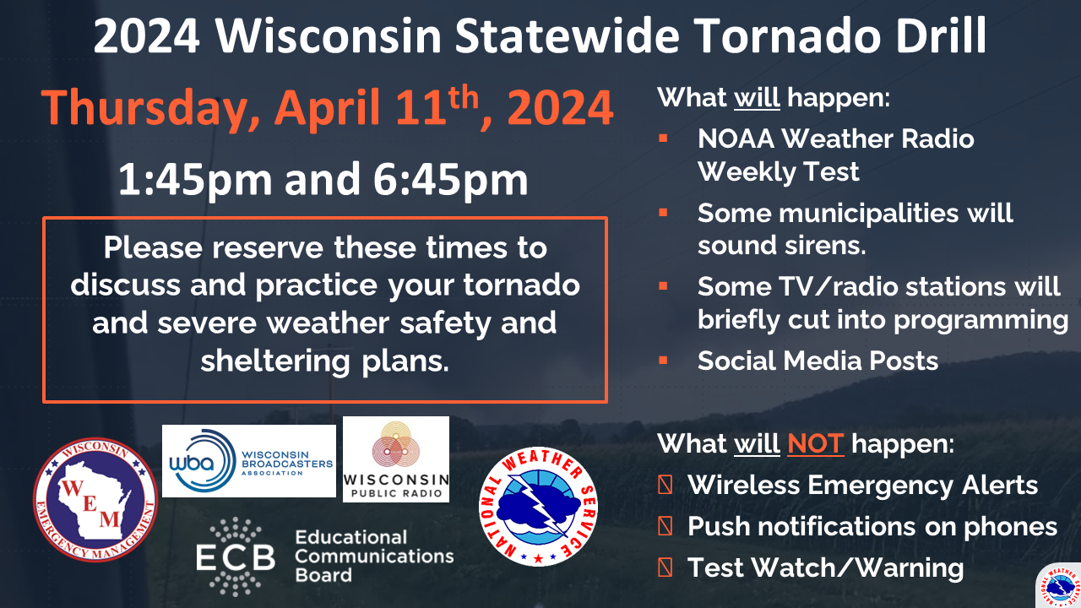](https://wem.wi.gov/ready240228/)

***Tornado and Severe Weather Safety: How can you be prepared?***

Wisconsin averages 23 tornadoes a year. Peak tornado season in Wisconsin is April through August, but it is important to understand that a tornado can occur at any time of the year. Tornadoes can lead to fatalities and devastate communities in a matter of seconds. This violent force of nature can occur at any time of day or night and may not always be visible.

***By preparing, planning, and practicing how and where you will take shelter could save your life!***

***Important Terms Used During a Tornado: Tornado Watch vs. Warning***

* **Tornado Watch: Be Prepared!** An alert issued when weather conditions in the area favor the formation of tornadoes-often during thunderstorms. Be ready to act quickly if a warning is issued or you suspect a tornado is approaching.
* **Tornado Warning: Take Action!** A tornado has been sighted or indicated by weather radar. This is imminent danger to life and property. Move to an interior room on the lowest floor of a sturdy building. AVOID WINDOWS.

[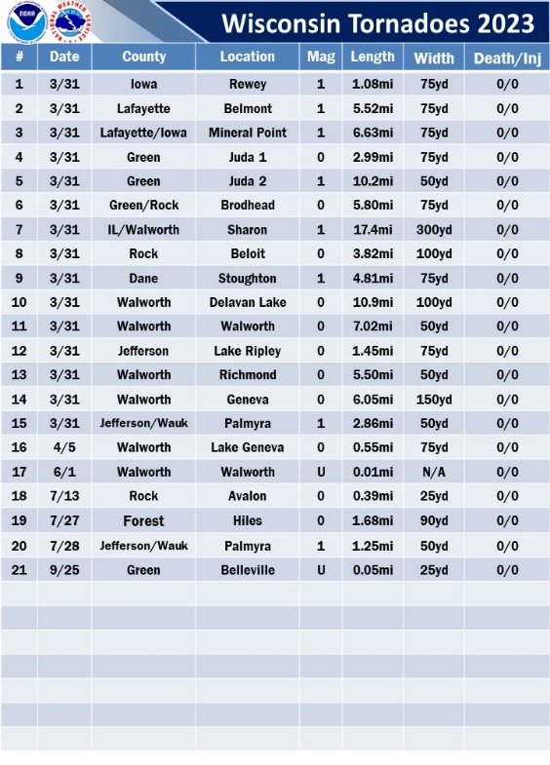](https://www.weather.gov/images/mkx/tornadoes/2023WiTorEvents.jpg)[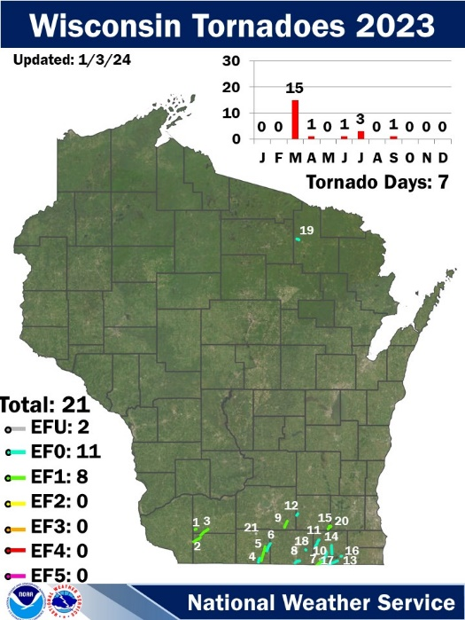](https://www.weather.gov/images/mkx/tornadoes/2023tor.jpg)

***Severe Weather Safety Tips: Thunderstorms and Tornadoes***

* Listen to the radio, television, or weather alert radios for updates.
* When a thunderstorm threatens, go inside a home or large building.
* During a thunderstorm, avoid using telephones, except for emergencies.
* During a tornado warning, TAKE ACTION IMMEDIATELY. Stay away from windows, doors, and outside walls.
* Seek shelter in the basement or an interior part on the lowest level.

Consumer Safety

[United States Consumer Product Safety Commission](http://www.cpsc.gov/)

Contact Us

<https://doa.wi.gov>

E-Mail

[Jake.Lowell@Wisconsin.gov](mailto:jake.lowell@wisconsin.gov)