Introduction
The WISBuy PCard Marketplace is the State eProcurement system which contains state contracted supplier catalogs. Users can log in to the system with a secure login and order from multiple contracted suppliers at one time. Agencies can assign an Administrator that can control who has access and what they can purchase in the PCard Marketplace.
Agency Administrators (Admins) will be able to approve users through user registration, assign user access for certain catalogs and export reports on orders placed through WISBuy. This guide will assist Agency Administrators with managing WISBuy for their Agency.

New User Registration
Users self-register through the WISBuy login page under the Create Account button. The WISBuy User guide was created to assist users that are starting to use WISBuy and replace in person training. When a user submits their account, Admins will receive an email saying that the user registered, if this was set up in their profile.
Admins can log in to WISBuy and approve or reject the registrations. If an Admin has set up notifications for new user registrations, they will see a number on the flag icon at the top of a screen when they log in to WISBuy. Registrations can be approved by clicking on the notification icon then clicking on Approve.
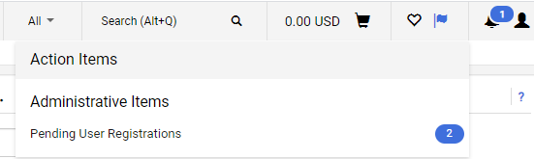
Admins can also approve the registration in the user profile under the Administrative Tasks menus. From the pending user registration screen, Admins can click on the username to access the user profile. The user profile can also be access through the Administer menu, then Manage Users.
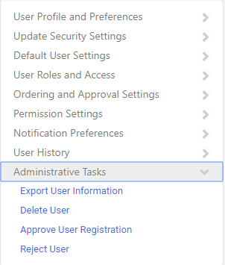
Prior to approving the registration from the User Profile and Preference page. Admins should check the information that has been entered correctly such as user email, phone number, department (if applicable), and username.
If a user has used a username that does not follow the agency guidelines for an IAM ID, the ID can be changed. Contact doawispro@wi.gov so the user ID can be changed.
Update Security Settings
Admins can change a user password within the Update Security Settings. If a user has forgotten their password, Admins can assign a one-time password for the user. Admins will need to enter a temporary password when user login they will need to change the password.
Default User Settings
In this menu, users or Admins can set up a predefined ship to address, add card information, or change the way the order shows on the screen. Changing the way an order shows in the checkout is done under the Checkout setting by editing between Express and Advanced checkout. This is a user preference on the view.
Ship to addresses

Ship to addresses in WISBuy have more than one function in WISBuy. Shipping addresses not only tell the supplier where to ship product, but they also tell the suppler which account to use, tax exempt information, and contract pricing. Some suppliers use the ship to address nickname to allow users access to their punchout. Make sure to mark an address as the default for these suppliers or users will receive an error when logging into punchouts. It is important to remember that users should not change the nickname for the ship to addresses.
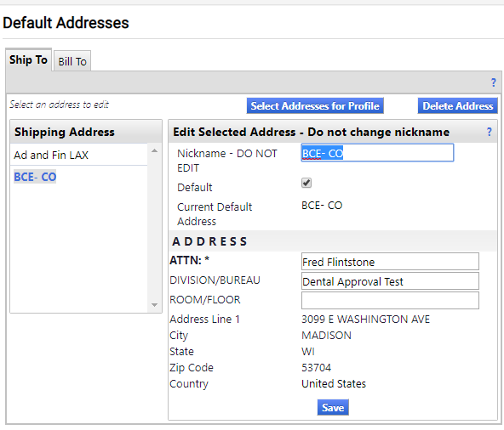

For these reasons, ship to addresses are entered by DOA so some of the punchout suppliers can set up access to their sites and create accounts. Users and Agency Admins in WISBuy are not able to create or change addresses. Once the suppliers have created the ship to address and account in their system, the address can be added to WISBuy.

Agency Admins can request addresses be entered or changed by submitting the address to DOA using the Address Template file. Address should be submitted no later than 5 pm on Fridays to doawispro.wi.gov.
When filling out the address file, please make sure to add your Agency and Agency number. Enter a nickname for the address; the nickname should not contain spaces or dashes and it cannot exceed 12 characters or numbers. Directions are located on the second workbook in the excel address file. Address cannot be deleted from WISBuy; they can only be inactivated.

DOA will send out addresses once a week, usually on Mondays (workload and holidays could affect when the addresses are sent) to the suppliers that will need to set these addresses up in their system. Once the addresses are set up with supplier, then the address will be entered into WISBuy. Admins will be emailed when this is complete.

Cart Assignee
If an agency wants, carts can be assigned to someone to approve the order. This is not an automatic assignment; users will need to assign their cart to someone else prior to checking out. The assign cart feature can also be used for users that may not have a PCard and require another user to pay for the order.

If an Agency requires users to assign carts to someone, then assignees should be added to this section. Simply search and add the person who the cart should be assigned to. When the user is ready to check out, they will see the assign the cart button to send the cart to someone.

Payment Options
This is where a PCard is entered and can be set up to automatically to be used on each order. Card numbers will be encrypted once they are entered by the users. Multiple cards can be added for a user who may be purchasing for different departments. When a card expires, a new card will need to be added under the payment options screen by the user.

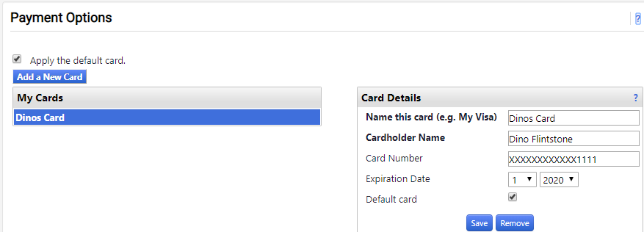

User Roles and Access
Assign Roles
Agency Administrator will need to assign roles to user profiles and/or submit new address to DOA when needed. Admins can access the user profile by going the Administer menu and then searching for a user. Select the user by clicking on the username, then on the left side of the profile is a list of menu options.
Select User Roles and Access, then Assign Roles. The next screen will show all the roles an Admin can assign to a user. Click on the role to assign, then click the arrow to add the role to the Agency Assigned box.
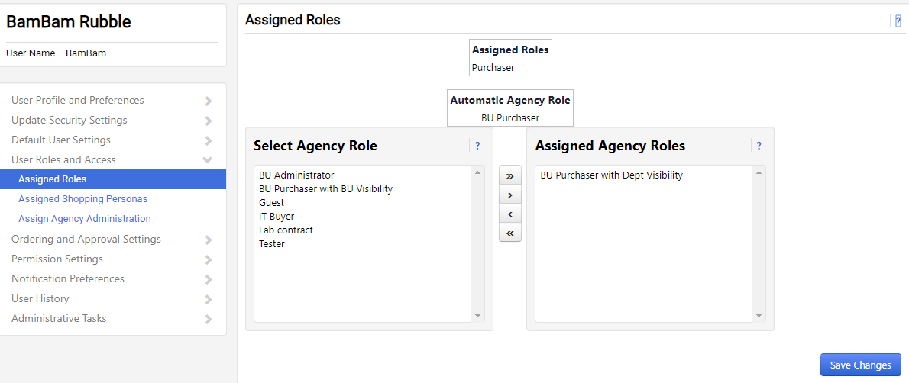
Below is a description on the roles available:
IT Buyer – to see the IT catalogs
Guest – view-only access. Users with this role cannot place orders.
BU Admin – Agency Admin access. This role gives access to change user profile information.
BU Purchases with BU Admin Visibility -- Agency Admin view only access. They will not be able to change profiles.

The Medical Role to purchase medical supplies requires proof that a user has been approved by MMCAP to place orders from the Medical or Dental Suppliers. This role can only be assigned by DOA for medical buyers in WISBuy. Agency Admins will need to submit the following for users to have access to the Medical or Dental contract to doawispro@wi.gov:

User profile name
User ship to nickname
Supplier account number
MMCAP ID

Inactivating Users
Agency Admins should inactive users when they leave an agency. User can be inactivated in the Administrative Tasks menu within the user profile.

WISBuy Orders

Admins can review WISBuy orders at any time by going to the Order menu and searching documents. As an Admin, all orders for your agency will be viewable. You may want to select the Advanced Search option and apply some filters before running the search. Without the filters, the system will return all order for your agency since 2014. In case you do not filter the orders before searching and you want to filter the results after they appear, there are several filters on the left screen that can narrow down the number of orders you are viewing.

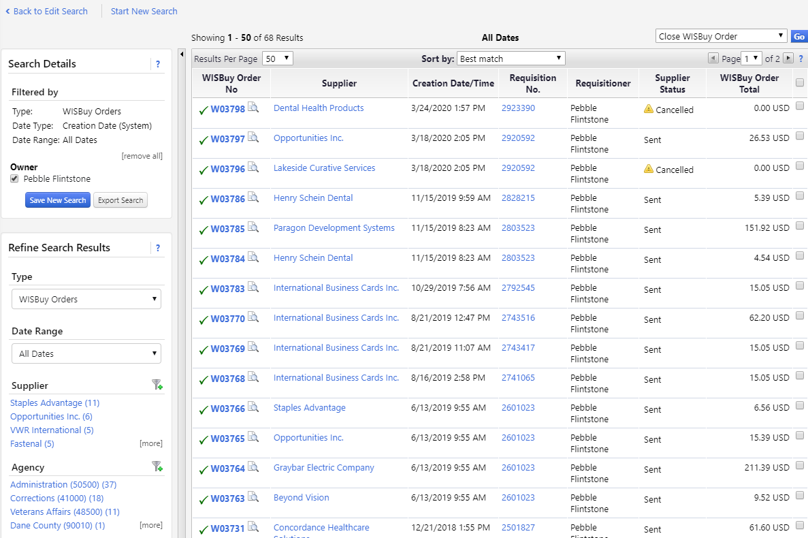

Admins can then click on the WISBuy order number to view the order that was placed. Admins can also export the results to an Excel file.

On the left, in the search detail box, there is an Export Search button. When the Export Search box comes up, give the file a name, then select a template. There are some standard templates, or you can customize a template for the information needed from WISBuy. Some templates have been shared with the Admins so you will see these templates to use.

If you choose a template, these can be edited. Click the Customize Further box then click Next until the screen with the filters come up.

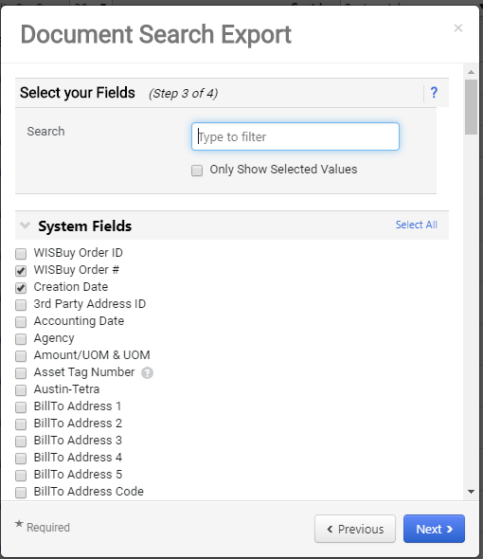

WISBuy will email you when the report is completed. Your report will stay in WISBuy for 30 days.

Common user issues
Bill to address -- Bill to addresses are not set up in WISBuy, suppliers will use the ship to address as the bill to

Location code errors – Grainger uses the nickname to allow access to their punchouts. If a user does not have a default bill set up or changed the nickname of an address, they will not get to the Grainger punchouts.

Special suppliers-A common misconception is if you use WISBuy you do not need to set up an account with suppliers. Larger suppliers such as Grainger and Staples can bill a preexisting agency account however some of the smaller suppliers cannot. There is a list of special suppliers that users need to contact prior to placing their first order in WISBuy. The list can be found on the DOA Website under the WISBuy information.

Returns or shipping problems – Most users believe since their order has gone through WISBuy DOA will have the status of the order or the return process is different. This is not true returns or shipping problems still need to be address by the supplier. Users need to make sure the customer care contact knows about WISBuy. If users don’t feel they are getting help from the supplier the Agency Admin can contact the supplier or either the user and Admin can contact doawispro@wi.gov.

