DFD Bluebeam Review Workflow
(Agency Process) V2.0

Why Bluebeam?
The electronic Bluebeam review process allows users to simultaneously make comments directly onto the same electronic document which allows for collaboration, saves time, reduces duplication, provides for more accurate commenting and ultimately increases efficiency.

- Agency receives Bluebeam review Session ID (XXX-XXX-XXX) and Session URL link (https://studio.bluebeam.com/join.html?ID=XXX-XXX-XXX) from the DFD Project Manager (PM).
- Agency joins the Bluebeam session which allows them to comment on the review documents. They can either join by entering the Session ID into Bluebeam or by entering the Session URL link into their web browser.
  - Note: If the Agency does not have a Bluebeam license, they will still be able to make comments during the Bluebeam review. A free trial version can be downloaded here: https://www.bluebeam.com/trials/. The trial version will provide users with Markup Mode for 30 days and then switch to View Mode, which allows for read-only access in Bluebeam. However, when a user is in View Mode, they will still be able to participate in Bluebeam reviews that are created by DFD.
  - Note: Bluebeam is not compatible with MAC computers. Work with the DFD PM regarding an alternative step to complete the electronic review.
- The Bluebeam link can be forwarded to others to participate in the review; however, comments from the Agency shall be reviewed by the Agency Contact prior to finalizing their review.
- Agency uploads the Agency Profile and Agency Toolset (see Importing Profiles and Toolsets below) prior to making comments to the documents. The Agency Profile and Agency Toolset will provide the Agency a standard view and designated properties (including color) for comments.
  - Note: This step only needs to be completed once unless the Agency is notified by DFD the Profile or Toolset need to be updated.
- Agency makes comments by clicking on the Tool Chest icon and selecting the tools provided in the Agency Tool Set (pink).
- Agency shall notify the DFD PM when they are finished commenting and their review is complete (see Review Status) below.

Importing Profiles and Toolsets
1. Save the following Agency Profile and Agency Toolset documents to your desktop (if you are unable to drag & drop or copy & paste the documents contact the DFD PM for assistance).
2. Open Bluebeam
3. Go to Revu > Profiles > Manage Profiles
4. Click Import. Navigate to your desktop
5. Click on Agency Profile and click Open.
6 Change your profile to the Agency Profile by clicking on Revu > Profiles > Agency.
7. Do the same for the Agency Toolset. In Bluebeam, click the Tool Chest icon. Click the down arrow next to the Tool Chest. Click Manage Tool Sets.
8. Click Import. Navigate to your desktop
9. Click on the Agency Toolset. Click Open.
10. Click the down arrow next to the Tool Chest and unselect all the tool sets except for Agency.
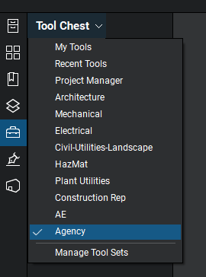
11. Go to Revu > Profiles > Save Profiles
12. Closeout of Bluebeam and reopen to make sure the updates display
13. Once the profile and toolset are imported, you may delete them from your desktop

Review Status
1. Click on the Studio icon
2. Go to My Status and click the down arrow
3. Select Finished
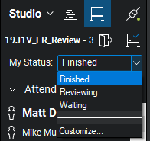
4. Send an email to the DFD PM to notify them that the Agency review is complete

Notes
- When a Bluebeam review session is created, the file is stored on Bluebeam’s server. This allows multiple users to access and comment at the same time.
- Comments are automatically saved, and other reviewers’ comments will be visible to everyone
- Comments in the Markups List at the bottom of the page can be sorted or filtered to view comments by a specific discipline, page, author, etc.
- When commenting, avoid covering existing background information on the page. Try to drag comment in an open space on the sheet or use a sticky note if the sheet is too cluttered.
- The Agency shall use the Agency Profile when completing DFD reviews and can switch between profiles by selecting Revu > Profiles > Select Desired Profile

- The Agency can enter and leave different review sessions by selecting the Studio icon then clicking on the Leave Session icon . Click on the session name to enter the session.
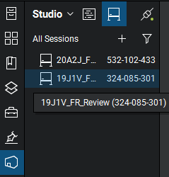

- Once in a certain session, the A/E can open the various documents for review by clicking on each of the documents under the Documents tab.
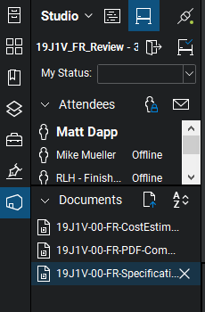

8. Comments should be made to the documents using one of the 6 tools in the designated Agency Tool Set. Click on the Tool Chest icon on the left side of the screen (highlighted in blue below) and then select one of the tools for commenting.
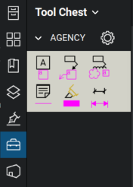
9. Consider changing your username so that it shows up clearly in the Author column in the Markups List at the bottom of the screen. In Bluebeam, go to Revu > Preferences > General > Options. In the User field, change your name. Click OK.
10. Training videos on using Bluebeam Revu can be found here: https://support.bluebeam.com/training-videos/

