DFD Bluebeam Review Workflow
(A/E Process) V2.0

Why Bluebeam?
The electronic Bluebeam review process allows users to simultaneously make comments directly onto the same electronic document which allows for collaboration, saves time, reduces duplication, provides for more accurate commenting and ultimately increases efficiency.

- A/E uploads pdf review documents onto SharePoint
  - Prior to uploading documents, the A/E shall refer to Drawing Requirements and Project Manual Requirements below for information on drawing and specification submittal requirements (combined PDFs, bookmarks, searchable text, etc.)
- DFD Project Manager (PM) sets up a Bluebeam review session and sends an email or Outlook invite with the Bluebeam review Session ID (XXX-XXX-XXX) and Session URL link (https://studio.bluebeam.com/join.html?ID=XXX-XXX-XXX) to the prime A/E
- A/E joins the Bluebeam session which allows them to track, collaborate and respond to review comments. They can either join by entering the Session ID into Bluebeam or by entering the Session URL link into their web browser. The Bluebeam review session information shall be forwarded to subconsultants for their participation.
  - Note: If the A/E does not have a Bluebeam license, they will still be able to make comments during the Bluebeam review. A free trial version can be downloaded here: https://www.bluebeam.com/trials/. The trial version will provide users with Markup Mode for 30 days and then switch to View Mode, which allows for read-only access in Bluebeam. However, when a user is in View Mode, they will still be able to participate in Bluebeam reviews that are created by DFD.
  - Note: Bluebeam is not compatible with MAC computers. Work with the DFD PM regarding an alternative step to complete the electronic review.
- A/E uploads the A/E Profile and A/E Toolset (see Importing Profiles and Toolsets below) prior to adding comments to the review documents. The A/E Profile and A/E Toolset will provide the A/E with a standard Bluebeam view and designated properties (color = light blue) for comments.
  - Note: This step only needs to be completed once unless the A/E is notified by DFD the Profile or Toolset need to be updated.
- As noted above, the prime A/E will be sent the Bluebeam session information at the start of a review. This allows them to track and review comments throughout the review process. The prime A/E will be responsible for sending the Bluebeam session information to their subconsultants. It is common for DFD reviewers to revise some of their comments throughout their review. The A/E team shall discuss any significant revisions with the DFD PM if they choose to modify the project documents prior to the review deadline.
- When finished with their review, the DFD PM and technical reviewers finalize their review in Bluebeam. They also score the A/E in WisBuild and include a comment that their review has been completed using Bluebeam.
- To reply to comments, the A/E shall right click and select reply, which will nest the response with each comment. The response will show up in the Markups List window at the bottom of the screen.
- A/E finalizes their review in Bluebeam (see Review Status below) and posts a response in WisBuild when all comments have been replied to. The response could read: The [PR/FR Review] comments have been replied to using Bluebeam.
- DFD PM closes the session in Bluebeam once all comments have been addressed. The SharePoint files contain all the review comments and responses and can be downloaded by the A/E for their records.

Drawing Requirements
Final electronic review drawings shall be submitted to DFD in PDF format.

- A single PDF shall be created for each volume of drawings. Each volume shall be limited to a maximum of 125 drawings.
- Vestiges of CAD work (e.g. AutoCAD SHX markups) should be “Flattened” as to not be shown as a comment in the PDF.
- Create bookmarks for each drawing contained within the PDF. Bookmarks shall include the sheet number (e.g. T100, M100, E100). It is acceptable to also include the DFD Project Number, Phase, and document status as a prefix to the Sheet Number (e.g. “PROJ#-00-PR-E100”). Extra bookmarks that result from conversion from CAD to PDF shall be removed prior to submittal to DFD.
- Drawings rendered as PDF images are not acceptable except for original pages containing manually generated registration stamps, signatures, etc.
- All text shall be searchable and not be “rendered”.
- All PDF files shall be created with a minimum resolution of 150 dpi and be a ‘flat’ image with no layering or other AutoCAD attributes.
- Compile the drawing set in the same order as indicated on the Sheet Index.
- Drawings should be presented in “Landscape” orientation.
- Bookmarks shall open the sheet to “Fit Page” view (Full sheet displayed).
- An outline organizing bookmarks by Divisions of Work (e.d. M-Series, E-Series) is encouraged but not required.
- Page name of each sheet shall match the bookmark for that sheet.

Project Manual Requirements
Final electronic review specifications shall be submitted to DFD in PDF format.

- A single PDF file shall be created for each specification volume (approximately 300 pages). Photographs, cut sheets, or 8 ½” x 11” drawings within the specification volume must be included as part of the single PDF.
- Specifications rendered as PDF images are not acceptable except for any original pages containing manually generated registration stamps, signatures, etc. Documents shall be created to allow for all text to be “searchable”.
- Add blank pages as required so that each section starts on an odd-numbered page in the PDF.
- Blank pages shall be indicated as intentionally left blank.
- Provide page numbering and a margin of one inch on all edges to facilitate printing and binding of the specification volume, should the recipient of the electronic files choose to print the documents.
- Compile the specification document files in the same order as the specification volume Table of Contents.
- Set “Navigation” to “Single Page” rather than “Continuous”.
- Provide electronic bookmarks for each PDF specification volume (approximately 300 pages). Bookmarks shall be created to reference the Cover Sheet, TOC, first sheet of each specification section (e.g. 01 74 19, 22 05 00, etc.), and for each individual form and/or segment listed under the Bidding Requirements of the specification volume Table of Contents. Also create individual bookmarks for photos, cut sheets, or drawings (e.g. 01 74 19, 22 05 00, Bid Form, Bid Bond Form, A101, A102, etc.) in the specification volume.
- Bookmarks shall be edited as to not include unnecessary content (e.g. PART or Article Headings).
- Bookmarks shall open the page to “Fit Page” view (Full page displayed).
- An outline organizing bookmarks by Divisions or Work (e.g. Div. 23, Div. 26) is encouraged but not required.

Importing Profiles and Toolsets
- Save the following AE Profile and AE Toolset documents to your desktop (if you are unable to drag & drop or copy & paste the documents contact the DFD PM for assistance).
- Open Bluebeam.
- Go to Revu > Profiles > Manage Profiles.
- Click Import. Navigate to your desktop.
- Click on AE Profile and click Open.
- Change your profile to the AE Profile by clicking on Revu > Profiles > AE.
- Do the same for the AE Toolset. In Bluebeam, click the Tool Chest icon. Click the down arrow next to the Tool Chest. Click Manage Tool Sets.
- Click Import. Navigate to your desktop
- Click on the AE Toolset. Click Open.
- Click the down arrow next to the Tool Chest and unselect all the tool sets except for AE.
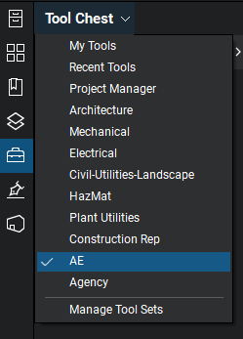
- Go to Revu > Profiles > Save Profiles.
- Closeout of Bluebeam and reopen to make sure the updates display.
- Once the profile and toolset are imported, you may delete them from your desktop

Review Status
1. Click on the Studio icon
2. Go to My Status and click the down arrow
3. Select Finished
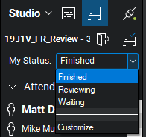

Notes:
- When a Bluebeam review session is created, the file is stored on Bluebeam’s server. This allows multiple users to access and comment at the same time.
- Comments are automatically saved, and other reviewers’ comments will be visible to everyone.
- Comments in the Markups List at the bottom of the page can be sorted or filtered to view comments by a specific discipline, page, author, etc.
- The A/E shall use the AE Profile when completing DFD reviews and can switch between profiles by selecting Revu > Profiles > Select Desired Profile
- The A/E can enter and leave different review sessions by selecting the Studio icon then clicking on the Leave Session icon . Click on the session name to enter the session.
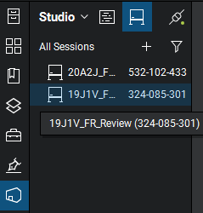

- Once in a certain session, the A/E can open the various documents for review by clicking on each of the documents under the Documents tab.
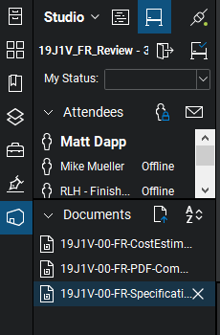

- Consider changing your username so that it shows up clearly in the Author column in the Markups List at the bottom of the screen. In Bluebeam, go to Revu > Preferences > General > Options. In the User field, change your name. Click OK.
- Training videos on using Bluebeam Revu can be found here: https://support.bluebeam.com/training-videos/.

