Van Driver Refresher Registration
Class Number | Term | Dates | Registration deadline
10996 | Summer 2021 | Now through Aug 28
33676 | Fall 2021 | Now Through Jan 15

How to Register:
You must be logged in to add classes to your cart or enroll.
- Log into the myMadisonCollege Portal (Need an account? Create an Account or Unsure if you have an account? Search for Your Account)
- Click on the "Classes" tile
- Click on "Class Search and Enroll"
- Select the term you wish to enroll in
- Enter a keyword (such as Van Driver) into the Search for Classes text box
- A list of classes will populate. The lists defaults to Open Classes Only
- Clicking on a class will show more course information and sections of the class.
- Once you've found the section of a class that meets your needs, click the row of the class and you'll begin the enrollment process.
- Step 1 of 3: Confirm this is the class section you want and click "Next".
- Step 2 of 3: Decide if you want to Enroll in the class now or add it to your Shopping Cart for later enrollment and click "Next". For further instructions on how to enroll from your shopping cart, skip to step 7.
- Step 3 of 3: Review your course selection one final time and then click "Submit".
- Click "View My Classes" in the left hand navigation to confirm your results.
- You can enroll or delete from your shopping cart by placing checkmarks in the corresponding "select' box for each class and then clicking "Enroll", "Delete" or "Validate".
- Click "View My Classes" in the left hand navigation to confirm results.
If you need help or wish to register by phone, be sure you have the five-digit class number and call (608) 258-2301, ext. 2.

After Registering:
Your online classroom is Blackboard. Log into Blackboard the day after you register and you should see Van Driver Refresher listed under “My Courses”. Click the course to start the training.

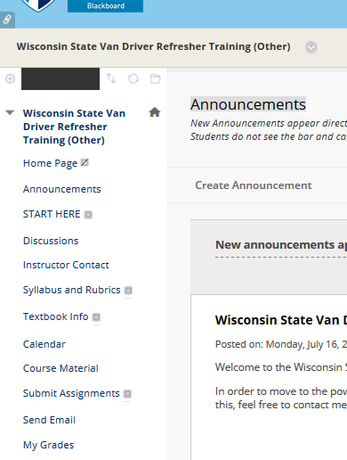
Use the menu to navigate through your course.

