*[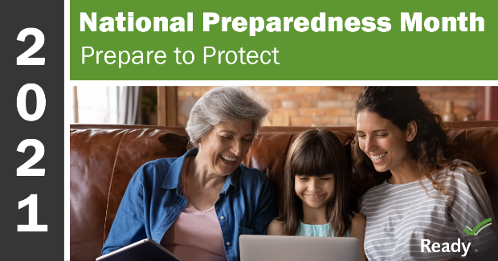](https://www.ready.gov/september)*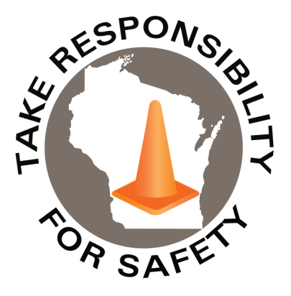

Volume 8, Number 9

September 2021

In This Issue:

**National Preparedness Month**

**Jefferson County Area Safety Network**

**OSHA Small Business Handbook**

**Work to Zero an NSC Program**

|  |
| --- |
| Safety Net(work)  Produced by Department of Administration Bureau of State Risk Management  Produced by Department of Administration Bureau of State Risk Management |

Safety Spotlight:

[Respiratory Protection Week](https://www.cdc.gov/niosh/npptl/Respiratory-Protection-Week-2021.html)

Workers Comp

368

Claims

FY22 YTD

[National Child Passenger Safety Week](https://www.trafficsafetymarketing.gov/get-materials/child-safety/child-passenger-safety-week)

“Work-related deaths in the U.S. have reached the highest number since 2007, meaning thousands of families have lost a loved one in a workplace incident. It’s time for a new approach to eliminating worker death.”

-Work to Zero an NSC Program

Quote of the Month:

Five Minutes for Safety:

89

92

Claims

FY21 YTD YTD

Launched in February 2003, [Ready](https://www.ready.gov/about-us) is a National public service campaign designed to educate and empower the American people to prepare for, respond to and mitigate emergencies, including natural and man-made disasters. National Preparedness Month (NPM) is recognized each September to raise awareness about the importance of preparing for disasters and emergencies that could happen at any time.

The 2021 theme is: **“Prepare to Protect. Preparing for disasters is protecting everyone you love.”** Each week in September, the campaign will focus on a different aspect of preparedness for individuals, families and communities.

**Week 1 September 1-4:**[**Make A Plan**](https://www.ready.gov/plan)

Talk to your friends and family about how you will communicate before, during, and after a disaster. Make sure to update your plan based on the Centers for Disease Control recommendations due to the coronavirus.

**Week 2 September 5-11:**[**Build A Kit**](https://www.ready.gov/kit)

Gather supplies that will last for several days after a disaster for everyone living in your home. Don’t forget to consider the unique needs each person or pet may have in case you have to evacuate quickly. Update your kits and supplies based on recommendations by the Centers for Disease Control.

**Week 3 September 12-18:**[**Low-Cost, No-Cost Preparedness**](https://www.ready.gov/be-informed)

Limit the impacts that disasters have on you and your family. Know the risk of disasters in your area and check your insurance coverage. Learn how to make your home stronger in the face of storms and other common hazards and act fast if you receive a local warning or alert.

**Week 4 September 19-25:**[**Teach Youth About Preparedness**](https://www.ready.gov/kids)

Talk to your kids about preparing for emergencies and what to do in case you are separated. Reassure them by providing information about how they can get involved.

<https://www.ready.gov/september>

Lost Time

FY22 YTD

Lost Time

FY21 YTD

369

[](https://www.nsc.org/workplace/safety-topics/work-to-zero)[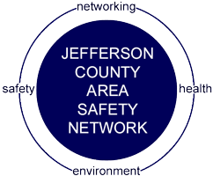](https://jeffersonsafetynetwork.org/join-our-network/)[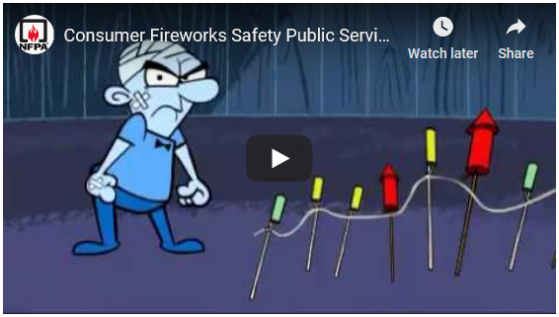](https://youtu.be/PcFuIEwbITA)

Consumer Safety

[United States Consumer Product Safety Commission](http://www.cpsc.gov/)

Contact Us

<https://doa.wi.gov>

E-Mail

[Jake.Lowell@Wisconsin.gov](mailto:jake.lowell@wisconsin.gov)

|  |
| --- |
|  |

The Jefferson County Area Safety Network (JCASN) is now in its 28th year and the Network’s membership and participation at the bi-monthly programs continues to grow, making the JCASN one of the largest and most active Local Chapter Safety Councils in Wisconsin!

The JCASN program year runs September to May and due to some recent Board Member transitions 2022 sessions are still being confirmed. Meetings for the 2021-22 year will be held virtually again out of a continued abundance of caution for safety of JCASN members. Which also means there will be no fees again this year!

**Upcoming Jefferson County Area Safety Network 2021-22 Calendar of Events**

**September 16th, 2021** **OSHA Update: What’s on the Horizon**

8:30 – 10:00 a.m. Presenter: Mary Bauer, Compliance Assistance Specialist, OSHA

**November 11th, 2021** **WI Work Comp Case Law Update**

10:00 – 11:15 a.m. Presenter: Attorney Paul Riegel

For future updates check out the JCASN website <https://jeffersonsafetynetwork.org/>. If you are interested in more information, please reach out to [Jake.Lowell@Wisconsin.gov](mailto:Jake.Lowell@Wisconsin.gov).

# OSHA Revised Handbook for Small Businesses

The U.S. Department of Labor’s Occupational Safety and Health Administration recently collaborated with the National Institute for Occupational Safety and Health (NIOSH) to revise a handbook on workplace safety and health information for small business employers.

The Small Business Safety and Health Handbook highlights the benefits of implementing an effective safety and health program, provides self-inspection checklists for employers to identify workplace hazards and review important workplace safety and health resources for small businesses.

View the handbook: [Small Business Safety and Health Handbook](https://www.osha.gov/sites/default/files/publications/small-business.pdf) (PDF)

# Work to Zero an NSC Program

Since 1913, the National Safety Council has used data, expertise and innovation to solve tough workplace safety problems. With thousands of workers still dying each year, NSC is working to change that through its [Work to Zero](https://www.nsc.org/workplace/safety-topics/work-to-zero) initiative, designed to eliminate workplace fatalities through the use of technology.

Under [“Work to Zero Resources”](https://www.nsc.org/workplace/safety-topics/work-to-zero/resources) webinars, reports, research and additional resources are available. The Fatigue in the Workplace Series – May 2021 explores several fatigue detection technologies and their ability to help save workers lives. It was quite fascinating and well worth watching! Be sure to check out the upcoming September “Driving Down Key Safety Risks with Drones” too!

Jefferson County Area Safety Network