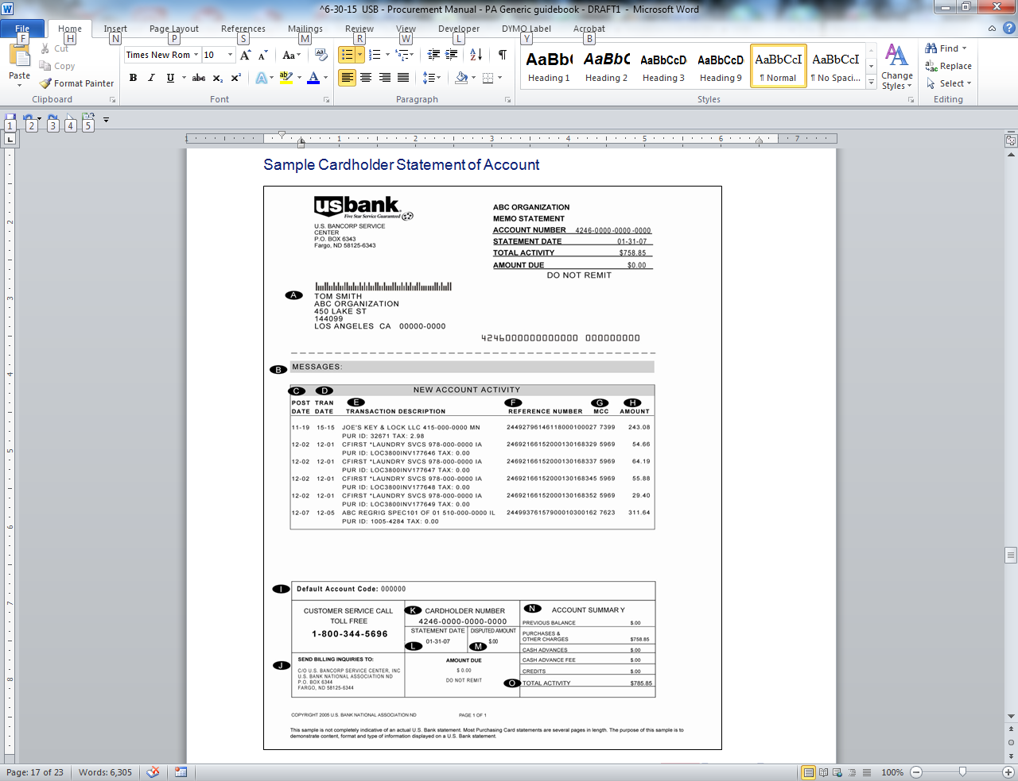

**Section/Explanation**:

1. **CARDHOLDER:** Your name as it appears on your card, along with your agency/organization name and office address.
2. **MESSAGE:** Your agency/organization, or U.S. Bank may provide important program information here.
3. **POST DATE:** The date U.S. Bank Government Services received, processed and posted the transaction posted to the account.
4. **TRAN DATE:** The date of your purchase. This date should match the date on the sales receipt provided by the merchant.
5. **TRANSACTION DESCRIPTION:** The merchant’s name, city, and state.
6. **REFERENCE NUMBER:** A six-digit number used internally by U.S. Bank Government Services to record the transaction posted to the account.
7. **MCC CODE:** The MCC or Merchant Category Code assigned by the merchant’s processing bank and used by the third party processor’s system to identify the type of merchant or product sold.
8. **AMOUNT:** The amount of each purchase as shown on your copy of the sales draft.
9. **DEFAULT ACCOUNTING CODE:** The Default Accounting Code assigned to your purchasing card, if applicable. All purchases will be automatically associated with this code.
10. **STATEMENT CORRESPONDENCE ADDRESS:** The statement’s billing inquiry correspondence address.
11. **CARDHOLDER ACCOUNT NUMBER:** The 16-digit account number on your card or account.
12. **STATEMENT DATE**: The date your Cardholder Statement of Account is issued and sent to you.
13. **DISPUTED AMOUNT:** The net total dollar amount of transactions in dispute.
14. **ACCOUNT SUMMARY:** Summary of account activity by charge category.
15. **TOTAL ACTIVITY:** Total balance of purchases and other charges, fees and credits since last statement date.

**Cardholder Statement Back Page:**

