Ladder Safety

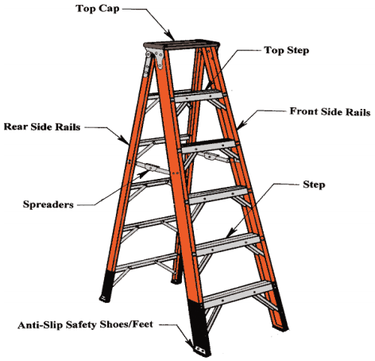
Ladders are a commonly used piece of equipment both in the workplace and at home. Working with a ladder may seem straight forward enough, but before you begin your projects, take a few moments to review some safety tips that involve the use of ladders. A quick inspection now might keep you from being one of the estimated 200,000 people that are injured each year from falling off a ladder in the United States. Remember, most ladder deaths involve falls from less than 10 feet. The most important tip is to select the correct ladder for the job; it’s not a one-size fits all situation. No person ever plans to fall and it happens in an instant. Whether your task is cleaning gutters, hanging structural supports for a roof, or changing a light bulb, safe practices must be utilized in the set up and use of ladders.

Before You Climb:

- Read and follow all the manufacturer’s
instructions and labels on the ladder.
- Look for overhead electrical before handling or climbing a ladder.
- Only put ladders on a stable and level surface that is not slippery.
- Keep ladders free from any slippery material.
- Use a barricade to keep traffic away from the ladder.
- Inspect for damaged parts (checklist attached).
- Check to make sure all components work.
- Only use fiberglass ladders when working near electrical.
- Position ladder to face work.
- Fully open or extend ladder before starting to climb (extension ladder rails fully supported).

Safe Ladder Use—DO:

- Maintain a 3-point contact (two hands and a foot, or two feet and a hand).
- Face the ladder while climbing or descending.
- Keep the body between the side rails.
- Use extra care when getting on or off the ladder at the top or bottom.
- Carry tools in a tool belt or raise tools up using a hand line. Never carry tools in your hands while climbing up/down a ladder.
- Extend the top of extension ladders three feet above the landing.
- Avoid tipping the ladder over sideways or causing the ladder base to slide out.
- Wear shoes with non-slip soles.
- Use extreme caution while pushing or pulling materials while on a ladder.
- Always move one step at a time, never skip a step.
- Properly store ladders for protection from impact, heat, weather, and corrosive materials.

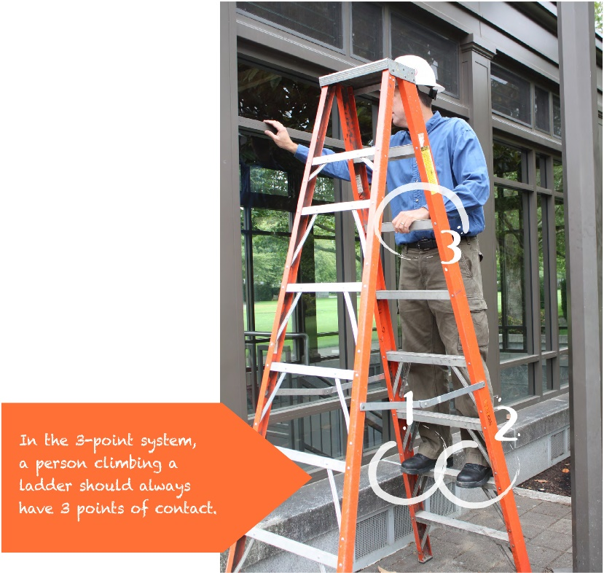

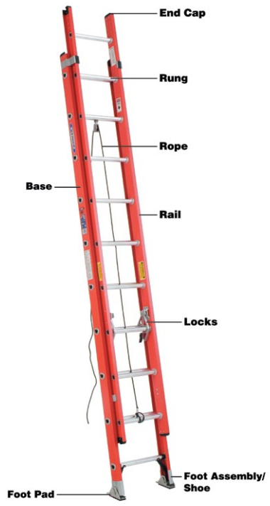
Safe Ladder Use—DO NOT:

- Use a stepladder with spreaders unlocked.
- Use ladders for a purpose other than that for which they were designed. For example, do not use a folded stepladder as a single ladder.
- Use a ladder horizontally like a platform.
- Leave tools/materials/equipment on stepladder.
- Move or shift a ladder with a person or equipment on the ladder (descend and reposition).
- Use cross bracing on the rear of stepladders for climbing.
- Stand above the second step from the top of a stepladder or the forth rung from the top of an extension ladder.
- Paint a ladder with opaque coatings.
- Sit on a step ladder top cap.
- Use a damaged ladder.
- Place a ladder on boxes, barrels, or unstable bases.
- Exceed the ladder’s maximum load rating.
- Tie two ladders together to make them longer.
- Ignore nearby overhead electrical.
- Lean out beyond the ladder’s side rails.
- Use metal or wood ladders when working near electricity.
- Climb a closed stepladder.
- Use a ladder if you are injured.
- Place an extension ladder too far or close to the building. (Maintain 4:1 ratio; set back is one foot for each four feet of length to upper support point).

State of Wisconsin, Bureau of State Risk Management
Sources: OSHA

Additional Reference:
-OSHA Extension Ladder Fact Sheet
-OSHA Stepladder Fact Sheet
-Stairways and Ladders Guide to OSHA Rules
-DOA Slip, Trip, Fall Prevention Manual
-Ladder Training Resource
-Podium Ladder Example

Ladder Inspection Checklist

Inspector: | Date:
Ladder ID Number: | Assigned Location/Department:
Type of Ladder:
If a ladder is determined to be defective it shall be removed from service immediately, marked with a tag reading “DANGEROUS – DO NOT USE” The Environmental Health & Safety Office shall be notified.
Ladder is free of sharp edges, splinters, cracks, slivers, or dents that would compromise structural integrity. |  | ○ Yes | ○ No | ○ NA
Joints between the steps/rungs and sides must be tight. Rungs should not move when twisted by hand. |  | ○ Yes | ○ No | ○ NA
Hardware and fittings are securely attached. |  | ○ Yes | ○ No | ○ NA
Moveable parts operate freely (lubricate, if necessary), but without undue play. |  | ○ Yes | ○ No | ○ NA
Safety feet/pads are non-slip, insulated, in place and unbroken. |  | ○ Yes | ○ No | ○ NA
Rungs/steps are free of grease, oil, or other slippery substances. Remove any buildup of dirt or mud, as well. Rungs must be corrugated, knurled, dimpled, or coated with a slip-resistant material. |  | ○ Yes | ○ No | ○ NA
No rungs/steps are missing or defective. |  | ○ Yes | ○ No | ○ NA
Ladder is not painted or coated with any material that might hide defects. Labels should be placed on only one face of side rails. |  | ○ Yes | ○ No | ○ NA
Step ladders must have a metal spreader or locking device of sufficient size and strength to securely hold the ladder in an open position. Any sharp points on the spreader must be covered or removed. |  | ○ Yes | ○ No | ○ NA
Mobile ladders with a working platform have protected toe guards, top, and mid-rails. |  | ○ Yes | ○ No | ○ NA
Is the ladder free from any other defects that may impair its safe usage. |  | ○ Yes | ○ No | ○ NA
Ladder Disposal Date:

Comments:

