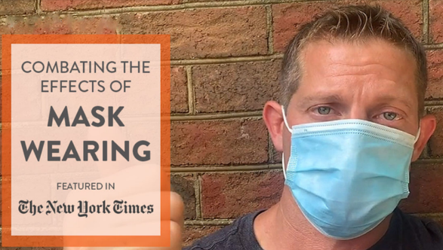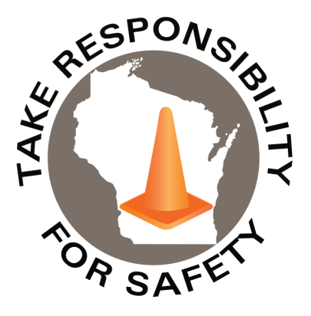

Volume 7, Number 7

July 2020

In This Issue:

**Combating Effects of Mask Wearing**

**Social Distancing in the Workplace**

|  |
| --- |
| Safety Net(work)  Produced by Department of Administration Bureau of State Risk Management  Produced by Department of Administration Bureau of State Risk Management |

Safety Spotlight:

[Fireworks Safety](http://www.cpsc.gov/en/Safety-Education/Safety-Education-Centers/Fireworks/)

Workers Comp

2,332

Claims

FY20 YTD

[Child Safety - Heatstroke Prevention](https://www.trafficsafetymarketing.gov/get-materials/child-safety/heatstroke-prevention)

“That breath that you just took, that’s a gift!”

-Rob Bell

Quote of the Month:

Five Minutes for Safety:

673

499

Claims

FY19 YTD YTD

According to PN Medical, improper breathing while wearing surgical or cloth masks have been shown to create anxiety, headaches, increased heart rate, dizziness, and fatigue. The respiratory experts at PN Medical developed some [guidelines](https://www.pnmedical.com/facemasks/) for better breathing:

1. **Take 5 Quality Breaths** – A quality breath equals 4 seconds inhale through the nose, 6 second exhale through the mouth. 2 second pause. Repeat 5 times.
   * #Take5Breaths right before putting on your mask.
   * #Take5Breaths immediately after you have the mask on.
   * #Take5Breaths one last time after removing the mask.

**Why it matters?** This technique sets the right pattern and helps prevent your automatic nervous system from being locked into a dysfunctional breathing pattern.

1. **Longer and Slower** – Notice people around you. Some change their breathing patterns while wearing a mask. Combat this by taking longer slower breaths while you are wearing yours.
2. **Take Mask Breaks**
   * If you are wearing a mask for extended periods of time, take breaks from the mask periodically when it is safe. Follow Step 1 above.
   * Breaks between times wearing a mask can reduce the negative effects.
3. **Respiratory Muscle Training (RMT)**
   * RMT helps to improve the function of respiratory muscles.
   * For 5 minutes in the morning & 5 minutes at night, practice RMT.
   * RMT is valuable in the face of COVID-19 (Severin et al 2020).

[Learn About RMT Training](https://www.pnmedical.com/training/)

For more information go to <https://www.pnmedical.com/facemasks/>

[**Poster Available to Print**](https://www.pnmedical.com/wp-content/uploads/2020/06/Combating-The-Effects-of-Mask-Wearing-Letter-Size.pdf)

Lost Time

FY20 YTD

Lost Time

FY19 YTD

2,794

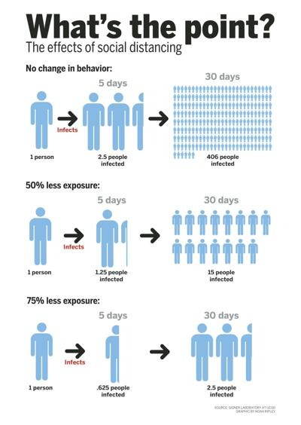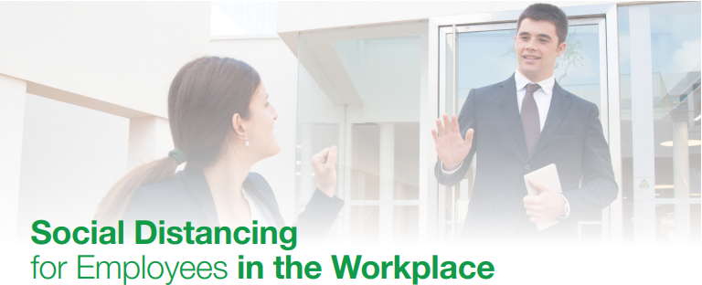[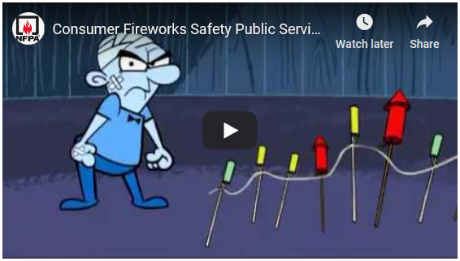](https://youtu.be/PcFuIEwbITA)

Consumer Safety

[United States Consumer Product Safety Commission](http://www.cpsc.gov/)

Contact Us

<https://doa.wi.gov>

E-Mail

[Jake.Lowell@Wisconsin.gov](mailto:jake.lowell@wisconsin.gov)

|  |
| --- |
|  |

As the state begins to slowly reopen, a reminder of the most important action we can take to slow the spread of COVID-19 is social distancing. Social distancing means deliberately increasing the physical space between you and another person, ideally six feet. By staying at least six feet away from others, you dramatically reduce the chance of coming into contact with viruses that may transmit through coughing or sneezing.

The National Safety Council created a “Social Distancing in the Workplace” checklist highlighting precautions as recommended by the CDC and OSHA:

**Tips for Employees**

**•** Practice at least six-foot social distancing in every situation possible

**•** Avoid using public transportation to commute if possible

**•** Avoid situations at or outside work where more than ten people are gathered

**•** Use phone, email or conferencing technology instead of face-to-face interactions

**•** Postpone travel plans and arrange alternatives such as conferencing

**•** Do not shake hands

**•** Wash your hands with soap and water for 20 seconds and/or apply hand sanitizer immediately after coming in contact with another person

**•** If wearing gloves, wash your hands immediately after taking them off

**•** Avoid touching your nose, mouth and eyes

**•** Cover coughs and sneezes with a tissue or elbow, and immediately wash hands and/or apply hand sanitizer

**•** Keep frequently touched areas clean, for example, phones, computers, desktops and other equipment

**•** Do not use other workers’ equipment

**Tips for Supervisors/Managers**

**•** Actively encourage sick employees to stay home

**•** Send home employees who appear to be sick or become sick during the day

**•** Do not require a doctor’s note to validate need for sick leave or returning to work

**•** Allow flexibility for employees who have a sick family member to care for

**•** Ask companies that provide contract or temporary employees to follow your policy

Be sure to visit the[NSC COVID-19 resource page](https://www.nsc.org/work-safety/safety-topics/coronavirus), which is continuously updated as new information becomes available.