

**State of Wisconsin**

**Department of Administration**

Reconciling and Approving P-Card Transactions

Job Aid

**Version 1.0**

Table of ContentsPurpose and Description 2

Purpose 2

Description 2

P-Card Reconciliation Through Payment Business Process Flow 3

Process Flow 3

TOPIC 1: Reconciling P-Card Transactions 6

Reconciling P-Card Transactions Procedure Steps 6

TOPIC 2: Using the Distribution Template 13

Using the Distribution Template Procedure Steps 13

TOPIC 3: Disputing P-Card Transactions 17

Disputing P-Card Transactions Procedure Steps 17

TOPIC 4: Approving P-Card Transactions 23

Approving P-Card Transactions Procedure Steps 23

**Purpose and Description**

## Purpose

This document explains the key topics involved in P-Card Reconciliation. It provides an overview of the sub-processes involved, as well as step-by-step procedural guidance to perform the activities.

## Description

The key topics involved in the P-Card Reconciliation process are reconciling, disputing, and approving P-Card transactions.

**P-Card Reconciliation Through Payment Business Process Flow**

## Process Flow

Below is the procurement card end-to-end business process flow. This process flow will help you understand the system-generated actions, as well as the tasks that are performed manually.

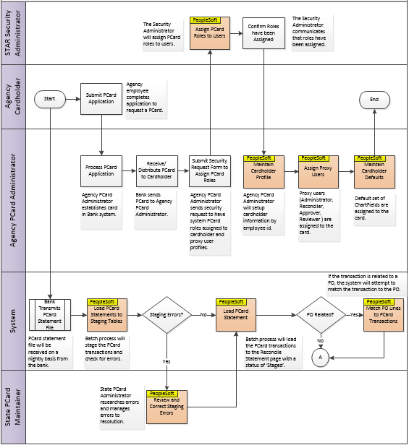

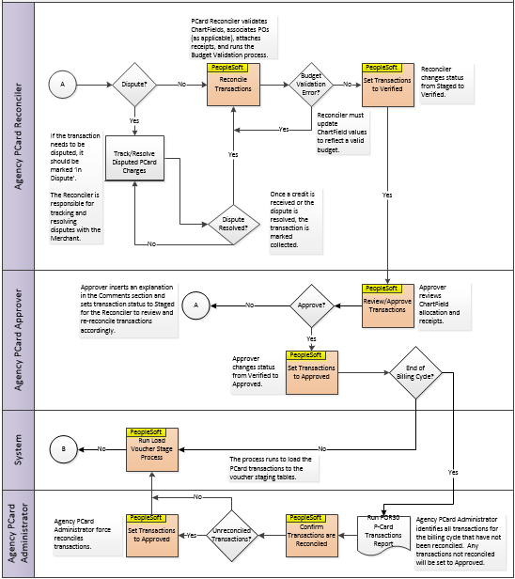

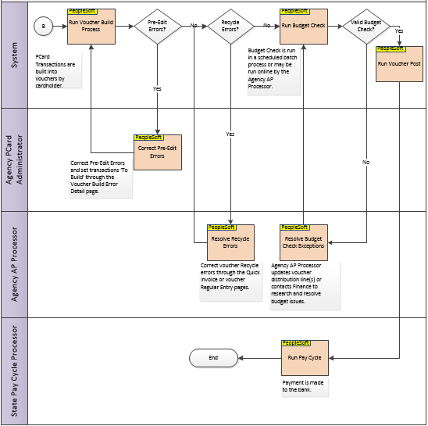

**TOPIC 1: Reconciling P-Card Transactions**

## Reconciling P-Card Transactions Procedure Steps

**Scenario**: You have P-Card transactions to reconcile. Follow the steps explained below.

|  |  |
| --- | --- |
| **Step** | **Action** |
|  | Navigation: **Main Menu** > **Purchasing > Procurement Cards > Reconcile > Reconcile Statement** |
|  | On the **Reconcile Statement Search** page, enter search criteria for P-Card transactions to reconcile, such as **Employee Name, Employee ID, Billing Date** and **Merchant.**  Search for a cardholder by clicking the **magnifying glass** to the right of **Name**.    Select **Staged** from the **Statement Status** drop-down menu. Click **Search** to be sent to the **Reconcile Statement** page. |

|  |  |
| --- | --- |
|  | On the **Reconcile Statement** page, review the list of P-Card transactions. The **Status** of all P-Card transactions is Staged, signifying they have not been reconciled.    **Note:** In this example, there are a total of 50 transactions available to reconcile. The system will default to display the first 9 transactions. Click **View All** to expand the scrollable list to view all 50 transactions. |
|  | The first activity to complete when reconciling P-Card transactions is to allocate the P-Card transactions to the appropriate ChartField coding. P-Card transactions for a cardholder are loaded for reconciliation with the default ChartField Distribution defined on the cardholder’s profile.    Select the **Distribution** icon for a desired transaction line to review the defaulted ChartField coding allocation. |

|  |  |
| --- | --- |
|  | On the **ProCard Account Distribution** window, review the default ChartField coding to confirm the charge is allocated to the correct ChartString. Update the default values, as applicable.    Use the **plus sign (+)** to add additional distribution lines. Use the **minus sign (-)** to delete distribution lines, if desired.    Click **OK** to return to the **Procurement Card Transactions** page.  **Note**: You can manually define the ChartField values, or you may select from a list of SpeedChart values that are associated to the cardholder’s profile. SpeedCharts may be setup by Agency P-Card Administrators. |

|  |  |
| --- | --- |
|  | Back on the **Procurement Card Transactions** page, note that changes to the default coding will change the transaction Budget Status to “**Not Chk’d**”. In addition, the **Redistrib** field will display “**Yes**” signifying that the ChartField coding has been changed from the default. The transaction ChartField coding will need to be re-checked via the Budget Validation process which will be discussed below in Step 10. |
|  | Click the **Comments** icon ( ) to add comments and attachments to the transaction. Add a comment in the **Comments** field.    Then click **Attach** to add a receipt and/or other documentation to the transaction. |

|  |  |
| --- | --- |
|  | On the **File Attachment** window, click **Browse** to search for the document to attach.    Then click **Upload** to attach the document. |
|  | Back on the **ProCard Comments** window, the document that was attached is now available under **Associated Document.**    Click **View** to review the attachment. Click **Delete** to delete the attachment.  Click **OK** to return to the **Reconcile Statement** page. |

|  |  |
| --- | --- |
|  | On the **Reconcile Statement** page, check the **checkbox** next to the transaction that was just updated to validate the budget.    Click **Validate Budget.**    **Note:** You can check the **Run Budget Validation on Save** checkbox to automatically run budget validation when you save any updates. |

|  |  |
| --- | --- |
|  | Again, review the transaction that was previously updated. When the **Budget Status** and **ChartField Status** are valid.    **Note:** For transactions with a Budget Status of "Error" or a ChartField Status of "Recycle", update the distribution ChartField values as applicable to reflect a valid budget string and/or ChartField value. You will need to re-run the Validate Budget process to confirm that the Budget Status and ChartField Status update to Valid. |
|  | Change the transaction **Status** to **Verified** from the dropdown or by clicking the **Verify** button to signify the transaction has been reconciled and is ready to be approved. |
|  | Click **Save.** |

**TOPIC 2: Using the Distribution Template**

## Using the Distribution Template Procedure Steps

**Scenario**: You need to update the ChartField coding on multiple transactions at once. Follow the steps explained below.

|  |  |
| --- | --- |
| **Step** | **Action** |
|  | Navigation: **Main Menu** > **Purchasing > Procurement Cards > Reconcile > Reconcile Statement** |
|  | On the **Reconcile Statement Search** page, enter the applicable search criteria necessary to display the transactions you need to update, such as **Employee Name, Employee ID, Billing Date** and **Merchant.**    Then click **Search** to be sent to the **Reconcile Statement** page. |

|  |  |
| --- | --- |
|  | On the **Reconcile Statement** page, check the **checkbox** next to the transactions lines that need to be updated.    Then click **Distribution Template** to open the **ProCard Distrib Template** window.  **Note**: The GL Unit ChartField value for all of the transactions that are in the search results must be the same in order for the Distribution Template link to display. |
|  | From the **ProCard Distrib Template** window, enter the applicable ChartField data. This will overwrite all of the ChartField data on all lines that are selected.    **Note:** The fields marked with an asterisk (*) are required. |

|  |  |
| --- | --- |
|  | Scroll to the far right to use the **plus sign (+)** to add additional distribution lines.    If additional distribution lines are added, ensure the **Pct** (percentage of distirubution) is equal to 100%.    When all ChartField information is accurate and the distribution percentage equals 100%, click **OK** to return to the **Reconcile Statement** page.  The ChartField coding will be updated on all of the transactions that were selected. |
|  | Back on the **Reconcile Statement** page, review the **Budget Status** for the lines that were just updated. The **Budget Status** is marked Not Chk’d and the **Redistrib** field is marked Yes.    Select the **checkboxes** next to each line where the ChartField coding was updated. Then click **Validate Budget.** |

|  |  |
| --- | --- |
|  | Again, review the lines that were processed through Budget Validation. The **Budget Status** is now Valid.    Click **Save.** |

**TOPIC 3: Disputing P-Card Transactions**

## Disputing P-Card Transactions Procedure Steps

**Scenario**: You need to identify that a transaction is being disputed. Follow the steps explained below.

**Note:** Disputing a transaction in STAR PeopleSoft is informational only. The Merchant or US Bank must be contacted as appropriate to resolve the dispute.

|  |  |
| --- | --- |
| **Step** | **Action** |
|  | Navigation: **Main Menu** > **Purchasing > Procurement Cards > Reconcile > Reconcile Statement** |
|  | On the **Reconcile Statement Search** page, enter the search criteria, such as **Employee Name, Employee ID, Billing Date** and **Merchant.**    Then click **Search**. |

|  |  |
| --- | --- |
|  | On the **Reconcile Statement** page, review the list of P-Card transactions. To dispute a transaction, select the **checkbox** next to the specific transaction, then click on the **Billing** tab. |
|  | On the **Billing** tab, enter a **Description** and the **Dispute Amount.**  In this example, the total amount of the purchase, $55.98, is entered into the **Disputed Amount** field. |
|  | Click **Save**. |
|  | To review the disputed charge, navigate to the following:  Navigation: **Main Menu > Purchasing > Procurement Cards > Reconcile > Review Disputes** |

|  |  |
| --- | --- |
|  | On the **Review Disputes Search** page, enter the search criteria, such as **Employee Name, Employee ID, Billing Date** and **Merchant.**    Then click **Search** to be sent to the **Review Disputes** page. |
|  | On the **Review Disputes** page, review the disputed charge that was previously entered. |

|  |  |
| --- | --- |
|  | From this page, add a comment explaining the details for the dispute by clicking on the **Comment** icon.    Enter the comment and attach any applicable documentation. Click **OK**. |
|  | If the Merchant charged an incorrect amount, the Merchant will post a credit amount that will be received in a subsequent US Bank file.    The dispute should be flagged as **Collected** once the credit is received signifying the dispute has been resolved. |
|  | Click **Save**. |

|  |  |
| --- | --- |
|  | Return to the **Reconcile Statement** page to review if the transaction:  Navigation: **Main Menu** > **Purchasing > Procurement Cards > Reconcile > Reconcile Statement**  On the **Reconcile Statement Search** page, enter the search criteria, such as **Employee Name, Employee ID, Billing Date** and **Merchant.**    Click **Search.** |
|  | On the **Reconcile Statement** page, review the transaction that was just disputed and updated. In this example, the transaction is **Transaction Number** 7. |

|  |  |
| --- | --- |
|  | Select the transaction, then click on the **Billing** tab. Note the **Credit Collected checkbox** is checked as noted indicated on the Review Disputes page.    Click **Save.**  **Note**: If the charge was actually a valid charge, you need to remove the disputed amount to undo the dispute. |

**TOPIC 4: Approving P-Card Transactions**

## Approving P-Card Transactions Procedure Steps

**Scenario**: You need to approve transactions that have been reconciled. Follow the steps explained below.

|  |  |
| --- | --- |
| **Step** | **Action** |
|  | Navigation: **Main Menu** > **Purchasing > Procurement Cards > Reconcile > Reconcile Statement** |
|  | On the **Reconcile Statement** page, enter the search criteria, such as **Employee Name, Employee ID, Billing Date** and **Merchant.**    In addition, select **Verified** from the **Statement Status** drop-down menu.  Then click **Search**. |

|  |  |
| --- | --- |
|  | On the **Reconcile Statement** page, review the list of P-Card transactions that have a **Status** of Verified.    Select the **Distribution** icon to review the ChartField allocation information. |
|  | On the **ProCard Account Distribution** page, review the ChartField information. Update if necessary.    Click **OK** to return to the **Reconcile Statement** page. |

|  |  |
| --- | --- |
|  | On the **Reconcile Statement** page, click the **Comment** icon to review any add comments and attachments.  **Note:** The Comments icon will be filled with squiggly lines to indicate that a comment has been entered.    Click **View** to view attached documents. When prompted, click **Open** to open the attachment. The file will open in a separate window. |
|  | Review the attachment. |
|  | Back on the **ProCard Comments** window, click **OK** to return to the **Reconcile Statement** page. |

|  |  |
| --- | --- |
|  | When everything has been reviewed, change the transaction **Status** to **Approved** from the dropdown or by clicking the **Approve** button to signify the transaction has been approved**.** Then click **Save.**    **Note:** If the Approver does not approve the reconciliation details, they may insert a comment to provide information back to the Reconciler to provide additional documentation as needed. The Approver will set the Statement Status back to **Staged** so that the Reconciler can review the transaction again. |

The following provides the various dates and timelines that users will have to reconcile and approve P-Card transactions, as well as correct P-Card vouchers to ensure timely payment to the bank.

**STAR PURCHASING CARD BILLING CYCLE AND APPROVAL DATE**

**2015 CALENDAR**



Issued by

STATE BUREAU OF PROCURMENT AND STATE CONTROLLER'S OFFICE

DEPARTMENT OF ADMINISTRATION