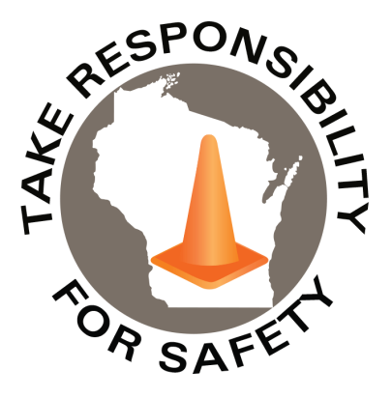

September 2026
Volume 13, Number 9
Safety Net(work)
Produced by Department of Administration Bureau of State Risk Management

Produced by Department of Administration Bureau of State Risk Management

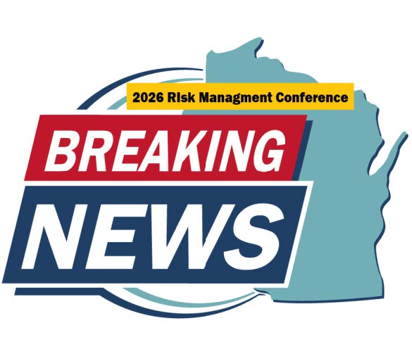
In This Issue:
2026 Risk Management Conference
Hazardous Waste Awareness Training

Safety Spotlight:

National Preparedness Month

Five Minutes for Safety:

Watch out for deer!

Workers Comp

Claims Claims
FY26 YTD FY27 YTD
389 394

Lost Time Lost Time
FY26 YTD FY27 YTD
76 75

2026 Risk Management Conference

Come join us at the Bureau of State Risk Management Conference, held on November 11, 2026, at the Monona Terrace in Madison, Wisconsin. The full day agenda highlights great opportunities for State of Wisconsin Supervisors, Leadership, Risk Management Personnel, Worker’s Compensation, Property, Liability & Safety Contacts, Facilities, Buildings & Grounds Personnel, Human Resources Personnel, Health & Safety Teams, and Budget & Finance Staff Integrated in Risk Management.

Some highlights to look forward to:
- State of the State in Risk Management – Jason Gates
- Breakout Networking Roundtable Sessions
  - Meet other State of Wisconsin Risk Management professionals and share experiences together.
- Risk Management Awards
- Why Carrier Recommendations Matter: A Practical Guide to Reducing Property Risk & Improving Insurability, Workers’ Compensation Legal Update, and Safety Leadership at Every Level: Empowering Employees to Own Risk Breakout Sessions
- Keynote Speaker: Joey Sylvester from Gallagher will speak on how AI is reshaping Risk Management. Explore the role of AI across public entities, from using AI in predictive loss analysis and considerations for State agency AI implementation.

Registration Information

We look forward to seeing you in November!

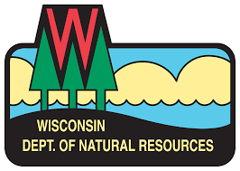

IMPORTANT NOTICE - The information presented in this newsletter is intended for internal State of Wisconsin agency consideration in loss prevention efforts. Due to space limitations, it may not always be all-inclusive in identifying all material associated with topics discussed. It is encouraged to adjust the contents to fit the specific audience of your operation.

Hazardous Waste Awareness Training

Did you know the Bureau of State Risk Management annually sponsors free training via the mandatory statewide hazardous waste services contract to explain the requirements and best management practices for waste handling, storage, disposal, and recycling? Over the years, our agency’s attendance levels have significantly dropped, and we are trying to better understand why and if there are any improvements that can be made for future planning. If you or anyone you know are part of this intended audience group listed below, we would greatly appreciate a few minutes of your time to please complete the survey link below by October 9th, 2026:

Survey: Hazardous Materials Awareness & Waste Disposal Training

Thank you for your time and attention.

*Intended Audience Groups:
Employees working at state-owned or operated facilities or employees of municipalities, tribal governments, public K-12 schools, technical colleges, and universities, need to be thoroughly familiar with proper waste handling and emergency procedures relevant to their facilities operations including:

- Employees who work with hazardous chemicals
- Facility operations, maintenance, buildings and grounds management
- Employees involved with vehicle and equipment maintenance
- Employees who manage waste storage areas
- Laboratory workers who generate waste solvents or other chemical waste
- Stock/supply-area workers who order, receive or store chemical products
- Supervisors who oversee personnel with the duties listed above

The training familiarizes, refreshes and engages the audience with material explaining the requirements and best management practices for waste handling, storage, disposal, and recycling. Some example products include fluorescent lamps, batteries, laboratory chemicals, oils, antifreeze, paints, thinners, cleaners, corrosives & poisons.

WDNR INFORMATION ON MANAGEMENT OF HAZARDOUS WASTE IN WISCONSIN

WDNR HAZARDOUS WASTE GUIDANCE AND INSPECTION FORMS

Enjoy the Scenery!

Mental health breaks may be beneficial to reduce workplace stress. Relax and enjoy Wisconsin’s scenic views! See the fall color report for peak leaf viewing times.

Consumer Safety
United States Consumer Product Safety Commission

Contact Us
https://doa.wi.gov

E-Mail
Jake.Lowell@Wisconsin.gov

