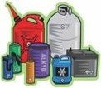
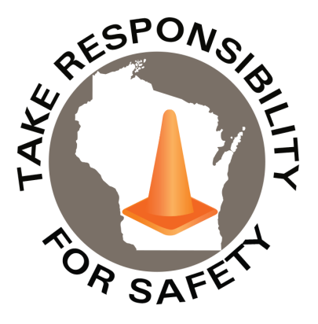

In This Issue:
Hazardous Waste Training Requirements
Higher ER Visits for Tick Bites
The National Safety Stand-Down

Volume 13, Number 5
May 2026
Safety Net(work)
Produced by Department of Administration Bureau of State Risk Management

Produced by Department of Administration Bureau of State Risk Management

Safety Spotlight:

National Electrical Safety Month

Fatalities caused by falls from elevation continue to be a leading cause of death for construction employees, accounting for 389 of the 1,034 construction fatalities recorded in 2024 (BLS).
Electrical Safety While Working from Home

WDNR Guidance on Hazardous Waste Training Requirements
The WDNR has created guidance documents to help people and facilities comply with hazardous waste requirements. One popular inquiry to highlight is, “Training Requirements and Records: Hazardous Waste Generators, Collection Sites and TSD Facilities (WA-099).” The WA-99 guidance document discusses the different training requirements for managing hazardous waste depending on the facility type.

Annually, the Bureau of State Risk Management sponsors hazardous materials awareness and waste disposal training through the State of Wisconsin mandatory contract. The 2026 learning opportunities were completed both in-person and virtually in April. In case any employees working at state-owned or operated facilities or employees of municipalities, tribal governments, public K-12 schools, technical colleges, and universities missed and would still like to attend, the virtual sessions are recorded and available online until May 17th at the following links (ensure signed into Microsoft Office online account to view):

Physical Properties of Chemicals, Chemical Hazards, Compatibility

Hazardous Waste & Spill Awareness

Solid & Universal Waste

WDNR Regulatory & Universal Waste Updates, Top Violations

2026 Hazardous Materials Awareness and Waste Disposal Training Survey (Complete by May 17th to Receive a Certificate of Completion)

Please keep in mind that this training is to be considered a starting point and is not all inclusive of the WA-099 publication guidance. As it is challenging with time constraints to be comprehensive enough for our large audience and meet the requirements of site-specific information.

473

1,965

Claims
FY26 YTD

Workers Comp

Alarming Statistic: 38%

Five Minutes for Safety:

460
Claims
FY25 YTD YTD

Lost Time
FY26 YTD

Lost Time
FY25 YTD

1,860

Weekly ER Visits for Tick Bites Higher than Usual

May is Lyme Disease Awareness Month, the CDC is urging the public to take steps to protect themselves and their families from tick bites, and the serious diseases they can cause, including Lyme disease, Rocky Mountain spotted fever, and alpha-gal syndrome. Visits to emergency rooms for tick bites are higher than normal in many parts of the country right now, according to CDC's Tick Bite Tracker. In Wisconsin, data from the state Department of Health Services for the week ending April 19 shows the state is seeing a similar trend, with a rate of 44 tick-bite visits for every 10,000 emergency room visits (double the number of ER visits for tick bites at this time last year). Wisconsin had a record 6,469 cases of Lyme disease in 2024, and cases have quadrupled over the past 20 years, due in part to more recognition and reporting.
CDC has tips and resources for coping with the tick season:
- Preventing Lyme Disease | CDC
- Preventing tick bites
- CDC Insect Repellent Guide (using and choosing repellent)
- CDC Tick Bite Guide (what to do after a tick bite, and what symptoms to look out for)
- How to safely remove ticks (tips on tick removal and photos)
- About Ticks and Tickborne Disease
- Where Ticks Live
- Video: When a Tick Bite Causes a Red Meat Allergy (a person's experience with alpha-gal syndrome)
- Preventing Ticks on Pets | Ticks | CDC
- CDC Tick Bite Tracker

Additional State of Wisconsin resources for dealing with the tick season:
- Wisconsin DHS Tick Bite Prevention
  - DHS Tick Prevention Publication P01751a
- University of Wisconsin-Madison Tick Guidance

CDC Data Show Weekly ER Visits for Tick Bites Higher than Usual
Wisconsin could be in for ‘a big year’ for Lyme disease as tick bites soar
IMPORTANT NOTICE - The information presented in this newsletter is intended for internal State of Wisconsin agency consideration in loss prevention efforts. Due to space limitations, may not always be all-inclusive in identifying all material associated with topics discussed. It is encouraged to adjust the contents to fit the specific audience of your operation.

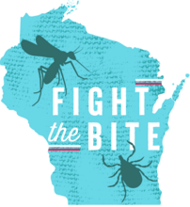

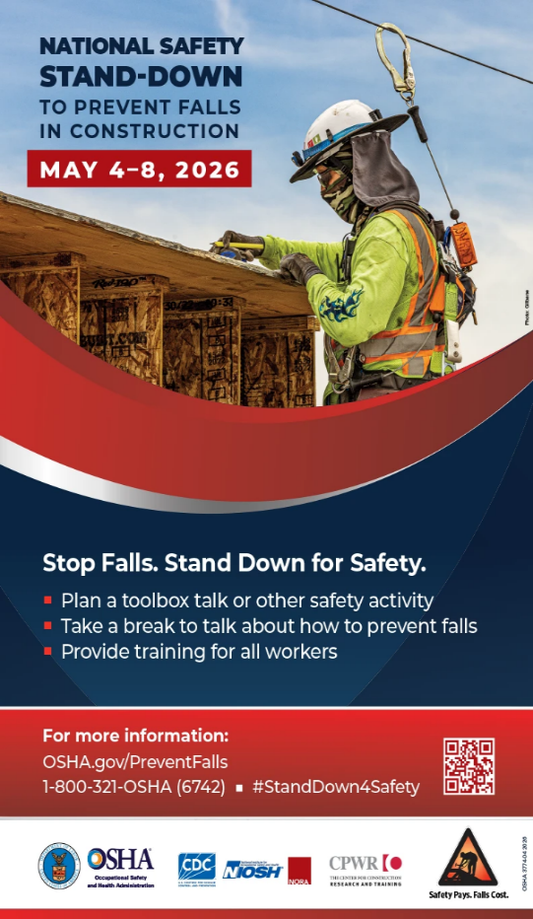
Safety Stand-Down
2026 Virtual Sessions
May 4-8, 2026
Register for FREE webinars with MSA trainers and safety experts.

How to Conduct a Site Hazard Assessment

Type I and Type II Head Protection: OSHA Standards, Industry Trends, and More

ABCs of Fall Protection
The National Safety Stand-Down To Prevent Falls in Construction

Consumer Safety
United States Consumer Product Safety Commission

Contact Us
https://doa.wi.gov

E-Mail
Jake.Lowell@Wisconsin.gov

