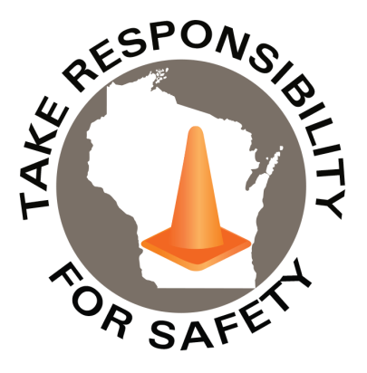

Volume 13, Number 3
In This Issue:
Hazardous Materials Awareness
& Waste Disposal Training
Driver Safety

Free for state, municipal, public school and tribal government employees
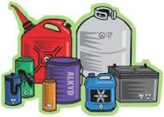
March 2026
Safety Net(work)
Produced by Department of Administration Bureau of State Risk Management

Produced by Department of Administration Bureau of State Risk Management

Safety Spotlight:

Workplace Eye Wellness Month

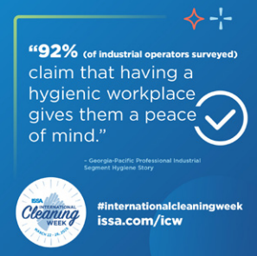
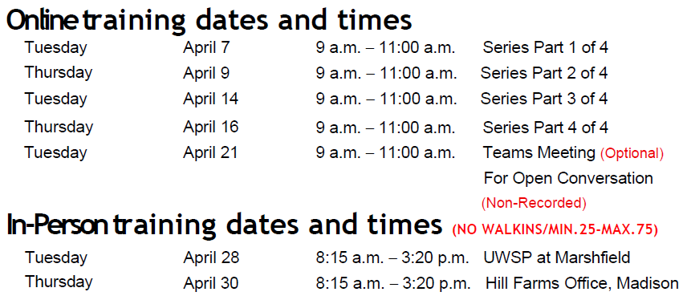
2026 Wisconsin Hazardous Materials Awareness
& Waste Disposal Training
Employees working at state-owned or operated facilities or employees of municipalities, tribal governments, public K-12 schools, technical colleges, and universities, need to be thoroughly familiar with proper waste handling and emergency procedures relevant to their facilities operations (State of Wisconsin Training Requirements for Hazardous Waste Generators).

The Bureau of State Risk Management sponsors this free training to familiarize, refresh and engage the audience with material explaining the requirements and best management practices for waste handling, storage, disposal, and recycling. Some example products include fluorescent lamps, batteries, laboratory chemicals, oils, antifreeze, paints, thinners, cleaners, corrosives & poisons.

During 2026, training options will be provided remotely through Microsoft Teams & two limited seating in-person options. For remote training, Microsoft Teams meeting invites with instructions will be sent to all registered email addresses in advance of the sessions. A phone call in option will be made available for those without computer access. For any potential scheduling conflicts or technical difficulty, recordings of the sessions will be available to review in the original Microsoft Teams calendar invites for a limited time.

Who Should Attend?
- Employees who work with hazardous chemicals
- Facility operations, maintenance, buildings and grounds management
- Employees involved with vehicle and equipment maintenance
- Employees who manage waste storage areas
- Laboratory workers who generate waste solvents or other chemical waste
- Stock/supply-area workers who order, receive or store chemical products
- Supervisors who oversee personnel with the duties listed above

REGISTER online at seminars.veoliaes.com/seminars
1,538

Claims
FY26 YTD

National Cleaning Week

Workers Comp

Five Minutes for Safety:

371

371

Claims
FY25 YTD YTD

Lost Time
FY26 YTD

Lost Time
FY25 YTD

1,481


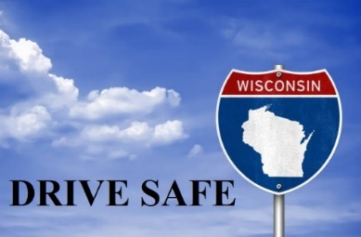
Traffic Safety: Teens and Young Adult Drivers Plus More Traffic Safety from the Wisconsin Department of Health Services

Feeling angry behind the wheel? Try the ‘Three R’s’

Earlier this year, Safety and Health Magazine shared a technique for anyone who has been behind the wheel and has felt moments of annoyance, frustration and even anger when another driver cuts them off, or won’t allow them to merge, or makes another aggressive or unsafe action. It’s important to not let these feelings escalate.

The National Safety Council says using the “Three R’s” can help:
Reflect: Take a mental step back and ask yourself why you’re angry and what you can safely do to change the situation.
Reframe: Think about the situation you’re in and ask yourself what you need to do to stay in control.
Refocus: Think about something other than what just happened to make you angry and put the situation behind you.

Use these techniques, which are part of NSC’s Defensive Driving Courses, anytime you need to regain your self-control.

“If you give courtesy to other drivers on the road, you’ll be able to share the road safely.”

Still Available: Drive Safe Wisconsin

Released in 2021, the Bureau of State Risk Management partnered with the Department of Transportation in creating a “Drive Safe Wisconsin” training course to help mitigate injuries and loses involving motor-vehicles. The course provides information about driving risks and best practices to help reduce the chances of motor vehicle collision, injury, and loss by improving knowledge and behavior while on the road. The training series is focused on four important driver safety topics that are common contributing areas of risk & loss for the State of Wisconsin. The topics included share valuable information that can dramatically lower the risk of injury when behind the wheel:

- Using Safety Belts
- Seeing Well
- Avoiding Dangerous Driving Behaviors
- Adjusting to Road Conditions

The “Drive Safe Wisconsin” training course is available through Employee Self Service (ESS) via the “My Learning” icon for agencies and via UW System OSH Training web page for campuses. Keyword search “Drive Safe” in Leader (Cornerstone). The course is broken into four sessions, topically as outlined above, and total run time of entire program is approximately 40 minutes. It’s designed either to be taken in a single sitting or by topic to accommodate any time constraints. This training is beneficial for both personal and work-related operation of vehicles and encourage anyone operating a vehicle to complete this training.

IMPORTANT NOTICE - The information presented in this newsletter is intended for internal State of Wisconsin agency consideration in loss prevention efforts. Due to space limitations, may not always be all-inclusive in identifying all material associated with topics discussed. It is encouraged to adjust the contents to fit the specific audience of your operation.

Consumer Safety
United States Consumer Product Safety Commission

Contact Us
https://doa.wi.gov

E-Mail
Jake.Lowell@Wisconsin.gov

