
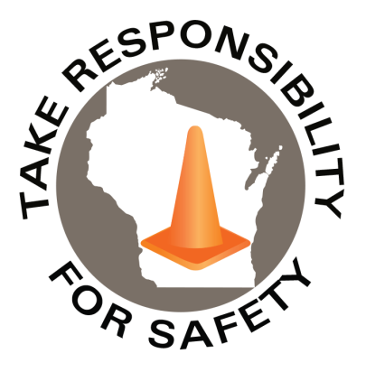

Safety Spotlight:
Vehicle Theft Prevention Month -NTSA

Statistics of the Month
In Wisconsin 2025, there were 120 Emergency Department visits with a fireworks-related injury.

In 2023, according to the National Fire Protection Association, 9,700 fireworks-related injuries were treated in U.S. hospital emergency rooms.

CPSC Urges Fireworks Safety Ahead of July 4th Holiday.

Lyme Disease Warning
In 2024, Wisconsin had 6,469 cases of Lyme disease, the highest on record. The average number of reported cases has now quadrupled over the past 20 years.

Lime disease is preventable and treatable. Learn more about Tick Bite Prevention.

In This Issue:
UV Safety Awareness Month
Extreme Heat

July 2026
Volume 13, Number 7
Safety Net(work)
Produced by Department of Administration Bureau of State Risk Management

Produced by Department of Administration Bureau of State Risk Management

UV Safety Awareness Month
The Skin and Cancer Institute shares that July is UV Safety Awareness Month, a time to encourage everyone to take steps to protect themselves from the dangers of sunny weather ultraviolet (UV) radiation. According to the American Cancer Society, approximately 99,000 new melanoma cases are diagnosed in the United States each year, leading to about 7,000 deaths. Just a few minutes of sun exposure each day can add up over time. Steps must be taken to protect against UV radiation, or there may be a risk for several serious health consequences that include sunburn, premature aging, eye damage, and skin cancer. Skin cancer is the most common type of cancer in the United States, and UV radiation is the leading cause of skin cancer but also the most preventable. So, make sure to take steps to protect against UV radiation during safety awareness month and all year long.

Tips for minimizing sun exposure and reduce the risk of skin damage:
- Try to stay in the shade as much as possible. If in the sun, wear protective clothing such as a long-sleeved shirt and pants.
- Apply sunscreen with a high SPF rating to exposed skin (choose a sunscreen with an SPF of 30 or higher. Make sure that the sunscreen is broad-spectrum, which will protect against both UVA and UVB rays. Choose a water-resistant sunscreen if spending time in the water).
- Avoid being in the sun during peak hours, typically between 10 am and 4 pm.
By taking these precautions, the skin is protected from the harmful effects of UV radiation.

There are also several myths about UV radiation that circulate each year. Here are a few of the most common UV myths – and why to stop believing in them:

Myth 1: I don’t need to worry about UV radiation when it’s cloudy.
The truth is that UV rays are just as harmful on cloudy days as on sunny days. Up to 80% of UV rays can penetrate through clouds. So, even if you’re only going to be outside for a short period of time on a cloudy day, it’s important to take precautions against UV exposure.

Myth 2: I don’t need to worry about UV radiation if I have dark skin.
While it’s true that people with darker skin have a higher natural SPF than those with lighter skin, this does not mean that they are immune to the effects of UV radiation. Darker skin can still suffer from sunburn, premature aging, and even skin cancer. So, it’s essential for everyone – regardless of skin color – to take steps to protect themselves from UV radiation exposure.

Myth 3: I don’t need to worry about UV radiation when wearing sunscreen.
While sunscreen is a vital part of any sun safety plan, it’s not the only thing you need to do to protect yourself from UV radiation. You should also take steps to avoid excessive sun exposure and wear protective clothing when you are in the sun.

Extreme Heat

Extreme heat is defined as summer temperatures that are much hotter and/or humid than average. In Wisconsin, temperatures above 90 degrees Fahrenheit for two or more days in a row are considered extreme heat. Did you know that our own Department of Health Services (DHS) has educational resources available on extreme heat and many more safety & health prevention topic resources? With Wisconsin experiencing more frequent and intense heat waves as our changing climate becomes warmer and wetter, many more severe heat waves are reportedly on the way, according to WICCI (the Wisconsin Initiative on Climate Change Impacts). WICCI predicts an annual increase of 20-30 days with 90-plus degrees Fahrenheit over the next 50 years.

On days when both temperatures and humidity levels are high, the body must work extra hard to cool off and maintain a normal temperature. Hot, sticky conditions are not only uncomfortable, but they can also cause serious heat-related illnesses and even death. It's important to get prepared, stay informed, and know how to protect your health when extreme heat arrives:

Follow these tips from DHS to keep yourself and your family healthy and safe on hot, humid days:
- Stay hydrated. Drink plenty of water on hot days (eight ounces every 15-20 minutes). Don't drink beverages high in caffeine, sugar, sodium or alcohol if possible—these cause loss of more body fluid. Avoid hot, heavy meals too.
- Stay cool.
  - Indoors – When possible, stay in air conditioning on hot days. If air conditioning is not available, call 211 to find a cool public space like libraries and malls to cool off. Use fans—only if indoor temperatures are less than 90 degrees Fahrenheit—any hotter and a fan can actually increase body temperatures.
  - Outdoors – Avoid the hottest part of the day and stick to the cooler morning and evening hours if you must be outside. Stay in the shade as much as possible, take breaks when you can (in air conditioning if possible), and wear loose, light clothing.
- Check on loved ones. Extreme heat can affect anyone of any age, including youth and adults. Be sure to check on older family, friends and neighbors, especially those who live alone, have chronic health conditions, and don’t have air conditioning.
- Beware of hot cars. Never leave a person or a pet in a parked car, even for a short time. On an 80 degree day, the temperature inside a car can reach 100 degrees in less than 10 minutes.
- Stay informed. Check your local weather forecasts often so you can plan outdoor activities safely. Pay attention to any extreme heat or air quality alerts, the humidity levels, and the overnight temperatures that can increase risks of heat illness.
- Know the symptoms. If your body gets too hot, you can get sick. Learn the signs of your body overheating and when to seek medical care in our Extreme Heat Toolkit, P-00632 (PDF). Symptoms can include muscle cramping, unusually heavy sweating, shortness of breath, dizziness, headaches, weakness and nausea.
Find more tips to prevent heat illness from CDC (Centers for Disease Control and Prevention) or OSHA.

Consumer Safety
United States Consumer Product Safety Commission

Contact Us
https://doa.wi.gov

E-Mail
Jake.Lowell@Wisconsin.gov

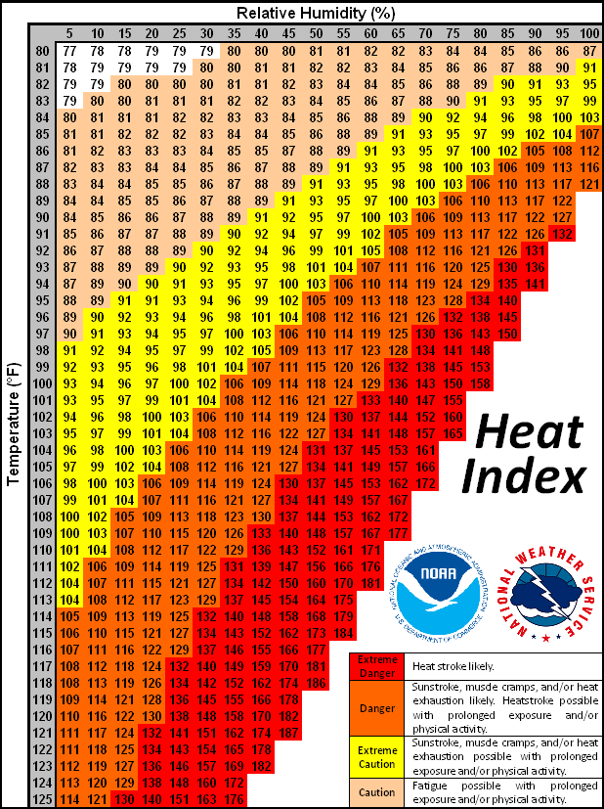
IMPORTANT NOTICE - The information presented in this newsletter is intended for internal State of Wisconsin agency consideration in loss prevention efforts. Due to space limitations, may not always be all-inclusive in identifying all material associated with topics discussed. It is encouraged to adjust the contents to fit the specific audience of your operation.

