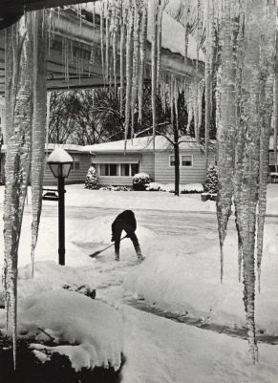
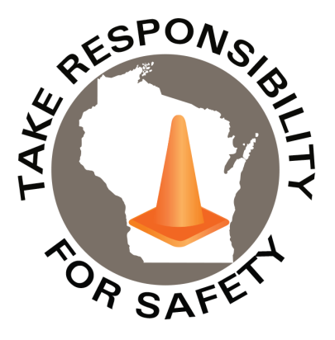

Volume 13, Number 1
January 2026
In This Issue:
Early Winter Wonderland
Winter Slip and Fall Prevention

Safety Net(work)
Produced by Department of Administration Bureau of State Risk Management

Produced by Department of Administration Bureau of State Risk Management

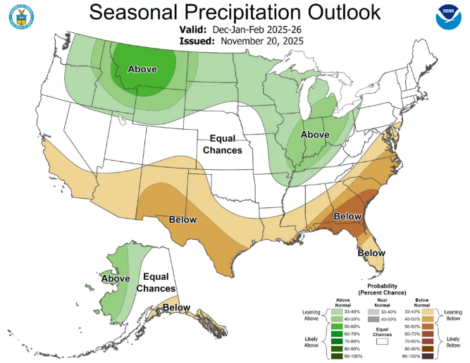
1,187

Safety Spotlight:

National Radon Action Month

Five Minutes for Safety:

Hazardous Chemicals in the Workplace?

Early Winter Wonderland

For the first time in over two decades, the entire state of Wisconsin is covered in snow on December 1. Two separate storms brought huge amounts of snow to the state during the final week of November. Snowfall totals from November 25 through 27 were more than a foot in most of northwestern Wisconsin, with numerous locations reporting higher than 20 inches. The highest reported total was 32.2 inches in Mercer (Iron County). This storm brought the largest totals and most widespread snowfall to northern Wisconsin by December 1 since 2019. Madison’s Dane County Regional Airport measured 9.3 inches of snow on November 29, setting a new daily snowfall record for the date (previous record was 6.0 inches set in 1991). It also became the snowiest November day on record in Madison, breaking the old monthly record of 7.6 inches set on November 27, 1995. The Milwaukee Mitchell Airport reported 6.1 inches on November 29, also a new daily record for the city (previous record was 3.3 inches in 1971). Over the two days, snow totals in southern Wisconsin ranged from five to 14 inches.

As of January 4, 2026, there has already been 50 too many State of Wisconsin employees receiving medical attention resulting from a slip and fall on ice or snow. This is concerning as January is often the state’s snowiest month, averaging 13.2 inches of snow statewide and 15 to 20 inches in the far northern counties.

The Midwest could see a wetter-than-average winter this year, according to the Climate Prediction Center. Wisconsin’s chances are on the lower end, only 33 to 40 percent, but chances are higher to our southeast in Illinois, Indiana, Ohio, and Michigan.

Remember that winter precipitation doesn’t necessarily mean snow, but any type of liquid precipitation. However, if the outlook materializes, cooler-than-average temperatures combined with wetter-than-average conditions could result in more snow.

Claims
FY26 YTD

Workers Comp

278

278

Claims
FY25 YTD YTD

Lost Time
FY26 YTD

Lost Time
FY25 YTD

1,091

The Department of Administration Bureau of State Risk Management in collaboration with the Bureau of Training and Development released, in Fall 2023, a home grown 30 minute winter slip and fall prevention module available in both Cornerstone (agencies) and Canvas (universities) for all state employees. Please be sure to take advantage of this educational opportunity in the coming days to help protect yourself and the team from one of the state’s leading causes of injury. This course will help you recognize potential winter slip and fall hazards and identify important safety practices that can lower your risk of injury due to slips, trips, and falls.

Keyword search “Winter” in Leader (Cornerstone)

Be sure to check out the Universities of Wisconsin Winter Weather Safety resources web page for additional tips such as the Snow & Ice Removal Safety document from the University of Wisconsin – Madison or learning to Walk Like a Penguin from Alberta Health Services.

IMPORTANT NOTICE - The information presented in this newsletter is intended for internal State of Wisconsin agency consideration in loss prevention efforts. Due to space limitations, may not always be all-inclusive in identifying all material associated with topics discussed. It is encouraged to adjust the contents to fit the specific audience of your operation.

Consumer Safety
United States Consumer Product Safety Commission

Contact Us
https://doa.wi.gov

E-Mail
Jake.Lowell@Wisconsin. gov

