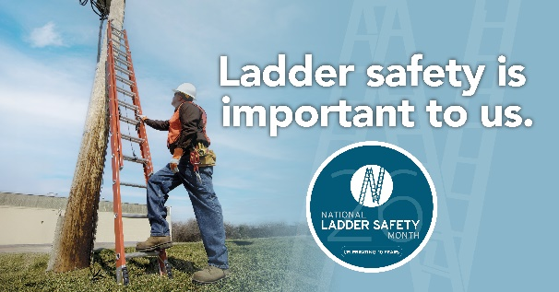



In This Issue:
Ladders and Chairs Oh My
Free Ladder Safety Learnings

Volume 13, Number 2
February 2026
Safety Net(work)
Produced by Department of Administration Bureau of State Risk Management

Produced by Department of Administration Bureau of State Risk Management

Safety Spotlight:

National Ladder Safety Month

Five Most Common Causes of Ladder Incidents
According to the American Ladder Institute (ALI), missing the last step and overreaching were the two most cited causes of ladder incidents. Provided below are five most common causes of ladder incidents.

- Missing the last step when climbing down the ladder.
- Overreaching while on the ladder.
- The ladder was not the right size for the job.
- The ladder was not on firm, level ground.
- Three points of contact were not used when climbing the ladder.

5 Most Common Causes of Ladder Incidents - ANSI Blog
Ladders and Chairs Oh My

According to the most recent figures from the Bureau of Labor Statistics, there were 22,710 ladder-related injuries at work in 2020. In recent months, State of Wisconsin employees also sustained some concerning working from heights injury claim trends. Some of these serious injuries resulted from improper decision making, wrong choice of the tools for the job (chairs are not designed to stand on), improper use of ladders to cause tipping, not maintaining three points of contact at all times (ascending and descending), and missing the last step climbing down. The moment has arrived to embrace March National Ladder Safety Month right now before anyone else gets unnecessarily hurt.

The presenting sponsor for National Ladder Safety Month, American Ladder Institute (ALI) is the only approved developer of safety standards for the U.S. ladder industry. ALI believes ladder accidents are preventable with thorough safety planning, training, and continuous innovation in product design. The goals of National Ladder Safety Month are to raise awareness around ladder safety, at home and at work, to decrease the number of ladder-related injuries and fatalities caused by misuse, and to increase the number of people certified in Ladder Safety Training.

2026 Focus of National Ladder Safety Month:
- Training and Awareness.
- Inspection and Maintenance.
- Stabilization, Setup, and Accessories.
- Safe Climbing and Positioning.

Click on the link below for more information on National Ladder Safety Month: National Ladder Safety Month
Ladder Safety Training

Flyers

Videos

Articles

ALI Offerings

National Ladder Safety Month Resources:

1,363

Claims
FY26 YTD

Workers Comp

319

329

Claims
FY25 YTD YTD

Lost Time
FY26 YTD

Lost Time
FY25 YTD

1,286

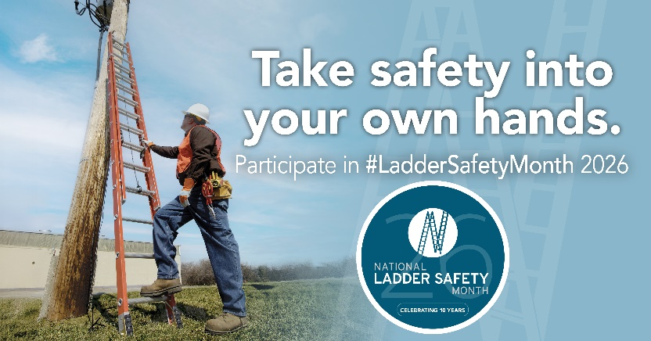
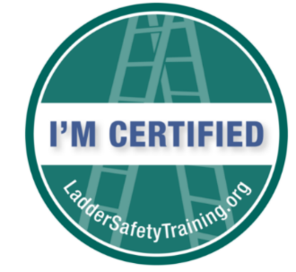
Climb Safely, Work Safely
Tuesday, March 24, 2026
10:00 AM – 11:00 AM CST
SUMMARY: This session focuses on the behaviors and decisions that prevent falls before they happen. Topics include:
- Overreaching – Why overreaching leads to loss of balance and sudden falls.
- Proper body positioning – How foot placement, hip alignment, and three points of contact work together to keep the ladder stable.
- Transitioning on and off a ladder – How to step on and off with control, maintain balance, and avoid rushed movements at the top and bottom.
- Use of accessories: How levelers and stabilizers improve footing, reduce movement, and support safer setup on uneven surfaces.
The takeaway is simple; safe climbing depends on disciplined positioning, controlled movement, and using the right equipment every time. Climb Safely. Work Safely.

DIY, Homeowner Ladder Safety
Thursday, March 19, 2026
10:00 AM – 11:00 AM CST
The majority of ladder accidents in the US happen at the home. We will discuss the most common causes of these accidents and show practical solutions to the problems. We will also be discussing the basic principles of ladder safety;
• Choosing the Right Ladder
• Inspection
• Set-up
• Proper Climbing

Please join us in our goal to prevent falls at home.

Free Ladder Safety Learnings
The non-for-profit American Ladder Institute (ALI) created a free Ladder Safety Training program and declared March as National Ladder Safety Month to inspire safer ladder use and reduce the rate of injuries. The ALI online Ladder Safety Training certification program is aimed at promoting safe ladder use, selection and care. The ALI Safety Training is a 100% free educational offering, so all employees can be required to complete the program without any training cost implications. The training is designed for both professionals and homeowners, and it teaches participants how to safely use and care for different types of ladders including:

- Stepladders
- Single and extension ladders
- Articulated ladders
- Mobile ladders

Participants that complete the Ladder Safety Training program will receive a certificate of completion, ensuring the most current and reputable ladder safety information is understood.
*For Trainers and Training Managers, The ALI has designed a Trainer’s Toolbox (simply check the “Trainer Toolbox” when signing up). Additional free tool available to register/assign to organization’s trainees.
https://www.laddersafetytraining.org/

IMPORTANT NOTICE - The information presented in this newsletter is intended for internal State of Wisconsin agency consideration in loss prevention efforts. Due to space limitations, may not always be all-inclusive in identifying all material associated with topics discussed. It is encouraged to adjust the contents to fit the specific audience of your operation.

2026 Ladder Safety Webinar Series
Louisville Ladder, Little Giant and Werner Co. are all sponsoring new ladder safety webinars each week during ladder safety month:

Choosing The Right Ladder For The Job
Thursday, March 5, 2026
1:00 PM – 2:00 PM CST
Selecting the correct ladder is one of the most important decisions before starting work at height. This webinar will cover how to choose the right ladder for the job by matching ladder type, height, and duty rating to the task at hand. Attendees will learn common mistakes to avoid and best practices to help reduce the risk of ladder-related injuries. The first half of the webinar will be presented in English, followed by a repeat of the presentation in Spanish.

Common Ladder Accidents and How to Avoid Them
Tuesday, March 10, 2026
10:00 AM – 11:00 AM CST
We will cover the six most common causes of ladder accident on the jobsite, discuss what the OSHA standard says and show practical solutions to the problems. We will also be discussing the basic principles of ladder safety;
• Choosing the Right Ladder
• Inspection
• Set-up
• Proper Climbing

Please join us in our goal to get everyone home safely at the end of the day.

Consumer Safety
United States Consumer Product Safety Commission

Contact Us
https://doa.wi.gov

E-Mail
Jake.Lowell@Wisconsin.gov

