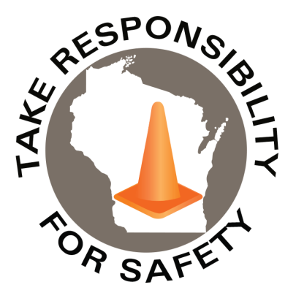


Safety Spotlight:

National Immunization Awareness Month

Five Minutes for Safety:

National Stop on Red Week

Workers Comp

Claims Claims
FY26 YTD FY27 YTD
197 197

Lost Time Lost Time
FY26 YTD FY27 YTD
37 36

August 2026
Volume 13, Number 8
Safety Net(work)
Produced by Department of Administration Bureau of State Risk Management

Produced by Department of Administration Bureau of State Risk Management

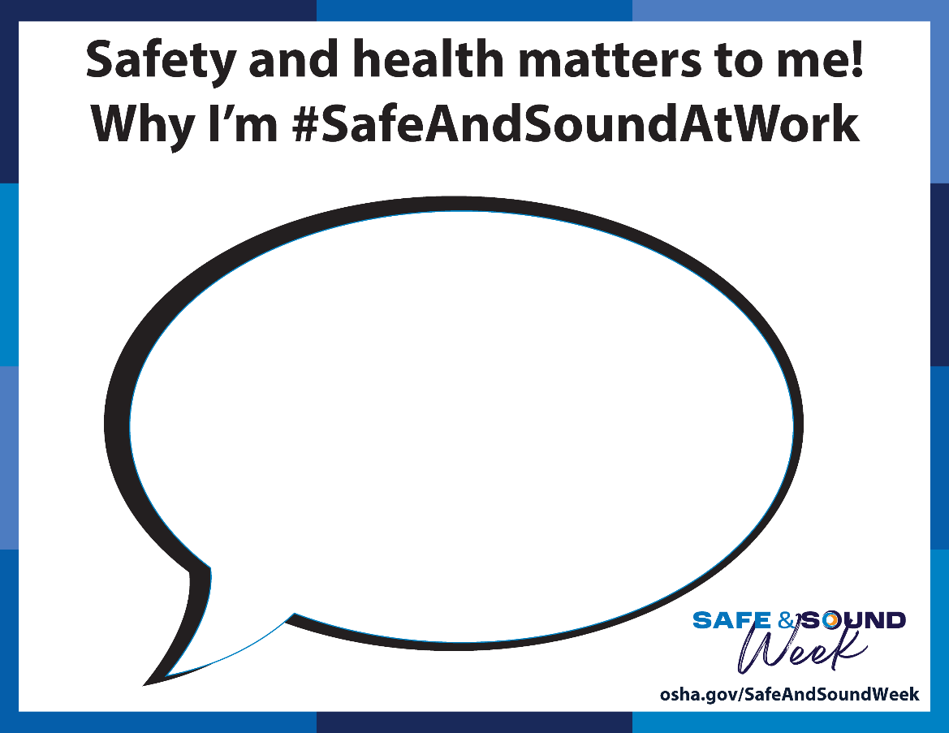
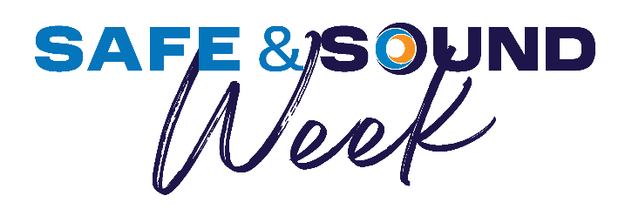

Safe & Sound Week

Led by OSHA, Safe & Sound Week is a nationwide event held each August that recognizes the successes of workplace safety and health programs, which also offers information and ideas on how to keep workers safe. Participating in Safe & Sound Week can help get a safety program started, energize an existing one, or provide a chance to recognize safety and health accomplishments. Participating in Safe & Sound Week is easy and fun!

Find materials like shown below to remind and promote why safety is important to you:

Safety and health matters to me! Why I'm #SafeAndSoundAtWork

In This Issue:
Safe & Sound Week

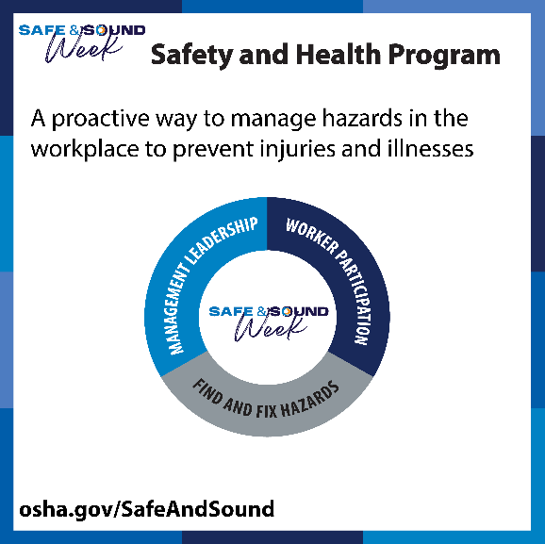
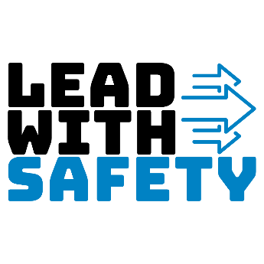
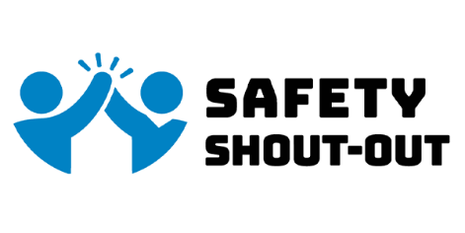

IMPORTANT NOTICE - The information presented in this newsletter is intended for internal State of Wisconsin agency consideration in loss prevention efforts. Due to space limitations, may not always be all-inclusive in identifying all material associated with topics discussed. It is encouraged to adjust the contents to fit the specific audience of your operation.

Safe & Sound Week
There are also challenge activities built around three core safety elements:

- Management leadership
  - Highlighted example: Lead With Safety
    - In a workplace, management provides the leadership, vision, and resources needed to implement an effective safety and health program. This is a challenge for Managers to show how you Lead with Safety. Identify a safety or health issue in your workplace and take steps to address it.

- Worker participation
  - Highlighted example: Safety Shout-Out
    - Get workers involved in safety recognition with the Safety Shout-Out Challenge. Safety Shout-Outs provide immediate recognition, make workers more aware of their daily safety actions, and can reinforce teamwork and collaboration.

- Fix and find hazards
  - Highlighted example: Find Four
    - Turn your evacuation drill into an interactive learning experience! Reinforce critical emergency evacuation procedures while keeping your team engaged. Have them think on their feet using the Find 4 Emergency Evacuation Scavenger Hunt.

Use these resources, along with the other ideas and marketing materials available, to make Safe & Sound Week a success at your workplace.

Consumer Safety
United States Consumer Product Safety Commission

Contact Us
https://doa.wi.gov

E-Mail
Jake.Lowell@Wisconsin.gov

