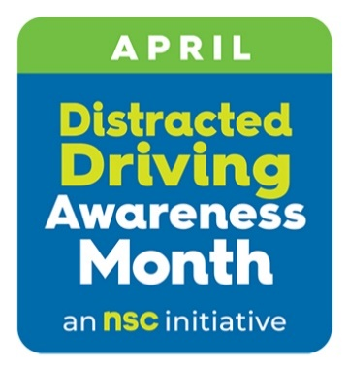
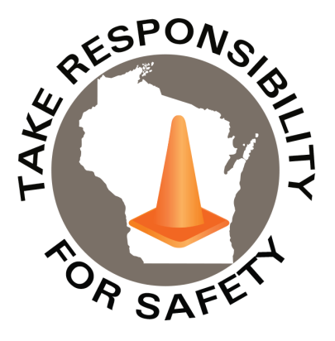

In This Issue:
Distracted Driving Awareness Month
Tornado & Severe Weather Awareness Week

Volume 13, Number 4
April 2026
Safety Net(work)
Produced by Department of Administration Bureau of State Risk Management

Produced by Department of Administration Bureau of State Risk Management

Safety Spotlight:

Distracted Driving Awareness Month
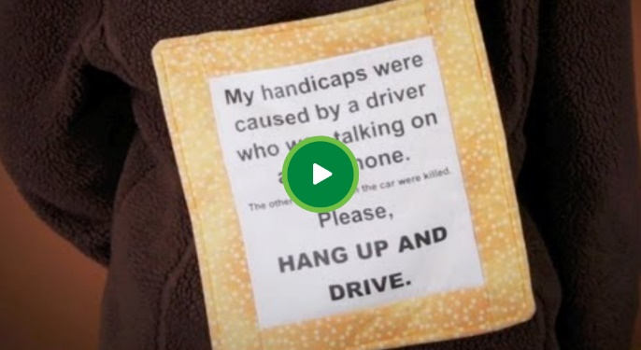
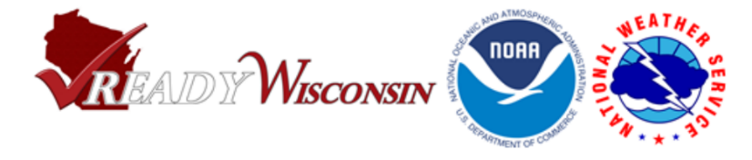
1,778

Claims
FY26 YTD

Lost Time
FY26 YTD

Free workplace health and safety assistance for public agencies:

Do you employ state or local public workers in Wisconsin? Would you like some expert advice with a workplace health or safety question? WisCon’s Public Sector Consultation Services offer free, non-punitive consultation services to help address your concerns. Virtual and on-site services available. Sign up now to ensure a spot, or email publicsectorconsulting@slh.wisc.edu for more information.

Lost Time
FY25 YTD

416

1,652

Claims
FY25 YTD YTD

Workers Comp

April is Distracted Driving Awareness Month
According to Injury Facts, on average nine people a day are killed in distracted driving crashes, but a few simple steps can reduce the risks for yourself and those around us. Each April, the National Safety Council (NSC), USDOT and others observe Distracted Driving Awareness Month to bring attention to the dangers of distracted driving and share simple steps drivers can take to avoid. Available all year round, the NSC offers a variety of free resources to help create safer roads for all.
- Driver Safety Toolkit (Member Exclusive – State Agency’s may reach out if assistance needed) that includes videos, tip sheets, 5-minute safety talks, posters, and more.
- Distracted Driving Playlist
- The Just Drive pledge to drive distraction-free

The NSC reports that Thousands Have Died in Crashes Involving Cell Phones. Many distractions exist while driving, but cell phones are a top distraction because so many drivers use them for long periods of time each day. Almost everyone has seen a driver distracted by a cell phone, but when you are the one distracted, you often don't realize that driver is you. Check out this new video featuring the stories of survivors and advocates to help people understand the impacts of distracted driving (Ctrl click image, then click on green play button shown on image below, from NSC web site):

This month, and any month, please join NSC to help protect workers on and off the job, reinforce our commitment to safety in the community, and help create safer roads for us all. To get started please visit distracted driving prevention resources such as National Safety Council or Network of Employers for Traffic Safety .

423

Tornado & Severe Weather Awareness Week
Our partners at Wisconsin Emergency Management would like to announce that Tornado and Severe Weather Awareness Week in Wisconsin will take place April 13-17 this year. This annual campaign encourages everyone in Wisconsin to prepare for the tornadoes and severe storms in the state that may develop during the spring and summer months. This is also a good opportunity for all to review their severe weather safety procedures by participating in statewide tornado drills at 1:45 p.m. and 6:45 p.m. on Thursday, April 16th. For more information regarding the 2026 Wisconsin statewide tornado drill, click on the link below!
Click on the link for more information on the 2026 Wisconsin statewide tornado drill! https://readywisconsin.wi.gov/be-informed/tornadoes/
Tornado and Severe Weather Safety: How can you be prepared?

Wisconsin averages 23 tornadoes a year (2025 was the sixth highest documented number of tornadoes in Wisconsin history with 39). Peak tornado season in Wisconsin is April through August, but it is important to understand that a tornado can occur at any time of the year. Tornadoes can lead to fatalities and devastate communities in a matter of seconds. This violent force of nature can occur at any time of day or night and may not always be visible.

By preparing, planning, and practicing how and where you will take shelter could save your life!

Important Terms Used During a Tornado: Tornado Watch vs. Warning

- Tornado Watch: Be Prepared! An alert issued when weather conditions in the area favor the formation of tornadoes-often during thunderstorms. Be ready to act quickly if a warning is issued or you suspect a tornado is approaching.
- Tornado Warning: Take Action! A tornado has been sighted or indicated by weather radar. This is imminent danger to life and property. Move to an interior room on the lowest floor of a sturdy building. AVOID WINDOWS.

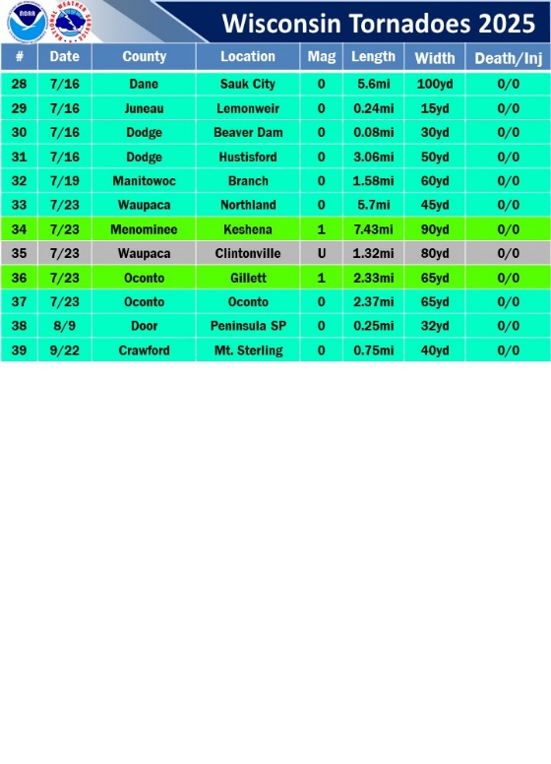
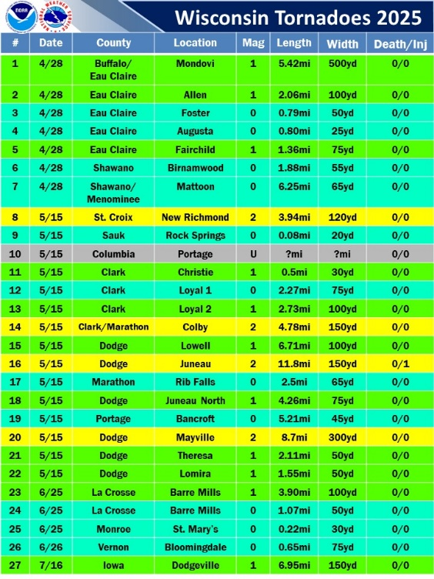
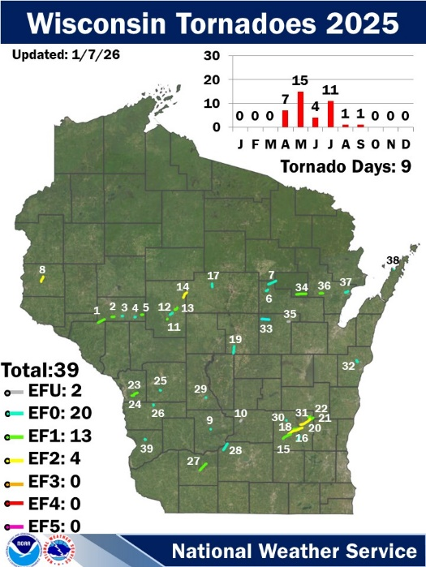

IMPORTANT NOTICE - The information presented in this newsletter is intended for internal State of Wisconsin agency consideration in loss prevention efforts. Due to space limitations, may not always be all-inclusive in identifying all material associated with topics discussed. It is encouraged to adjust the contents to fit the specific audience of your operation.

Severe Weather Safety Tips: Thunderstorms and Tornadoes
- Listen to the radio, television, or weather alert radios for updates.
- When a thunderstorm threatens, go inside a home or large building.
- During a thunderstorm, avoid using telephones, except for emergencies.
- During a tornado warning, TAKE ACTION IMMEDIATELY. Stay away from windows, doors, and outside walls.
- Seek shelter in the basement or an interior part on the lowest level.

Consumer Safety
United States Consumer Product Safety Commission

Contact Us
https://doa.wi.gov

E-Mail
Jake.Lowell@Wisconsin.gov

