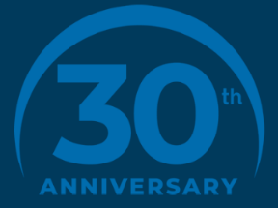
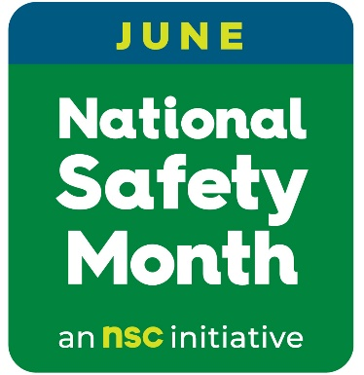

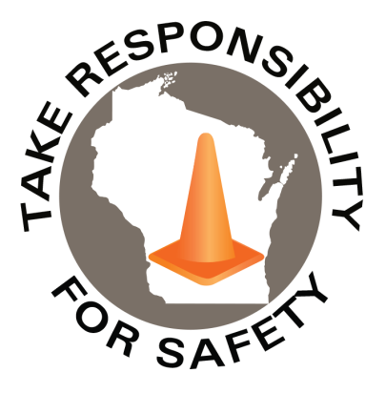
June 2026
Volume 13, Number 6
In This Issue:
National Safety Month
“When thunder roars, get indoors!”

Safety Net(work)
Produced by Department of Administration Bureau of State Risk Management

Produced by Department of Administration Bureau of State Risk Management

Safety Spotlight:

National CPR & AED Awareness Week
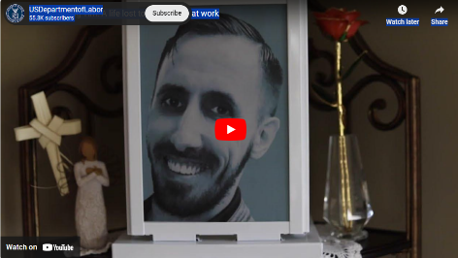
A Heartfelt Video Message to All:

2,162
Claims
FY26 YTD

Heat Illness Prevention Campaign
Workers Comp

Five Minutes for Safety:

525

502

Claims
FY25 YTD YTD

Since 1996, June is National Safety Month (NSM), and we are prioritizing safety by joining the National Safety Council to keep Wisconsin state employees safe.

All of us at the Bureau of State Risk Management in the of Department of Administration prioritize #WorkplaceSafety, and you can too!
This year, NSC is offering free weekly resources on these important topics: moving safety forward, staying safe on the roads, promoting holistic worker health, and preventing slips, trips and falls. Sign up now to claim your free materials: https://nsc.org/nsm

(don’t miss the anniversary 30 Daily Safety Tips!).

Each year, more than 2,000 too many State of Wisconsin employees are injured at work. A leading cause of injury for many state workers results from preventable slips, trips and falls. Opportunities to engage with safety are all around us:

- Department of Administration homegrown programs within Cornerstone include Winter Slip & Fall, Drive Safe, Office Ergonomics Self-Assessment and other risk prevention learning.

- National Safety Council materials include Prevent slips, trips and falls tip sheet, Distracted Walking digital quick tips, and more.

- Take the NSC SafeAtWork Pledge, and commit to:
  - Actively help my employer improve our safety programs.
  - Report hazards promptly and suggest solutions.
  - Be a good safety role model for my friends and family, even off the job.

Let’s work together to make people safer this June and all year long!

The Department of Administration – Bureau of State Risk Management secures annual statewide membership through the Wisconsin Safety Council. Membership includes exclusive National Safety Council (NSC) Safety Month materials such as: 5-minute safety talks, videos/virtual events, posters, checklists, and quizzes. Please contact Jake.Lowell@Wisconsin.gov from the Bureau of State Risk Management – Safety & Loss Control for assistance accessing exclusive materials.

Lost Time
FY26 YTD

Lost Time
FY25 YTD

2,049
National Safety Month Schedule/Highlights

Week 1 Public Materials: June 1-6
Moving Safety Forward

• 5-Minute Safety Talk: Identifying and addressing safety hazards (English and Español)
• Webinar June 2 - The Evolution of Safety Tech and the Safety Innovation Journey
Register Now

Week 2 Public Materials: June 7-13
Staying Safe on the Roads

• 5-Minute Safety Talk: Sharing the roads safely (English and Español)

Week 3 Public Materials: June 14-20
Promoting Holistic Worker Health

• 5-Minute Safety Talk: Causes of impairment (English and Español)
• Webinar June 16 – California Worksites and Naloxone: Awareness to Action
Register Now
• Webinar June 23 – Workplace Safety Summit: Five Years of Advancing Musculoskeletal Disorder Prevention Register Now

Week 4 Public Materials: June 21-30
Preventing Slips, Trips and Falls

• 5-Minute Safety Talk: Keep an eye out for slip, trip and fall hazards (English and Español)
• Webinar June 25 - Operationalizing Frontline Safety with Connected AI & Worker Insights Register Now

Consumer Safety
United States Consumer Product Safety Commission

Contact Us
https://doa.wi.gov

E-Mail
Jake.Lowell@Wisconsin.gov

“When thunder roars, get indoors!”

National Lightning Safety Awareness Week – June 21 - 27, 2026
International Lightning Safety Day – June 28, 2026
Recursos en Español

Established in 2001, National Lightning Safety Awareness Week (NLSAW) highlights how to stay safe during a thunderstorm. The National Lightning Safety Council (NLSC) provides information highlighting U.S. lightning fatalities during recent years.

Each day of NLSAW focuses on a specific area of lightning safety, beginning the first day with a general introduction to lightning safety. The consistent NLSAW message throughout the week is to monitor the weather in your area and get to safety before a storm starts. You should also wait at least 30 minutes after the last lightning or thunder before leaving your shelter.

Wherever you’re working or vacationing this year, follow the NLSC’s advice: “When thunder roars, get indoors!”

IMPORTANT NOTICE - The information presented in this newsletter is intended for internal State of Wisconsin agency consideration in loss prevention efforts. Due to space limitations, may not always be all-inclusive in identifying all material associated with topics discussed. It is encouraged to adjust the contents to fit the specific audience of your operation.

