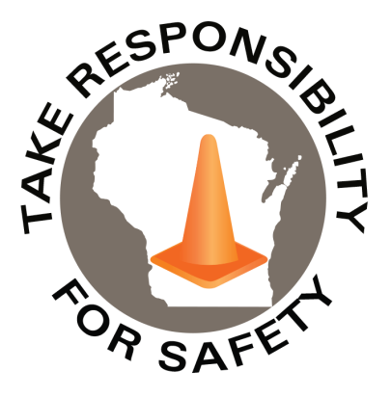


Safety Spotlight:

National School Bus Safety Week

Five Minutes for Safety:

Check out some Halloween Safety tips from the National Safety Council on costume safety and avoiding automobiles while outside.

Workers Comp

Claims Claims
FY26 YTD FY27 YTD
615 634

Lost Time Lost Time
FY26 YTD FY27 YTD
125 138

October 2026
Volume 13, Number 10
Safety Net(work)
Produced by Department of Administration Bureau of State Risk Management

Produced by Department of Administration Bureau of State Risk Management

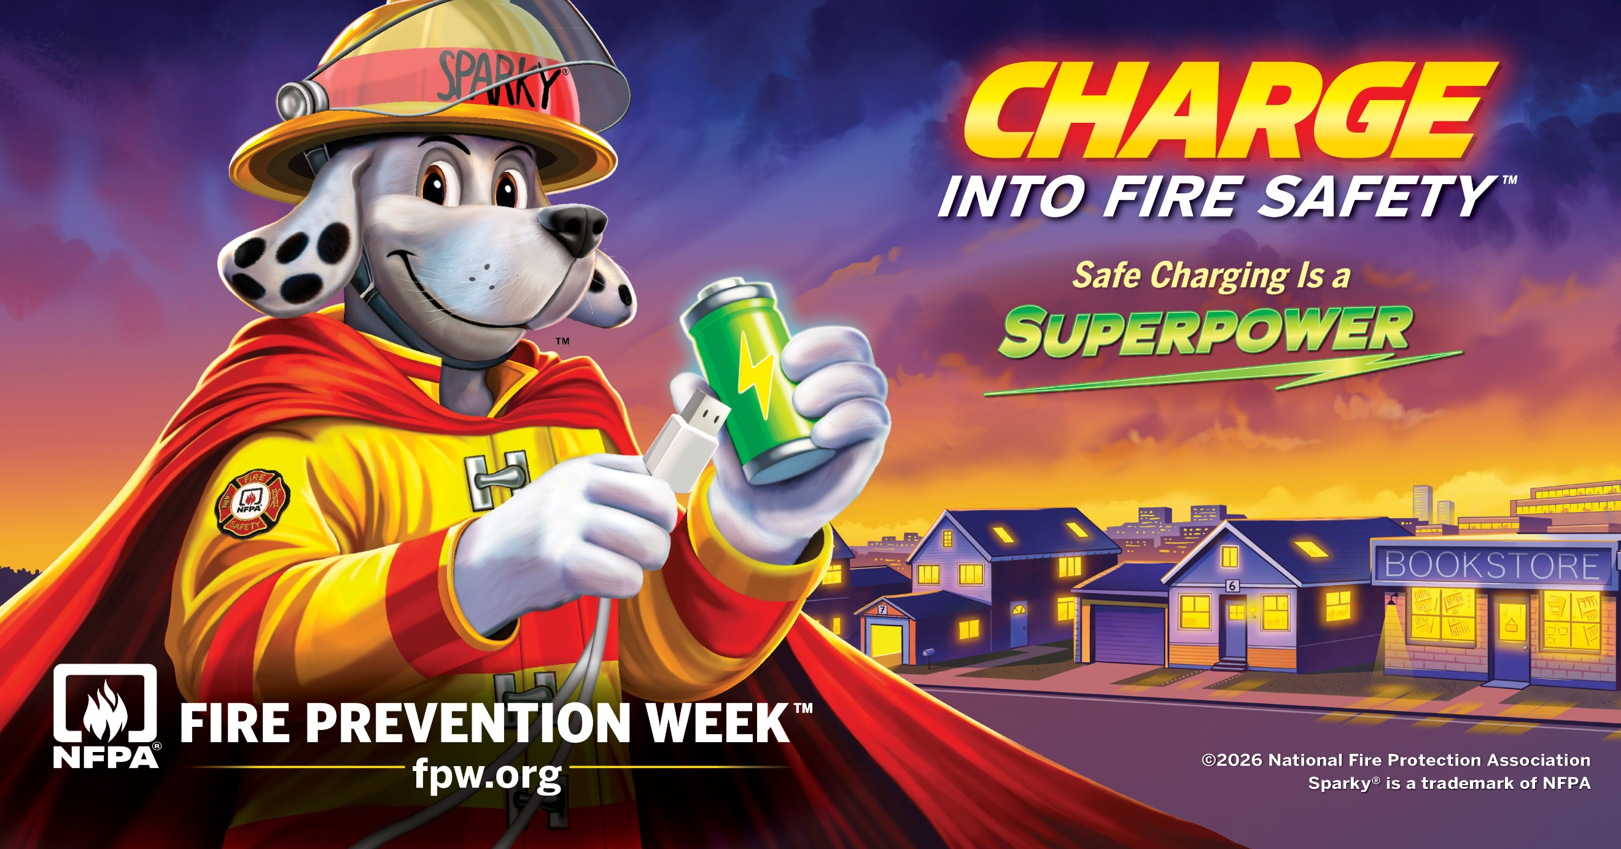
In This Issue:
Safe Charging Is a Superpower!

Everyone Is a Pedestrian

The theme for Fire Prevention Week™ (FPW™), October 4–10, 2026, is “Charge into Fire Safety™: Safe Charging Is a Superpower.” This year’s FPW theme focuses on the simple steps people can take to recharge safely. Safe charging means making smart choices every time you plug in. Many devices used in our daily lives such as - phones, tablets, laptops, tools, toys, e-bikes, and scooters—run on rechargeable lithium-ion batteries, which store a lot of energy in a small space. If they are damaged or charged the wrong way, they can overheat, start a fire, or even explode. The way lithium-ion battery devices are charged can make a difference in helping prevent home fires; it can come down to using simple habits each time plugging in. Here are some simple recommendations from the NFPA:

- Use the cord and charger that came with the device or one approved by the manufacturer. Using the wrong charger can damage the battery and increase the risk of fire.
- Charge devices on a table, desk, or other hard, flat surface. Do not charge them on beds, couches, or under pillows. Devices and chargers produce heat during normal charging. Soft surfaces can trap heat and block airflow, which can cause the battery to overheat.
- Stop using the device if it feels very hot, starts to swell, is smoking, or has a strange smell. These are warning signs that the battery may be damaged or failing.
- Unplug the device when it is fully charged. Do not leave it plugged in longer than needed. Leaving a device plugged in too long can increase heat and stress on the battery.
- Charge larger items like e-bikes, scooters, and power tools outside and away from exits. These batteries are larger and store more energy. If they fail, fires can grow quickly and spread.
- When on a plane, keep your device where you can see it while charging. Do not charge devices in overhead compartments. Do not charge e-cigarettes or vapes on a plane. If a battery overheats or fails, it is important for the flight crew to respond quickly.

To learn more about lithium-ion battery safety, visit Fire Prevention Week.

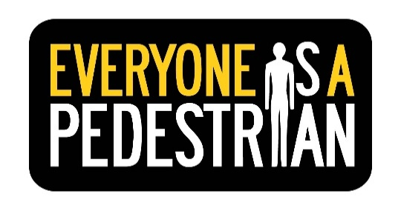
IMPORTANT NOTICE - The information presented in this newsletter is intended for internal State of Wisconsin agency consideration in loss prevention efforts. Due to space limitations, it may not always be all-inclusive in identifying all material associated with topics discussed. It is encouraged to adjust the contents to fit the specific audience of your operation.

Everyone Is a Pedestrian

October is designated as National Pedestrian Safety Month by the U.S. Department of Transportation and the National Highway Traffic Safety Administration (NHTSA) to lower traffic accidents and fatalities. NHTSA reports on average, in 2024, a pedestrian died every 74 minutes, and one was injured every seven minutes in traffic crashes. There were an estimated 71,635 pedestrians injured in 2024 and 7,080 pedestrians killed — a 4% decrease from 2023. Pedestrian fatalities remain high in the United States, accounting for 18% of all traffic fatalities in 2024. This highlights a critical safety issue that has an impact on everyone. When it comes to keeping pedestrians safe, everyone has a responsibility — pedestrians, drivers, and all those who utilize our roads. Drivers are urged to please take the time to look out for pedestrians, slow down, and incorporate pedestrian awareness into their driving routines. Everyone is also a pedestrian, whether walking to work, school, errands, or just for exercise, at some point in the day, and must additionally take personal responsibility for safety. NHTSA offers these tips to keep everyone safe:

For Pedestrians
- Follow the rules of the road and always obey signs and signals.
- Walk on sidewalks whenever they are available. If there is no sidewalk, walk facing traffic and as far from traffic as possible.
- Always cross at a crosswalk. If a crosswalk or intersection is not available, locate a well-lit area where you have the best view of traffic.
- Do not rely on others to keep you safe; make eye contact with drivers when possible and wait for a clear, complete stop before crossing.
- Children under 10 are not to cross the street alone. Encourage children to find a walking buddy and let children know who can help them cross the street safely — generally adults or siblings over the age of 12.
- Make a walkability checklist. Walk with family and friends in your community to determine safe and unsafe features on your walk. More information about improving community walkways may be found at NHTSA.gov/WalkabilityChecklist.
For Drivers
- Drivers must slow down and always watch for pedestrians. When approaching a crosswalk, always yield (stop) to pedestrians and give plenty of room around crosswalks so that other vehicles may see them, too.
- Never pass vehicles stopped at a crosswalk. There may be people crossing where drivers can’t see.
- Exercise extra caution at nighttime or in bad weather, since pedestrians can be harder to see and may appear suddenly — 76% of pedestrian fatalities in 2024 occurred in the dark.
- Follow the speed limit, especially around people on the street, in school zones, and in neighborhoods where children are present.
- Be extra cautious when backing up and look for pedestrians everywhere minimizing blind spots.
- Drive sober — alcohol use (for the driver and/or pedestrian) was reported in 43% of all fatal pedestrian crashes in 2024.

For more information about pedestrian safety, please visit NHTSA.gov/Pedestrian.

Consumer Safety
United States Consumer Product Safety Commission

Contact Us
https://doa.wi.gov

E-Mail
Jake.Lowell@Wisconsin.gov

