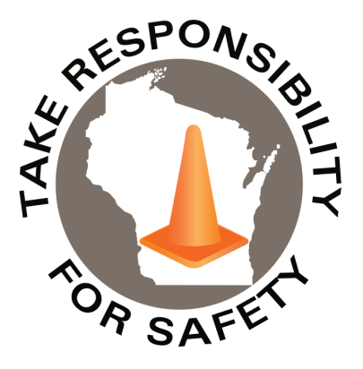

September 2025

Volume 12, Number 9

|  |
| --- |
| Safety Net(work)  Produced by Department of Administration Bureau of State Risk Management  Produced by Department of Administration Bureau of State Risk Management |

Safety Spotlight:

[National Preparedness Month](https://www.ready.gov/september#:~:text=National%20Preparedness%20Month%20is%20an%20observance%20each%20September,and%20emergencies%20that%20could%20happen%20at%20any%20time.)

Five Minutes for Safety:

[Watch out for deer!](https://www.ruralmutual.com/resource/personal/deer-safety-tips-for-avoiding-an-accident/" \l ":~:text=Follow%20these%204%20safety%20tips%20to%20reduce%20your,often%20holds%20true.%20...%204%20Buckle%20up.%20)

Workers Comp

Claims Claims

FY25 YTD FY26 YTD

405 337

Lost Time Lost Time

FY25 YTD FY26 YTD

92 57

In This Issue:

**New Hire Safety**

**Prevent Lithium-Ion Battery Fires**

New Hire Safety

According to Injury Facts, an online source of preventable death and injury statistics compiled by the National Safety Council, nearly 278,000 employees experienced an incident that resulted in days away from work – in their first 90 days on the job in 2021 and 2022. Additionally, Travelers Insurance Company showed from data of more than 1.2 million workers’ compensation claims submitted between 2017 and 2021, that employees in their first year on the job accounted for 35% of the claims.

[Safety+Health magazine](https://www.safetyandhealthmagazine.com/articles/26567-safety-at-work-the-first-90-days) provides a free tip sheet on [7 ways to keep workers safe in their first 90 days](https://www.safetyandhealthmagazine.com/ext/resources/images/2025/04-apr/first90Days_tipSheet.pdf):

1. Start before they start. Present a realistic view of job duties and risks in job postings and descriptions. Some employers also use YouTube videos to explain safety-related job duties *(check a video example out* [*linked*](https://www.youtube.com/watch?v=w2nTtuMvcww) *in the headlined UW image)*.
2. Talk safety early and often. Ask safety-related questions during job interviews. Once someone’s been hired, use the onboarding process to share regular communications about safety.
3. Build a strong safety plan. Have a well-documented, well-communicated and well-understood plan that includes safety training.
4. Encourage new hires to ask questions. The more workers ask, the more they’ll understand the hazards and risks of the job.
5. Identify new workers. Give them a different colored hard hat, vest or shirt to let their co-workers know they’re new and may need a helping hand.
6. Find a buddy/mentor. Have a seasoned employee serve as a mentor for a new employee and allow them to shadow their mentor.
7. Certify for competency. As part of training, new workers can benefit from getting certified on the competent use of equipment. These competencies can be established by a safety professional.

[](https://www.travelwisconsin.com/fall-color-report)

*IMPORTANT NOTICE - The information presented in this newsletter is intended for internal State of Wisconsin agency consideration in loss prevention efforts. Due to space limitations, may not always be all-inclusive in identifying all material associated with topics discussed. It is encouraged to adjust the contents to fit the specific audience of your operation.*

|  |
| --- |
|  |

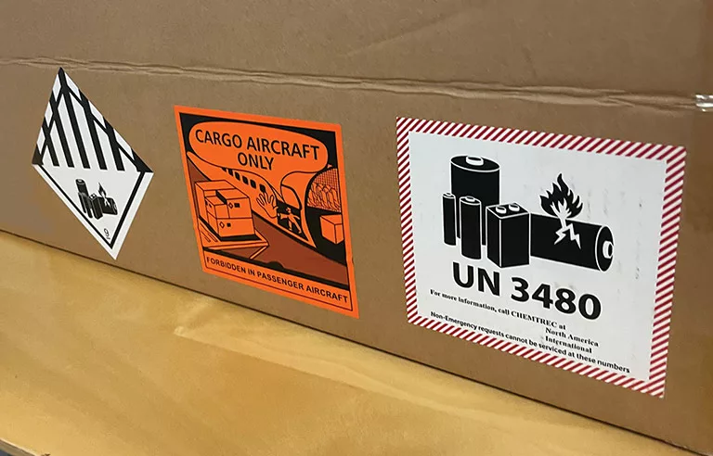

Prevent Lithium-Ion Battery Fires

In 2018, the U.S. [**Consumer Product Safety Commission**](https://www.cpsc.gov/s3fs-public/High_Energy_Density_Batteries_Status_Report_2_12_18.pdf?UksG80UJqGY0q4pfVBkbCuUQ5sNHqtwO) reported over 25,000 reports of overheating or fire incidents that occurred over five years in more than 400 varying consumer products powered by lithium batteries. These batteries store a large amount of energy in a small space and are commonly found in the home and workplace with items such as laptops, cellphones, vape devices, e-cigs, electric vehicles, e-scooters, e-bikes, rechargeable power tools, wearable devices and many other items. They can also serve as the main component for energy storage and battery backup systems.

OSHA and other safety experts say the batteries are generally safe to use under normal conditions. However, fires caused by lithium-ion batteries have some challenging properties that make it critical to ensure the home and workplace are prepared:

* They can emit toxic gases.
* They may spread out across an area because of combustion, resulting in a multipoint fire.
* They can burn so long that the facility’s sprinkler system may not provide enough water to extinguish them.
* They may reignite after the initial burn is over.

[Safety+Health magazine](https://www.safetyandhealthmagazine.com/articles/26703-help-prevent-lithium-ion-battery-fires) suggests some tips to help prevent lithium-ion battery fires:

1. Use lab-certified products – To help ensure the product isn’t defective, check to see if it’s certified by a Nationally Recognized Testing Laboratory (NRTL). Typical markings or symbols to look for on lithium-ion batteries: CSA (CSA Group), ETL (Interlek) or UL Solutions. A CE marking is for products sold in Europe. Those products aren’t certified by an NRTL.
2. Watch for warning signs – Changes can include heat, color, smell, noises, bulging, leaking or smoking. If safe to do so, move suspected damaged or defective batteries or devices to an area away from the structure or into fireproof containers and notify 911. Keep lithium-ion batteries and their powered devices away from flammables.
3. Charge devices the right way – Charge batteries to their full capacity and then remove them from the charger. Only use charging equipment that’s specifically designed for the battery or device and avoid using “aftermarket” chargers.
4. Store and use batteries safely – Keep as close to room temperature. Don’t store in sunlight. Only use batteries designed for the product.
5. Plan and train – Ensure workers understand the potential hazards, as well as the signs of a failing or problematic battery. Fire protection experts should be consulted in sprinkler design and storage practices.

Enjoy the Scenery!

Mental health breaks may be beneficial to reduce workplace stress. Relax and enjoy Wisconsin’s scenic views! See the fall color report for [peak](https://www.travelwisconsin.com/fall-color-report) leaf viewing times.

Consumer Safety

[United States Consumer Product Safety Commission](http://www.cpsc.gov/)

Contact Us

<https://doa.wi.gov>

E-Mail

[Jake.Lowell@Wisconsin.gov](mailto:jake.lowell@wisconsin.gov)