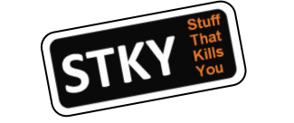
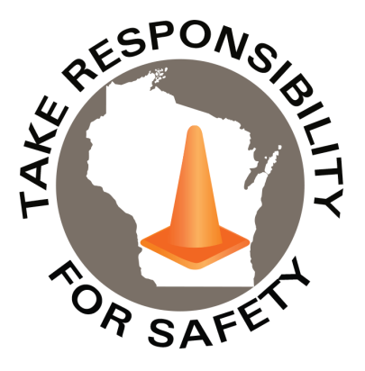

Volume 12, Number 12
December 2025
In This Issue:
Serious Injury & Fatality Prevention
Stop, Think, Act in Practice

Safety Net(work)
Produced by Department of Administration Bureau of State Risk Management

Produced by Department of Administration Bureau of State Risk Management

Safety Spotlight:

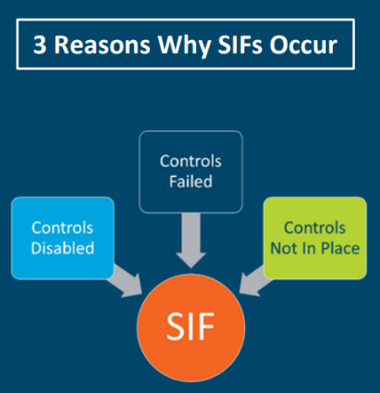
Make it a Home Safe Home for the Holidays

National Handwashing Awareness Week

Five Minutes for Safety:

Serious Injury & Fatality Prevention

A life altering event is an experience with a strong effect that changes a person’s circumstances and can be permanent. Sometimes we do not take enough time in advance to step back and reflect on the serious consequences of what could happen from human error. “It is not a matter of if, but when an accident occurs, we want to ensure all life-threatening, high-energy hazards have adequate controls in place that will provide coworkers the capacity to recover safely. Prevention will always be important, but no one is perfect. No matter how much we try to prevent failure, failure is going to happen. Building capacity with the presence of our essential controls is how we can ensure that when an accident occurs, everyone and everything is Safe.” This imperative statement is excerpted from the PG&E Serious Injury & Fatality (SIF) prevention guide. The purpose of the SIF prevention guide is to help workers who perform and touch the work identify the Stuff That Can Kill You (STKY) and essential controls to put in place to meet the demands of the job to build enough capacity to safely recover when an incident occurs.

The identified “Keys to Life,” at PG&E, that must be followed to help prevent serious injury or loss of life are:

1. Conduct pre-job safety briefings prior to performing work activities.
2. Follow safe driving principles and equipment operating procedures.
3. Use personal protective equipment for the task being performed.
4. Follow electrical safety testing and grounding rules.
5. Follow clearance and energy lockout/tagout rules.
6. Follow confined space rules.
7. Follow suspended load rules.
8. Follow safety at heights rules.
9. Follow excavation procedures.
10. Follow hazardous environment procedures.

What STKY tasks do you perform each day that could become life altering? You don’t have to be in the skilled trades either to be exposed to STKY tasks, as applications can be made to exposures around vehicles, powered equipment, patient care, or even severe weather. Are there others not on this list above unique to what you do? Do you have essential controls in place to safely recover when a failure occurs? While driving, it could be as simple as wearing a seatbelt, avoiding distractions and being a guardian for the rules of the road to save lives.

“The increase in crashes when drivers interact with their screens is stark: The worst offenders are 240% more likely to crash than the safest drivers.”

979

Claims
FY26 YTD

Workers Comp

235

212

Claims
FY25 YTD YTD

Lost Time
FY26 YTD

Lost Time
FY25 YTD

946

Stop, Think, Act in Practice

Organizations can demonstrate safety excellence and a strong safety commitment by implementing practices in place that support their employee’s decision making. Please take a minute to review some of these examples:

Veolia’s Commitment to Safety Excellence
If anyone identifies an unsafe working condition, they are empowered to:
STOP: halt work immediately, stay calm, and secure the area
THINK: alert supervision and analyze the situation together
ACT: resolve the issue together and return to work safely
Safety Week MEA 2025: Stop, Think, Act

PG&E Human Performance Tools
Questioning Attitude
A questioning attitude promotes a preference for facts over assumptions and opinions and encourages thought about safety before action is taken. It prompts gathering verifiable facts to ensure enough essential controls are in place to build capacity to safely recover when an accident occurs.
Tailboards and Pre-Job Brief
A tailboard or pre-job brief is a meeting of coworkers, crew leads, and possibly supervisors conducted before performing a job to discuss the tasks hazards and related safety precautions.
Situational Awareness
Situational Awareness is the accuracy of a person’s current knowledge and understanding of the task conditions and their hazards compared to actual task conditions and hazards at a given time. A person’s knowledge and understanding (of task conditions and hazards) inform their decisions and actions.
Self-Checking (STAR)
STAR (Stop, Think, Act, Review) is a self-checking tool that helps to focus attention on the appropriate component, think about the intended actions, understand the expected outcome before action, and verify the results after the action. This tool must be used by an individual with sound technical knowledge and task experience.
Two-Minute Rule
When the job scope has changed, take at least two minutes to reassess the hazards. The key objective is to improve your Situational Awareness of any new STKY hazards that may be present and verify that the crew’s technical knowledge and task experience are still adequately matched to the task being performed.
Three-Way Communication
Three-Way Communication promotes a reliable transfer of information and understanding, ensuring that the intended action is taken. Three-Way Communication depends on repetition to ensure an accurate response.
Stop When Unsure
When confronted with uncertainty, stop and get help from someone who understands how to proceed with the work safely. This will help to reduce the chance of error and serious injury.
Procedure Use and Adherence
Understanding the overall purpose and strategy of approved procedures promotes a safe, reliable outcome. Adhering to approved procedures clarifies questions in the execution of various tasks and duties. Following the procedure without question does not guarantee safety because procedures sometimes contain hidden flaws. With this in mind, follow procedures while being mindful of the impact actions could have before taking the actions.
Phonetic Alphabet
The use of the phonetic alphabet avoids the confusion of similar sounding words.
Placekeeping
Placekeeping involves physically marking steps in a procedure or other guiding document that have been completed. Managing a procedure, especially a detailed technical procedure with frequent branching or multiple decision points, can place the facility, equipment, or process in jeopardy if the user inadvertently omits a step or performs a series of steps in an incorrect sequence. When a user is interrupted or delayed, an effective method will help the user return to the last step performed.

Consumer Safety
United States Consumer Product Safety Commission

Contact Us
https://doa.wi.gov

E-Mail
Jake.Lowell@Wisconsin.gov

IMPORTANT NOTICE - The information presented in this newsletter is intended for internal State of Wisconsin agency consideration in loss prevention efforts. Due to space limitations, may not always be all-inclusive in identifying all material associated with topics discussed. It is encouraged to adjust the contents to fit the specific audience of your operation.

