
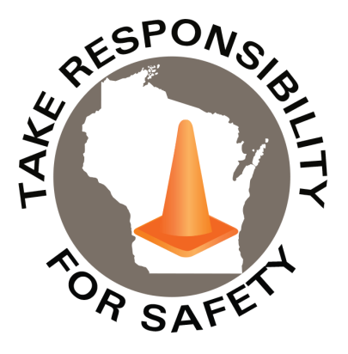

November 2025
Volume 12, Number 11
In This Issue:
Walk Like a Penguin
WARNING SERIOUS INJURIES:
Winter Slip & Fall Prevention Module
Would You Risk Your Life to Save Your Cellphone?

Safety Net(work)
Produced by Department of Administration Bureau of State Risk Management

Produced by Department of Administration Bureau of State Risk Management

Safety Spotlight:

Mothers Against Drunk Driving

Wisconsin: Help Stop Drunk Driving
Drunk driving remains a major problem in Wisconsin. According to NHTSA in 2023, there were 182 OWI deaths.

Five Minutes for Safety:

Get Smart About Antibiotics Week

Slips, trips and falls are one of the leading causes of injury each year for State of Wisconsin workers. Historically, the highest months of injury frequency tends to be during the winter season – December through March. Figure 1 shown below depicts the total number of slip, trip and fall workers compensation claims, by month, over the past five fiscal years. Figure 2 shown below illustrates the total number of slippery surface related workers compensation claims, which may include descriptions such as ice, water, or grease, by month, over the past five fiscal years.

Figure 1

Figure 2

786

Claims
FY26 YTD

Workers Comp

192

162

Claims
FY25 YTD YTD

Lost Time
FY26 YTD

Lost Time
FY25 YTD

787

WARNING SERIOUS INJURIES HAVE PREVIOUSLY OCCURRED

The Department of Administration Bureau of State Risk Management in collaboration with the Bureau of Training and Development released, in Fall 2023, a home grown 30 minute winter slip and fall prevention module available in both Cornerstone (agencies) and Canvas (universities) for all state employees. Please be sure to take advantage of this educational opportunity in the coming days to help protect yourself and the team from one of the state’s leading causes of injury. This course will help you recognize potential winter slip and fall hazards and identify important safety practices that can lower your risk of injury due to slips, trips, and falls.
Keyword search “Winter” in Leader (Cornerstone)

WOULD YOU RISK YOUR LIFE TO SAVE YOUR CELLPHONE?

Safety and Health Magazine reports for many people the answer unfortunately is yes according to Impact protection manufacturer D30 that recently commissioned a survey of consumers from the United States and the United Kingdom to understand how connected they are to their cellphones with what lengths they’d go to retrieve or save the device.

Findings show that 20% of the respondents would climb onto subway tracks to retrieve their phone, while 54% would retrieve it from a portable toilet at a festival. Additionally:

- 59% would jump into a pool fully clothed at a wedding.
- 56% would climb into a dumpster.
- 51% would miss an international flight rather than leave a lost phone behind.

The phone isn’t just technology, it’s a connection to friends, family, work, entertainment, and important memories, which explains why people would go to great lengths for their phones. Does the risk outweigh the reward? Julia Kite Laidlaw, senior program manager of the Road to Zero initiative at the National Safety Council said, “You can always replace a phone. You can never replace your life. It’s worth it to spend a little bit of money on phone insurance or a data storage plan to have peace of mind. With the ability to upload your data and photos into the cloud, even if your physical phone disappears, you will still have your digital life. Have a backup plan that doesn’t involve risking your personal safety.”

Consumer Safety
United States Consumer Product Safety Commission

Contact Us
https://doa.wi.gov

E-Mail
Jake.Lowell@Wisconsin.gov

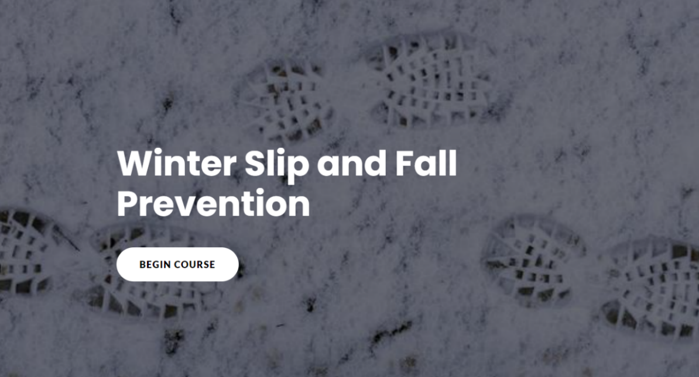



IMPORTANT NOTICE - The information presented in this newsletter is intended for internal State of Wisconsin agency consideration in loss prevention efforts. Due to space limitations, may not always be all-inclusive in identifying all material associated with topics discussed. It is encouraged to adjust the contents to fit the specific audience of your operation.

