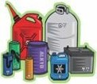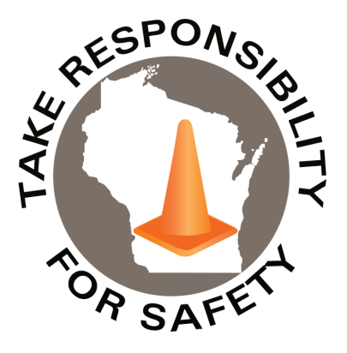

In This Issue:

**Hazardous Waste Training Requirements**

**Lawn Mower Safety Reminders**

**The National Safety Stand-Down**

Volume 12, Number 5

May 2025

|  |
| --- |
| Safety Net(work)  Produced by Department of Administration Bureau of State Risk Management  Produced by Department of Administration Bureau of State Risk Management |

Safety Spotlight:

[National Electrical Safety Month](https://www.esfi.org/program/national-electrical-safety-month/)

**Fatalities caused by falls from elevation continue to be a leading cause of death for construction employees, accounting for 421 of the 1,075 construction fatalities recorded in 2023 (BLS).**

[Electrical Safety While Working from Home](https://www.esfi.org/electrical-safety-while-working-from-home/)

|  |  |
| --- | --- |
| |  | | --- | | **WDNR Guidance on Hazardous Waste Training Requirements**  The WDNR has created [guidance documents](https://dnr.wisconsin.gov/topic/Waste/HWResources.html) to help people and facilities comply with hazardous waste requirements. One popular inquiry to highlight is, “[Training Requirements and Records: Hazardous Waste Generators, Collection Sites and TSD Facilities (WA-099)](https://apps.dnr.wi.gov/doclink/waext/wa099.pdf).” The WA-99 guidance document discusses the different training requirements for managing hazardous waste depending on the facility type.  Annually, the Bureau of State Risk Management sponsors hazardous materials awareness and waste disposal training through the [State of Wisconsin mandatory contract](https://vendornet.wi.gov/Contract.aspx?Id=25b864dc-3095-ef11-905a-00505684483d). The 2025 learning opportunities were completed both in-person and virtually between February and April. In case any employees working at state-owned or operated facilities or employees of municipalities, tribal governments, public K-12 schools, technical colleges, and universities missed and would still like to attend, the virtual sessions are recorded and available online until May 10th at the following links (ensure signed into Microsoft Office online account to view):  [Physical Properties of Chemicals, Chemical Hazards, Compatibility](https://events.gcc.teams.microsoft.com/event/5b5636fc-c5c4-4a75-b9eb-e4c6095ecff5@f4e2d11c-fae4-453b-b6c0-2964663779aa)  [Hazardous Waste & Spill Awareness](https://events.gcc.teams.microsoft.com/event/d0c2f673-f201-4ae1-b20a-6da8ca98c559@f4e2d11c-fae4-453b-b6c0-2964663779aa)  [Solid & Universal Waste](https://events.gcc.teams.microsoft.com/event/17ddbf7c-9f1a-4043-aae9-07eea04d8282@f4e2d11c-fae4-453b-b6c0-2964663779aa)  [WDNR Regulatory & Universal Waste Updates, Top Violations](https://events.gcc.teams.microsoft.com/event/3e03fe6a-0abd-4868-9644-f5f2f2bb50c4@f4e2d11c-fae4-453b-b6c0-2964663779aa)  [2025 Hazardous Materials Awareness and Waste Disposal Training Survey](https://forms.office.com/Pages/ResponsePage.aspx?id=HNHi9OT6O0W2wClkZjd5qlFYcOHwsslIkMmhKVexjcpURFNXUVdTNDBYN0lTUTJZRjlKWVJLNjREMy4u) (Complete by May 10th to Receive a Certificate of Completion)  Please keep in mind that this training is to be considered a starting point and is not all inclusive of the WA-099 publication guidance. As it is challenging with time constraints to be comprehensive enough for our large audience and meet the requirements of site specific information. | |

437

1,813

Claims

FY25 YTD

Workers Comp

Alarming Statistics:

Five Minutes for Safety:

439

Claims

FY24 YTD YTD

Lost Time

FY25 YTD

Lost Time

FY24 YTD

1,717

**Lawn Mower Safety Reminders**

According to the US Consumer Product Safety Commission, 60,000+ people are treated by hospital emergency rooms each year because of unsafe operation of power lawn mowers. Briggs and Stratton shares some [safety guidelines](https://www.briggsandstratton.com/na/en_us/buying-guides/lawn-mowers/safety.html) to keep yourself safe while using a lawn mower:

* Always wear sturdy closed toe shoes, protective eyewear, and hearing protection.
* Mow only in daylight and when the grass is dry.
* Check your yard for any debris or objects, such as toys that could pose a hazard if you mowed over them.
* Keep pedestrians and pets away from the mowing area.
* Never let the starter rope snap back when starting a mower.
* Look 3-4 feet directly ahead of you while mowing.
* Drive the mower slowly, and avoid sudden starts, stops, and turns.
* Never tilt a mower – always keep all four wheels on the ground.
* Take special care when mowing areas with drop-offs, bodies of water, hills, and inclines.
* With your push mower, always mow across an incline or hill.
* Always turn off mower when crossing a sidewalk or driveway.
* Don’t run the mower over gravel or rocks.
* Never adjust mower height, clean grass chute, remove grass catcher or repair the mower while the engine is running.
* Never deactivate safety devices.
* Never pull mower towards you.
* Always stay clear of a hot engine as mufflers can reach up to 1,200˚ F.
* Don’t fill a gasoline-powered mower indoors, and don’t add gasoline while the engine is hot or running.
* Always read your [Operator’s Manual](https://www.briggsandstratton.com/na/en_us/support/manuals.html) thoroughly before operating the mower.
* Inspect the mower before each use to ensure all protective devices are in place and all parts are in good condition.
* Children under 12 should not operate a push mower.
* Do use rollover protective structures (ROPS) and seat belts if your mower is equipped with them.
* Don’t allow any passengers to ride with you on the mower.
* Don’t leave a mower unattended while it’s running, turn it off, and take the key with you.

*IMPORTANT NOTICE - The information presented in this newsletter is intended for internal State of Wisconsin agency consideration in loss prevention efforts. Due to space limitations, may not always be all-inclusive in identifying all material associated with topics discussed. It is encouraged to adjust the contents to fit the specific audience of your operation.*

](https://www.cpsc.gov/safety-education/safety-guides/home/avoid-mower-mishaps)

[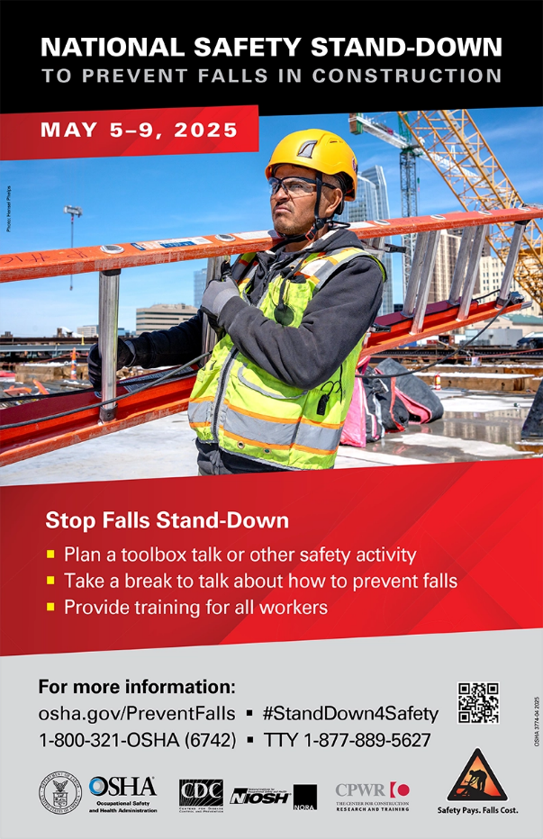](https://www.osha.gov/stop-falls-stand-down)

**Safety Stand-Down**

**2025 Virtual Sessions**

**May 5-9, 2025**

[**Register for FREE webinars with MSA trainers and safety experts.**](https://us.msasafety.com/safetyweek?utm_source=mkto&utm_medium=email&utm_campaign=safety-week-2024&utm_content=10300&mkt_tok=MzI4LVNSVi05NzEAAAGSkLZXBmt3kNxdYgbvOvvJ5rZG9juxnuD13Yrja_WkS5RidZoo3E8xSX6z0wRpoHNxGuGlheaIrjat1WdLJtyDF0VP4as-jfaJOvBJuRwZlkm1XLw)

Fall Protection FAQs: Panel Discussion

Type I and Type II Head Protection: OSHA Standards & Trends

ABCs of Fall Protection

Portable Gas Detection for Confined Space Entry

[**The National Safety Stand-Down To Prevent Falls in Construction**](https://www.osha.gov/stop-falls-stand-down)

Consumer Safety

[United States Consumer Product Safety Commission](http://www.cpsc.gov/)

Contact Us

<https://doa.wi.gov>

E-Mail

[Jake.Lowell@Wisconsin.gov](mailto:jake.lowell@wisconsin.gov)