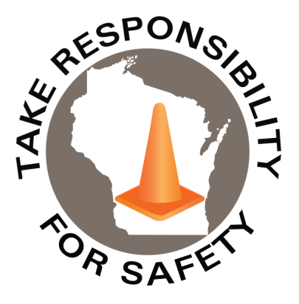

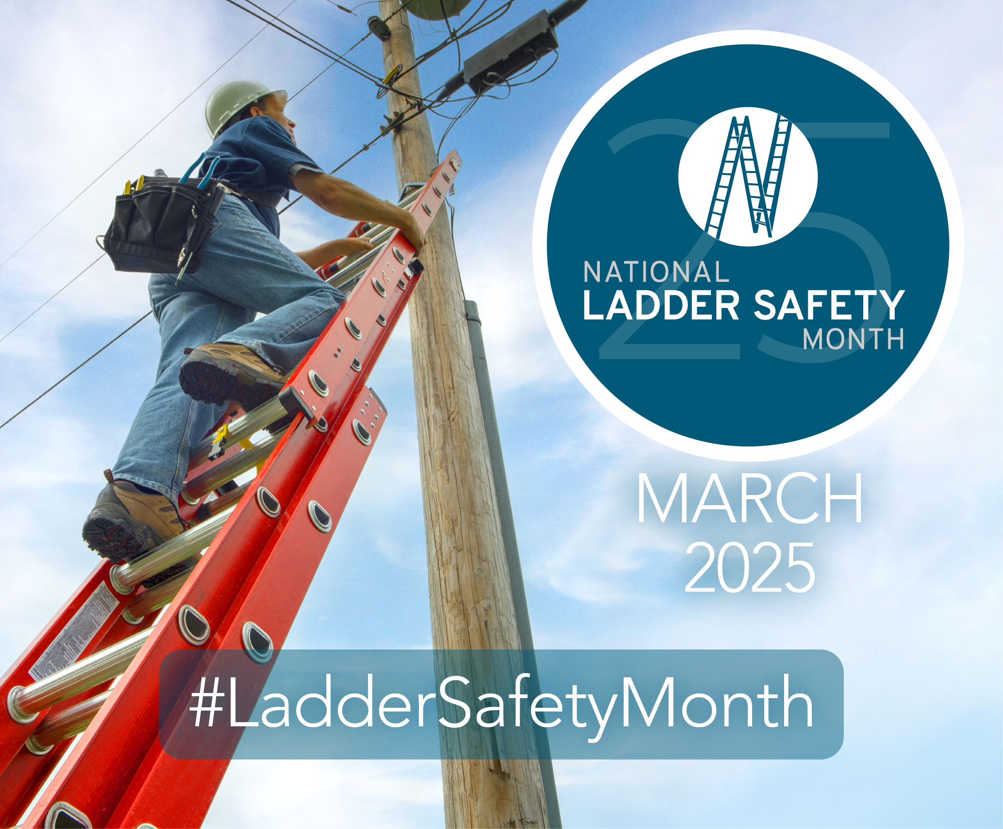

In This Issue:

**National Ladder Safety Month**

**Free Online Ladder Safety Learning**

Volume 12, Number 3

March 2025

|  |
| --- |
| Safety Net(work)  Produced by Department of Administration Bureau of State Risk Management  Produced by Department of Administration Bureau of State Risk Management |

Safety Spotlight:

[National Ladder Safety Month](https://www.laddersafetymonth.com/About/National-Ladder-Safety-Month)

[News Flash](https://abcnews.go.com/Health/Healthday/story?id=4507177&page=1#:~:text=The%20study%20also%20found%20that%2C%20among%20cases,study%20co%2Dauthor%20Lara%20Trifiletti%2C%20a%20principal%20investigator):

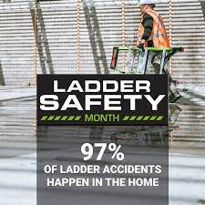

***Five Most Common Causes of Ladder Incidents***

According to the American Ladder Institute (ALI), missing the last step and overreaching were the two most cited causes of ladder incidents. Provided below are five most common causes of ladder incidents.

1. ***Missing the last step when climbing down the ladder.***
2. ***Overreaching while on the ladder.***
3. ***The ladder was not the right size for the job.***
4. ***The ladder was not on firm, level ground.***
5. ***Three points of contact were not used when climbing the ladder.***

[5 Most Common Causes of Ladder Incidents - ANSI Blog](https://blog.ansi.org/ali/common-causes-ladder-incidents/)

**National Ladder Safety Month | March 2025**

According to the most recent figures from the Bureau of Labor Statistics, there were 22,710 ladder-related injuries at work in 2020. That’s about 87 injuries every workday. The presenting sponsor for National Ladder Safety Month, American Ladder Institute (ALI) is the only approved developer of safety standards for the U.S. ladder industry. ALI believes ladder accidents are preventable with thorough safety planning, training, and continuous innovation in product design. The goals of National Ladder Safety Month are to raise awareness around ladder safety, to decrease the number of ladder-related injuries and fatalities caused by misuse, and to increase the number of people certified in Ladder Safety Training.

***2025 Focus of National Ladder Safety Month:***

* Training and Awareness.
* Inspection and Maintenance.
* Stabilization, Setup, and Accessories.
* Safe Climbing and Positioning.

***Click on the link below for more information on National Ladder Safety Month:*** [National Ladder Safety Month](https://www.laddersafetymonth.com/About/National-Ladder-Safety-Month)

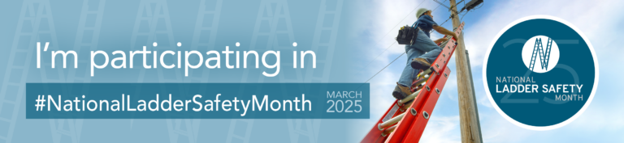

1,428

Claims

FY25 YTD

[Basic Ladder Safety](https://www.americanladderinstitute.org/page/BasicLadderSafety)

Workers Comp

Five Minutes for Safety:

328

343

Claims

FY24 YTD YTD

Lost Time

FY25 YTD

Lost Time

FY24 YTD

1,378

**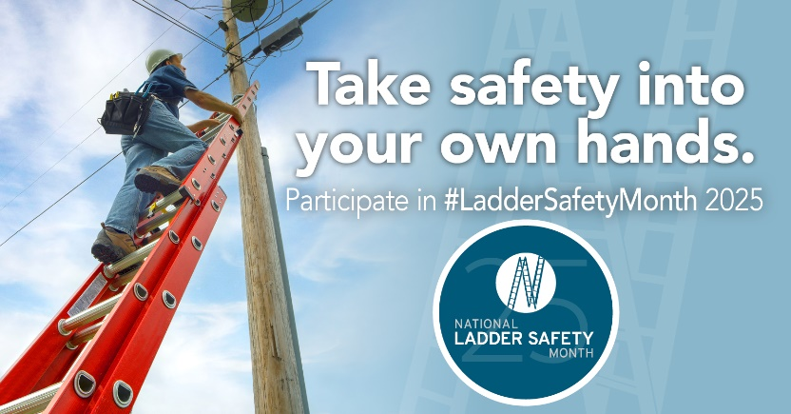

**Free Online Ladder Safety Training**

The non-for-profit American Ladder Institute (ALI) created a free Ladder Safety Training program and declared March as National Ladder Safety Month to inspire safer ladder use and reduce the rate of injuries. The [ALI online Ladder Safety Training certification program](https://www.laddersafetytraining.org/) is aimed at promoting safe ladder use, selection and care. The ALI Safety Training is a 100% free educational offering, so all employees can be required to complete the program without any training cost implications. The training is designed for both professionals and homeowners, and it teaches participants how to safely use and care for different types of ladders including:

* Stepladders
* Single and extension ladders
* Articulated ladders
* Mobile ladders

Participants that complete the Ladder Safety Training program will receive a certificate of completion, ensuring the most current and reputable ladder safety information is understood.

*\*For Trainers and Training Managers, The ALI has designed a Trainer’s Toolbox (simply check the “Trainer Toolbox” when signing up). Additional free tool available to register/assign to organization’s trainees.*

<https://www.laddersafetytraining.org/>

*IMPORTANT NOTICE - The information presented in this newsletter is intended for internal State of Wisconsin agency consideration in loss prevention efforts. Due to space limitations, may not always be all-inclusive in identifying all material associated with topics discussed. It is encouraged to adjust the contents to fit the specific audience of your operation.*

***2025 Ladder Safety Webinar Series***

[Little Giant](https://www.littlegiantladders.com/blogs/blog) and [Werner Co.](https://www.wernerco.com/us/safety/safety-videos) are sponsoring new ladder safety webinars each week during ladder safety month:

[**Common Ladder Accidents & How to Avoid Them**](https://register.gotowebinar.com/register/5296186327734904669)

**Monday, March 10, 2025**

**11:00 AM – 12:00 PM CST**

We will cover the six most common causes of ladder accident on the jobsite, discuss what the OSHA standard says and show practical solutions to the problems. We will also be discussing the basic principles of ladder safety; • Choosing the Right Ladder • Inspection • Set-up • Proper Climbing

[**Ladder Safety: Setup & Pro Tips**](https://register.gotowebinar.com/register/2728314304350686554)

**Monday, March 17, 2025**

**12:00 PM – 1:00 PM CST**

Join us to master essential ladder safety skills, including proper setup techniques to ensure stability and prevent accidents. Our expert will share pro tips on best practices, from thorough ladder inspections to maintaining the right posture while climbing. By the end of this session, you'll gain the confidence and knowledge to use ladders safely and efficiently in any situation. Secure your spot now and elevate your safety game!

[**DIY, Homeowner Ladder Safety**](https://register.gotowebinar.com/register/4793284002841385053)

**Monday, March 24, 2025**

**2:00 PM – 3:00 PM CST**

The majority of ladder accidents in the US happen at the home. We will discuss the most common causes of these accidents and show practical solutions to the problems. We will also be discussing the basic principles of ladder safety; • Choosing the Right Ladder • Inspection • Set-up • Proper Climbing

Consumer Safety

[United States Consumer Product Safety Commission](http://www.cpsc.gov/)

Contact Us

<https://doa.wi.gov>

E-Mail

[Jake.Lowell@Wisconsin.gov](mailto:jake.lowell@wisconsin.gov)