*[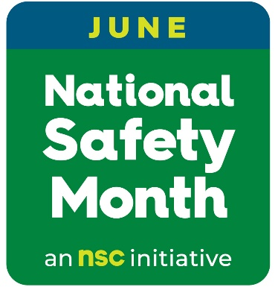](https://www.nsc.org/workplace/national-safety-month/nsm-public-materials)*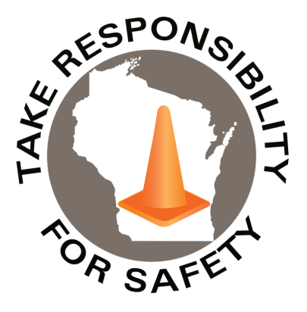

June 2025

Volume 12, Number 6

In This Issue:

**National Safety Month**

**National Forklift Safety Day**

|  |
| --- |
| Safety Net(work)  Produced by Department of Administration Bureau of State Risk Management  Produced by Department of Administration Bureau of State Risk Management |

Safety Spotlight:

[National CPR & AED Awareness Week](https://cpr.heart.org/en/training-programs/cpr-and-aed-awareness/cpr-and-aed-awareness-week)

[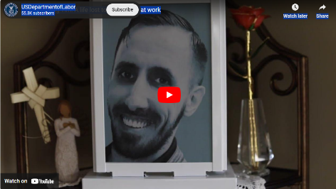](https://www.youtube.com/embed/o3ULhPd0KQg?feature=oembed)

A Heartfelt Video Message to All:

2,008

Claims

FY25 YTD

[Heat Illness Prevention Campaign](https://www.osha.gov/heat)

Workers Comp

Five Minutes for Safety:

479

496

Claims

FY24 YTD YTD

Since 1996, June is National Safety Month, and we are prioritizing safety by joining the National Safety Council to keep Wisconsin state employees safe.

All of us at the Bureau of State Risk Management in the of Department of Administration prioritize #WorkplaceSafety, and you can too!

This year, NSC is offering free weekly resources on these important topics: continuous improvement, employee engagement, roadway safety, and wellbeing. Sign up now to claim your free materials: [https://nsc.org/nsm](https://nsc.org/nsm" \t "_blank)

Each year, more than [2,000](https://doa.wi.gov/DEO/Benchmark%20FY%202023.pdf) too many State of Wisconsin employees are injured at work. The leading cause of injury for state workers results from preventable slips, trips, or falls. Opportunities to engage with safety are all around us:

* Department of Administration homegrown programs within [Cornerstone](https://ess.wi.gov/psp/ess/EXTERNAL/HRMS/?cmd=login&languageCd=ENG&) include Winter Slip & Fall, Drive Safe, Office Ergonomics Self-Assessment and other risk prevention learning.
* National Safety Council materials include [Prevent slips, trips and falls](https://www.nsc.org/getmedia/791a28f6-352e-4990-9559-6b19b46c935b/stf-tipsheet-combo.pdf.aspx) [tip sheet](https://www.nsc.org/getmedia/791a28f6-352e-4990-9559-6b19b46c935b/stf-tipsheet-combo.pdf.aspx), [Distracted Walking digital quick tips](https://www.youtube.com/watch?v=HbdXg_Bw2x4), and [more](https://www.nsc.org/nsm).
* Take the [NSC SafeAtWork Pledge](https://www.nsc.org/faforms/safeatworkpledge), and commit to:
  + Actively help my employer improve our safety programs.
  + Report hazards promptly and suggest solutions.
  + Be a good safety role model for my friends and family, even off the job.

Let’s work together to make people safer this June and all year long!

The Department of Administration – Bureau of State Risk Management secures annual statewide membership through the Wisconsin Safety Council. Membership includes exclusive National Safety Council (NSC) Safety Month materials such as: 5-minute safety talks, videos/virtual events, posters, checklists, and quizzes. Please contact [Jake.Lowell@Wisconsin.gov](mailto:Jake.Lowell@Wisconsin.gov) from the Bureau of State Risk Management – Safety & Loss Control for assistance accessing exclusive materials.

Lost Time

FY25 YTD

Lost Time

FY24 YTD

1,903

**National Safety Month Schedule/Highlights**

**Week 1 Materials: June 1-7**

[**Continuous Improvement**](https://www.nsc.org/workplace/national-safety-month/nsm-public-materials/week-1-public-materials)

**• 5-Minute Safety Talk:**[Talking points to introduce the JSA process to your workforce](https://www.nsc.org/getmedia/1fa5cba6-c82e-447d-8422-a5bfca219298/2025-nsm-jsa-process-combo.pdf) (English and Español)

**•Webinar June 3 -** [Scaling safety with software: Creating a culture of continuous improvement that grows with you](https://nsc-org.zoom.us/webinar/register/WN_dOYFFMlETrKzO-ApnIaDUA#/registration)

**Week 2 Materials: June 8-14**

[**Employee Engagement**](https://www.nsc.org/workplace/national-safety-month/nsm-public-materials/week-2-public-materials)

**• 5-Minute Safety Talk:**[The power of safety teams](https://www.nsc.org/getmedia/0cf6f75e-2dc0-4f72-818d-1e11b1eff655/2025-nsm-safety-teams.pdf)(English and Español)

**• Webinar June 11 -** [Retain Workers, Boost Safety: The Science and Strategy](https://nsc-org.zoom.us/webinar/register/WN_smYeZZE6SlewRudHQiwwaw#/registration)

**Week 3 Materials: June 15-21**

[**Roadway Safety**](https://www.nsc.org/workplace/national-safety-month/nsm-public-materials/week-3-public-materials)

**•** [Safety is Personal CEO Series: Anthony Nuckles, UPS](https://www.youtube.com/watch?v=V5q9GPvm_jY&t=9s)

**Week 4 Materials: June 22-30**

[**Wellbeing**](https://www.nsc.org/workplace/national-safety-month/nsm-public-materials/week-4-public-materials)

**• 5-Minute Safety Talk:**[Managing stress at work](https://www.nsc.org/getmedia/58d1a686-ed89-4010-8f24-7954a08da0c2/2025-nsm-managing-stress.pdf)(English and Español)

**• Webinar June 24 -** [Annual Workplace Safety Summit: Innovation to Application](https://nsc-org.zoom.us/webinar/register/WN_dL5KC-NsRsOR4pP9fCD9ZA#/registration) **• Webinar June 25 -** [Impact of Cannabis on Workplace](https://iecho.org/public/program/PRGM1744652048884GPUZXEKU5K)

Consumer Safety

[United States Consumer Product Safety Commission](http://www.cpsc.gov/)

Contact Us

<https://doa.wi.gov>

E-Mail

[Jake.Lowell@Wisconsin.gov](mailto:jake.lowell@wisconsin.gov)

[Safety and Health Magazine](https://www.safetyandhealthmagazine.com/articles/26843-get-ready-for-national-forklift-safety-day?utm_source=sfmc&utm_medium=email&utm_campaign=mbrnewsalertmay23&utm_content=) reminds impacted individuals that June 10, 2025, is National Forklift Safety Day. The importance of forklift safety, operator training, and daily equipment checks will be highlighted on June 10th, as part of the 12th annual [National Forklift Safety Day](https://www.indtrk.org/national-forklift-safety-day). The free event is organized by the Industrial Truck Association and includes invitation to those in the material handling industry or government (a portion is available [virtually](https://www.workcast.com/register?cpak=4108592623057124)).

Additional Powered Industrial Truck Resource Information:

* <https://www.osha.gov/powered-industrial-trucks>
* <https://www.osha.gov/etools/powered-industrial-trucks>

*IMPORTANT NOTICE - The information presented in this newsletter is intended for internal State of Wisconsin agency consideration in loss prevention efforts. Due to space limitations, may not always be all-inclusive in identifying all material associated with topics discussed. It is encouraged to adjust the contents to fit the specific audience of your operation.*

[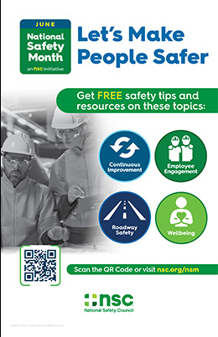](https://www.nsc.org/getmedia/23a07ede-66e7-4b93-b52b-55ff1d8cc1ba/nsm25-public-poster-combo.pdf)

