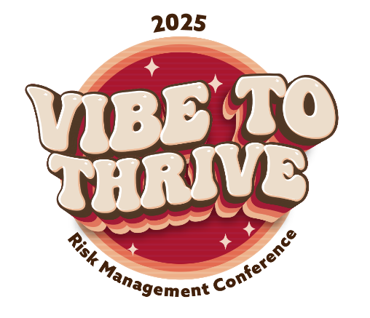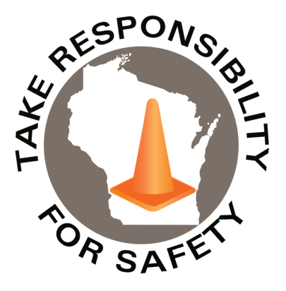

Safety Spotlight:

[Vehicle Theft Prevention Month -NTSA](https://www.nhtsa.gov/vehicle-safety/vehicle-theft-prevention)

Statistics of the Month

In Wisconsin [2022](https://www.dhs.wisconsin.gov/injury-prevention/fireworks-stats.htm#:~:text=In%202022%2C%20there%20were%20107,firework%2Drelated%20injuries%20in%202022.), there were 107 Emergency Department visits with a fireworks-related injury.

In 2022, according to the [National Fire Protection Association](https://www.nfpa.org/education-and-research/home-fire-safety/fireworks), 10,200 fireworks-related injuries were treated in U.S. hospital emergency rooms.

[CPSC](https://www.cpsc.gov/Newsroom/News-Releases/2025/CPSC-Urges-Fireworks-Safety-Ahead-of-July-4th-Holiday) Urges Fireworks Safety Ahead of July 4th Holiday

Lyme Disease Warning

In 2023, Wisconsin had 6,379 cases of Lyme disease, the highest on record. The average number of reported cases has now [tripled](https://www.dhs.wisconsin.gov/tick/lyme-data.htm#:~:text=In%202022%2C%20Wisconsin%20had%205%2C327,number%20of%20cases%20each%20year.) over the past 15 years.

Lime disease is preventable and treatable. Learn more about [Tick Bite Prevention](https://www.dhs.wisconsin.gov/tick/bite-prevention.htm).

In This Issue:

**2025 Risk Management Conference**

**Elevator Safety – Watch Your Step**

July 2025

Volume 12, Number 7

|  |
| --- |
| Safety Net(work)  Produced by Department of Administration Bureau of State Risk Management  Produced by Department of Administration Bureau of State Risk Management |

](https://www.youtube.com/watch?v=x4IXdOnl3IE)

2025 Risk Management Conference

Come find your beat at the 30th Bureau of State Risk Management Conference, held on October 22, 2025, at the Monona Terrace in Madison, Wisconsin. The full day agenda highlights great opportunities for State of Wisconsin Supervisors, Leadership, Risk Management Personnel, Worker’s Compensation, Property, Liability & Safety Contacts, Facilities, Buildings & Grounds Personnel, Human Resources Personnel, Health & Safety Teams, and Budget & Finance Staff Integrated in Risk Management.

Some highlights to look forward to:

* State of the State in Risk Management – Jason Gates
* Breakout Networking Roundtable Sessions
  + Meet other State of Wisconsin Risk Management professionals and share experiences together.
* Risk Management Awards
* Excess Property Insurance, WC Principles of Private Investigation or Managing Compliance with a One-Person Safety Team Breakout Sessions
* Keynote Speaker: [The Off Duty Chief – Tim Eggebraaten](https://www.offdutychief.com/) – “Find Your Beat”
  + Tim knows the importance of paying attention to the rhythm of life. Having worked in law enforcement for 25 years, he is an expert at Working the Beat; and has learned through experience, the value of discovering the harmony in it all.
  + We all face challenges which create our own beat in life when balancing family, careers, and struggling to find time for ourselves and our physical, mental and spiritual health. Prepare to be energized, inspired and entertained as “The Off Duty Chief” shares strategies and tactics for working YOUR BEAT!

[**Registration Information**](https://forms.office.com/Pages/ResponsePage.aspx?id=HNHi9OT6O0W2wClkZjd5qlFYcOHwsslIkMmhKVexjcpUQTlGWUY3SlRXQlNKSFlWNEU0QkxRS05DOS4u)

We look forward to seeing you this Fall!

Elevator Safety – Watch Your Step

According to data provided by the [U.S. Bureau of Labor Statistics and the Consumer Product Safety Commission](https://www.elcosh.org/document/1232/d000397/Deaths%2Band%2BInjuries%2BInvolving%2BElevators%2Band%2BEscalators%2B-%2BA%2BReport%2Bof%2Bthe%2BCenter%2BTo%2BProtect%2BWorkers%2527%2BRights.html), incidents involving elevators and escalators kill close to 30 and seriously injure 17,000 people each year in the United States. State of Wisconsin employees are also not immune to these unfortunate statistics, as multiple life changing events have occurred in the past decade. Some of these unlucky events had a common denominator, misstepping over the threshold while entering an elevator, tripping, and falling hard.

[The Pinnacle List](https://www.thepinnaclelist.com/articles/dos-and-donts-of-elevator-safety/) provides some do’s and don’ts of elevator safety, that includes an important reminder:

**Assess the Elevator’s Leveling**

* As the elevator arrives, watch to see that it stops level with the floor. There shouldn’t be a significant step up or down to enter the cabin.
  + Internet example of [classic elevator leveling](https://www.youtube.com/watch?v=Sq_CanaD3N8)
  + Internet example of [dangerous elevator leveling issue](https://www.youtube.com/watch?v=kQfCdU5bb4I)
* Proper leveling is crucial to prevent trips and falls, especially for those with mobility issues or when carrying items. An elevator that doesn’t level correctly can be a sign of mechanical issues and should be reported immediately.
* Take your time! Ensure the door has completely opened and safely step over the threshold, to ensure nothing gets caught causing a nasty trip and fall. To avoid a rushed behavior, waiting for the next elevator to arrive may also be a good decision.

[Mowrey Elevator](https://www.mowreyelevator.com/elevator-hazards-and-how-to-avoid-them%EF%BF%BC/) also provides some additional elevator hazards and how to avoid them:

**Top Elevator Risks**

* Falls: Falls down an elevator shaft are the most lethal risk, **but the most common fall injury is when people trip while exiting or entering due to the cab not being even with the floor**. Estimates show that 75 percent of elevator injuries result from trips and falls.
* Getting Caught: This is a big risk, especially for escalators: getting caught in or between unforgiving moving parts, whether between elevator doors or between the top or bottom of an escalator. Kids are at the highest risk for getting hands, shoes, and clothing caught, with many losing fingers and toes each year.
* Malfunctions: These can cause serious injury and even death, and can include sudden changes of speed, faulty brake systems or erratic braking.
* Germs: Elevators are extremely germy places. High-touch areas such as buttons and handrails have the most germs, which can cause colds and other illnesses.

**Elevator Safety Tips**

Check out these safety tips when riding an elevator:

* Watch your step, as floors are not always level.
* Stand away from the doors so as not to catch a finger, purse or clothing in them.
* Keep children and pets close.
* As the rider closest to the doors, step aside first when the car arrives.
* Push the DOOR OPEN button when someone is trying to catch a ride.
* Don’t step between a closing door, using your foot, arm or a cane.
* Pay attention to floor indicators.
* When the elevator has stopped and the doors have opened but it’s between two floors, don’t panic. Call for help. Stay inside and don’t try to climb out. The ventilation system is sufficient to give you air for a long time. Don’t attempt getting out by the elevator hatch – that’s only for approved personnel.
* Call for help on your phone or the elevator phone or press a help or alarm button inside the cab.
* Wait calmly for someone to get to you.
* Use the handrail when in the elevator.
* Exit when arriving at your floor. Don’t delay. Be alert and refrain from rummaging through bags, purses and briefcases.
* Exit immediately.
* Don’t push.

Consumer Safety

[United States Consumer Product Safety Commission](http://www.cpsc.gov/)

Contact Us

<https://doa.wi.gov>

E-Mail

[Jake.Lowell@Wisconsin.gov](mailto:jake.lowell@wisconsin.gov)

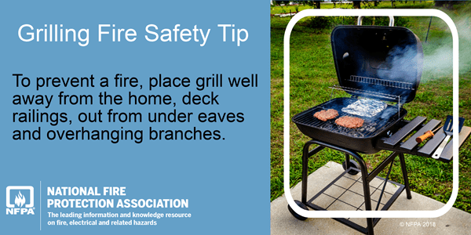

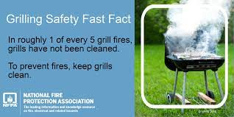

*IMPORTANT NOTICE - The information presented in this newsletter is intended for internal State of Wisconsin agency consideration in loss prevention efforts. Due to space limitations, may not always be all-inclusive in identifying all material associated with topics discussed. It is encouraged to adjust the contents to fit the specific audience of your operation.*