

Safety Spotlight:

[National Immunization Awareness Month](https://www.cdc.gov/vaccines/events/niam/)

Five Minutes for Safety:

[National Stop on Red Week](https://ncsrsafety.org/stop-on-red-week-2025/)

Workers Comp

Claims Claims

FY25 YTD FY26 YTD

191 171

Lost Time Lost Time

FY25 YTD FY26 YTD

51 21

August 2025

Volume 12, Number 8

|  |
| --- |
| Safety Net(work)  Produced by Department of Administration Bureau of State Risk Management  Produced by Department of Administration Bureau of State Risk Management |

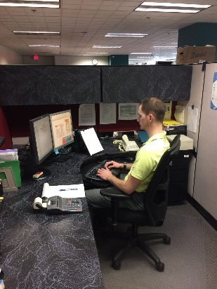

Preventing Office Ergonomics Injuries

Are you part of the 2021 [CDC reported](https://blogs.cdc.gov/niosh-science-blog/2022/10/31/ergonomics-month-2022/) $1.7 billion exposure for repetitive motions involving microtasks, small tasks, or jobs that are performed in a matter of seconds or a few minutes such as typing? The risk for musculoskeletal disorder exposures from these types of work tasks is related to the intensity, frequency, and duration. The first step in prevention is to assess risk factors associated with the task. Do you have 25 minutes to protect yourself from a potential cumulative trauma bodily injury down the road?

The Department of Administration Bureau of Training and Development in collaboration with the Bureau of State Risk Management released a home grown Office Ergonomics Self-Assessment Tool available in both [Cornerstone](https://ess.wi.gov/psp/ess/EXTERNAL/HRMS/?cmd=login&languageCd=ENG&) (agencies) and [Canvas](https://www.wisconsin.edu/ehs/training2/) (universities) for all state employees. **Please be sure to take advantage of this educational opportunity to help protect yourself from a future cumulative trauma exposure.** This course offers basic information about ergonomics that can help you adjust your work area to prevent fatigue and discomfort. Although the focus is on office ergonomics, you can easily apply the principles to many different settings.

Keyword search “Ergonomics” in Leader (Cornerstone)

In This Issue:

**Preventing Office Ergonomics Injuries**

**Avoid Prolonged Sitting or Standing**

](https://ergowellsolutions.com/video/)[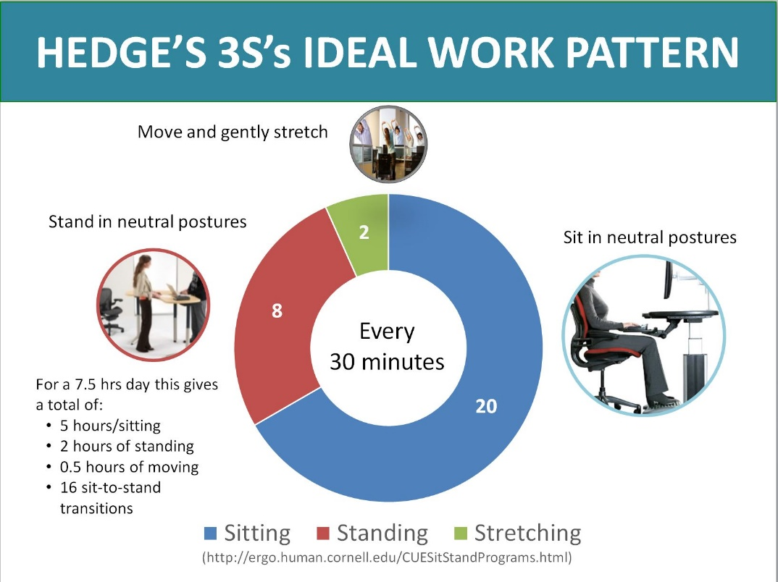](https://ergo.human.cornell.edu/hedges3Ss.JPG)

*ONLINE YOUTUBE STRETCHING VIDEO OPTION FROM:*

*IRIS SOKOL,*

*ERGOWELL SOLUTIONS*

[*https://ergowellsolutions.com/video/*](https://ergowellsolutions.com/video/)

[*https://www.youtube.com/watch?v=5NmgEhTEJug&t=3s*](https://www.youtube.com/watch?v=5NmgEhTEJug&t=3s)

*IMPORTANT NOTICE - The information presented in this newsletter is intended for internal State of Wisconsin agency consideration in loss prevention efforts. Due to space limitations, may not always be all-inclusive in identifying all material associated with topics discussed. It is encouraged to adjust the contents to fit the specific audience of your operation.*

|  |
| --- |
|  |

Avoid Prolonged Sitting or Standing

In 2016, Humantech (now Velocity EHS) released a position paper regarding prolonged static sitting and standing at work. Research demonstrates an association with negative health outcomes between the amount of time people spend sitting and their risk of diabetes, obesity, cardiovascular disease, some cancers, and premature mortality. For example, those who sit for most of the day (more than 80% of the day) and for extended periods (2 hours or more at one time) have twice the risk of type 2 diabetes and cardiovascular disease, a 13% increased risk of cancer incidence, and a 17% increased risk of mortality. For every additional hour of sedentary behavior per day, there is a 10% higher risk of developing type 2 diabetes, a 7.5% higher risk of developing cardiovascular disease, and a 5% increase in risk of premature mortality. Prolonged sitting with the additional presence of awkward postures has also been identified as one of the major risk factors for developing low back pain. Unfortunately, prolonged static standing is also associated with similar negative health outcomes, including cardiovascular system changes (carotid atherosclerosis and varicose veins), lower limb discomfort, and low back pain. Simply changing the work posture from prolonged static sitting to prolonged static standing does not improve health or MSD outcomes. A hybrid combination is suggested.

Humantech provides these guidelines to optimize well-being at work:

• Limit prolonged static sitting to 2 hours at one time.

• Limit static (constrained) standing to 15 minutes at one time.

• Transition regularly among sitting, standing, and walking throughout the workday. Transition prior to feeling pain or discomfort.

• Strive for a 1:1 ratio between seated work and non-seated work (walking, standing, and noticeable movement) throughout the day. For an 8-hour workday, this equates to 4 hours of seated work and 4 hours of non-seated work.

• Start with accumulating at least 2 hours non-seated work throughout the workday. Then transition toward a total accumulation of 4 hours.

• Limit average sitting time to 9 hours (≤ 6 hours at work and ≤ 3 hours at home) per day.

Another tool that could be referenced is the [Hedge’s 3S’s Ideal Work Pattern](https://ergo.human.cornell.edu/hedges3Ss.JPG) (shown in diagram below), which recommends for every 30 minutes, a cycle that includes 20 minutes of sitting, eight minutes of standing, and two minutes of moving/stretching. Over a 7.5-hour workday there would be 16 sit-to-stand transitions with a total of five hours of sitting, two hours of standing, and 30 minutes of moving/stretching.

In summary sitting or standing in a static posture for prolonged periods of time can have negative effects on health and comfort. Ensure work tasks and workspaces are designed to promote regular changes in posture and movement.

Consumer Safety

[United States Consumer Product Safety Commission](http://www.cpsc.gov/)

Contact Us

<https://doa.wi.gov>

E-Mail

[Jake.Lowell@Wisconsin.gov](mailto:jake.lowell@wisconsin.gov)