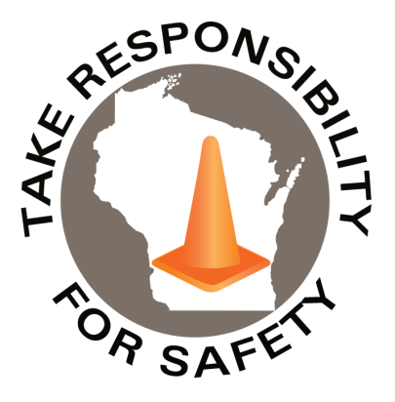

Safety Spotlight:

[National School Bus Safety Week](https://www.napt.org/nsbsw)

Five Minutes for Safety:

October 6-12 is [Fire Prevention Week](https://www.nfpa.org/events/fire-prevention-week). This year’s important campaign is, “Smoke alarms: Make them work for you!” Learn the importance of having working smoke alarms. Resources include safety tips and guidelines focused around: Install, Test, and Replace (click image below to learn more).

](https://www.nfpa.org/events/fire-prevention-week)

Halloween Safety Tips

Check out some [tips](https://www.nsc.org/community-safety/safety-topics/seasonal-safety/autumn-safety/halloween?src=fbc-AshtonOctober+28) from the National Safety Council on costume safety and avoiding automobiles while being outside.

October 2024

Volume 11, Number 10

|  |
| --- |
| Safety Net(work)  Produced by Department of Administration Bureau of State Risk Management  Produced by Department of Administration Bureau of State Risk Management |

](https://www.youtube.com/watch?v=ehV9d7gabfc)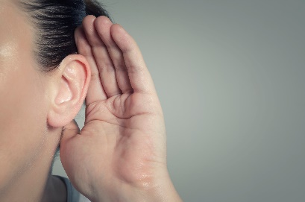

In This Issue:

**Would you lend an ear?**

**Prevent hearing loss!**

*Would you lend an ear?*

October is [National Protect your Hearing Month](https://www.noisyplanet.nidcd.nih.gov/have-you-heard/october-national-protect-your-hearing-month). [According](https://www.cdc.gov/niosh/noise/about/index.html) to the National Institute for Occupational Safety and Health (NIOSH), hearing loss is the third largest chronic health condition for US adults. Additionally, 1 in 8 workers experience hearing difficulty and 1 in 32 are exposed to hazardous noise levels.

When it comes to hazardous noise, the general “THREE FOOT RULE” may be useful to apply: If you must raise your voice to talk to someone just three feet away…that is a sign for potentially hazardous noise and hearing protection [should](https://www.cdc.gov/niosh/noise/about/noise.html) be worn.

Howard Leight/Honeywell also produced a “[Noise Thermometer](https://prod-edam.honeywell.com/content/dam/honeywell-edam/sps/his/en-gb/products/hearing-protection/documents/sync-stereo/sps-his-hppe-hearing-howard-leight-noise-infographic-eu.pdf),” poster which provides good insight on general noise exposure.

To protect your hearing in the workplace or at home, watch PROTECT YOUR HEARING! Hearing conservation safety training video by Ally Safety:

Link: <https://www.youtube.com/watch?v=ehV9d7gabfc>

Hearing loss is often slow, builds over time, and not always fully recoverable. So, it’s very important to protect what you have now. In the future you will really appreciate it!

Did you know occasionally some chemicals can even aggravate noise-induced hearing loss, these are called [*ototoxicants*](https://www.cdc.gov/niosh/noise/about/chemicals.html)? Some examples of these include lead, mercury, carbon monoxide, tobacco smoke, and certain pesticides. If these substances are identified, familiarize yourself with control measures identified in [Safety Data Sheets](https://www.osha.gov/sites/default/files/publications/OSHA3514.pdf) (SDSs) and in your workplace’s health and safety policies to limit your exposure.

](https://www.cdc.gov/niosh/noise/about/noise.html)

|  |
| --- |
|  |

Prevent hearingloss!

Noise-induced hearing loss is preventable. NIOSH has [resources](https://www.cdc.gov/niosh/noise/?CDC_AAref_Val=https://www.cdc.gov/niosh/topics/noise/) on how to [prevent](https://www.cdc.gov/niosh/noise/prevent/index.html) hearing loss and identify risks. Implementing risk mitigation measures with quieter processes such as reducing pneumatic tool air pressure and swapping out pneumatic tools for quieter alternatives. Or as a last hierarchy of control, PPE, like hearing protection.

[](https://www.cdc.gov/niosh/noise/about/noise.html)

Retired 3M senior scientist and acoustical expert, Elliot Berger, has worked with foam ear plugs since they were invented in the 1970’s. Mr. Berger provides an excellent five-minute video to optimize the ear plug wearing experience:

[](https://www.youtube.com/watch?v=3S6dthcSVIM)

Link: <https://www.youtube.com/watch?v=3S6dthcSVIM>

Honeywell/Howard Leight have put together some earmuff fitting [instructions](https://prod-edam.honeywell.com/content/dam/honeywell-edam/sps/his/en-ca/products/hearing-protection/documents/HL_impact_sport_sound_amplification_earmuff_earmuff%20fitting%20poster%20au.pdf) to help you ensure the correct seal and placement of earmuffs.

Some tips to remember from Honeywell/Howard Leight’s instructions:

1. Don’t let hair, glasses or other obstructions block off the seal to earmuffs.
2. Have the earmuffs cover both ears completely.
3. Make sure that the seal is firm and doesn’t have gaps.
4. Maintain and inspect hearing protection
5. Select the appropriate hearing protection device.

Consumer Safety

[United States Consumer Product Safety Commission](http://www.cpsc.gov/)

Contact Us

<https://doa.wi.gov>

E-Mail

[Jake.Lowell@Wisconsin.gov](mailto:jake.lowell@wisconsin.gov)