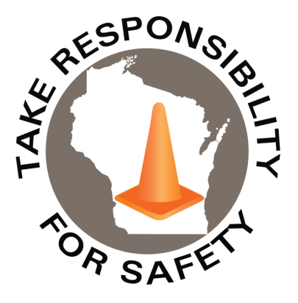

In This Issue:

**Eight Seconds: One Fatal Distraction**

**Lawn Mower Safety Reminders**

**The National Safety Stand-Down**

Volume 11, Number 5

May 2024

|  |
| --- |
| Safety Net(work)  Produced by Department of Administration Bureau of State Risk Management  Produced by Department of Administration Bureau of State Risk Management |

Safety Spotlight:

[National Electrical Safety Month](http://www.esfi.org/program/national-electrical-safety-month-314)

](https://dps.mn.gov/divisions/ots/hands-free/Pages/impact-stories.aspx)

**60,000+ people that are treated by hospital emergency rooms each year because of unsafe operation of power lawn mowers (**[**CPSC**](https://www.briggsandstratton.com/na/en_us/buying-guides/lawn-mowers/safety.html)**).**

[Electrical Safety While Working from Home](https://www.esfi.org/electrical-safety-while-working-from-home/)

|  |  |
| --- | --- |
| |  | | --- | | **Minnesota Office of Traffic Safety Hands-Free Impact Stories**  Last month, we gave focus to Distracted Driving Awareness Month promoting several different free resources and learning opportunities. One impact story titled, “Eight Seconds: One Fatal Distraction” was emphasized for EVERYONE to put down their phone and watch/share with anyone they know:  <https://dps.mn.gov/divisions/ots/hands-free/Pages/impact-stories.aspx>  Another tragedy, among thousands of people killed each year from a distracted driver. This time from checking a Zillow listing text message, for eight seconds, and while even on a work truck dash camera. Please put your phone away while driving. This is unacceptable.  No state is resistant to tragic stories like the above and hands-free laws are in different stages across the country. Additional Wisconsin Distracted Driving messaging is available in the Drive Safe module in agency learning management systems and [Zero In Wisconsin Together We Can Save Lives](https://zeroinwisconsin.gov/programs/distracted-driving/). | |

417

1,670

Claims

FY24 YTD

Workers Comp

Alarming Statistics:

Five Minutes for Safety:

401

Claims

FY23 YTD YTD

Lost Time

FY24 YTD

Lost Time

FY23 YTD

1,637



**Lawn Mower Safety Reminders**

According to the US Consumer Product Safety Commission, 60,000+ people are treated by hospital emergency rooms each year because of unsafe operation of power lawn mowers. Briggs and Stratton shares some [safety guidelines](https://www.briggsandstratton.com/na/en_us/buying-guides/lawn-mowers/safety.html) to keep yourself safe while using a lawn mower:

* Always wear sturdy closed toe shoes, protective eyewear, and hearing protection.
* Mow only in daylight and when the grass is dry.
* Check your yard for any debris or objects, such as toys that could pose a hazard if you mowed over them.
* Keep pedestrians and pets away from the mowing area.
* Never let the starter rope snap back when starting a mower.
* Look 3-4 feet directly ahead of you while mowing.
* Drive the mower slowly, and avoid sudden starts, stops, and turns.
* Never tilt a mower – always keep all four wheels on the ground.
* Take special care when mowing areas with drop-offs, bodies of water, hills, and inclines.
* With your push mower, always mow across an incline or hill.
* Always turn off mower when crossing a sidewalk or driveway.
* Don’t run the mower over gravel or rocks.
* Never adjust mower height, clean grass chute, remove grass catcher or repair the mower while the engine is running.
* Never deactivate safety devices.
* Never pull mower towards you.
* Always stay clear of a hot engine as mufflers can reach up to 1,200˚ F.
* Don’t fill a gasoline-powered mower indoors, and don’t add gasoline while the engine is hot or running.
* Always read your [Operator’s Manual](https://www.briggsandstratton.com/na/en_us/support/manuals.html) thoroughly before operating the mower.
* Inspect the mower before each use to ensure all protective devices are in place and all parts are in good condition.
* Children under 12 should not operate a push mower.
* Do use rollover protective structures (ROPS) and seat belts if your mower is equipped with them.
* Don’t allow any passengers to ride with you on the mower.
* Don’t leave a mower unattended while it’s running, turn it off, and take the key with you.

[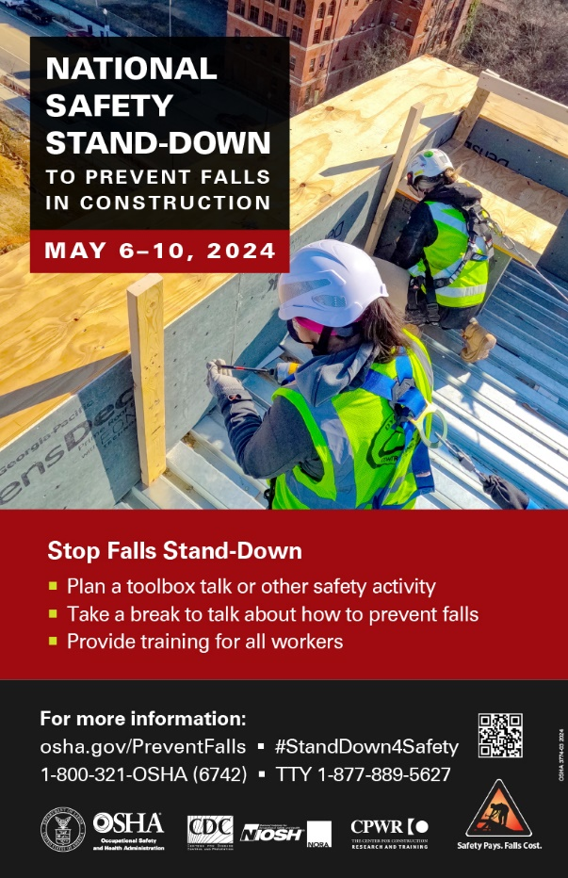](https://www.osha.gov/stop-falls-stand-down)

**Safety Stand-Down 2024**

**Virtual Sessions**

**May 6-10, 2024**

[**Register for FREE webinars with MSA trainers and safety experts.**](https://us.msasafety.com/safetyweek?utm_source=mkto&utm_medium=email&utm_campaign=safety-week-2024&utm_content=10300&mkt_tok=MzI4LVNSVi05NzEAAAGSkLZXBmt3kNxdYgbvOvvJ5rZG9juxnuD13Yrja_WkS5RidZoo3E8xSX6z0wRpoHNxGuGlheaIrjat1WdLJtyDF0VP4as-jfaJOvBJuRwZlkm1XLw)

ABCs of Fall Protection

Choosing Head Protection

Portable Gas Detection for Confined Space Entry

ANSI Z359.14: Overview & Recent Changes

[**The National Safety Stand-Down To Prevent Falls in Construction**](https://www.osha.gov/stop-falls-stand-down)

Consumer Safety

[United States Consumer Product Safety Commission](http://www.cpsc.gov/)

Contact Us

<https://doa.wi.gov>

E-Mail

[Jake.Lowell@Wisconsin.gov](mailto:jake.lowell@wisconsin.gov)