

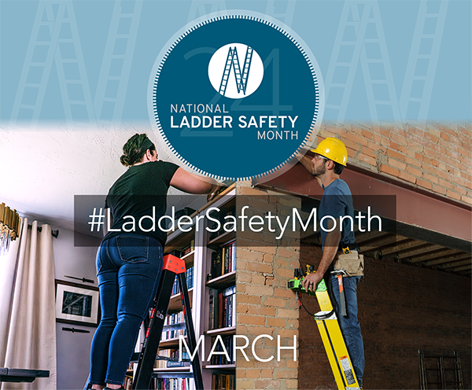

In This Issue:

**National Ladder Safety Month**

**Free Online Ladder Safety Learning**

Volume 11, Number 3

March 2024

|  |
| --- |
| Safety Net(work)  Produced by Department of Administration Bureau of State Risk Management  Produced by Department of Administration Bureau of State Risk Management |

Safety Spotlight:

[National Ladder Safety Month](https://www.laddersafetymonth.com/About/National-Ladder-Safety-Month)

Thought Provoking Question of the Month:

***Five Most Common Causes of Ladder Incidents***

According to the American Ladder Institute (ALI), missing the last step and overreaching were the two most cited causes of ladder incidents. Provided below are five most common causes of ladder incidents.

1. ***Missing the last step when climbing down the ladder***
2. ***Overreaching while on the ladder.***
3. ***The ladder was not the right size for the job.***
4. ***The ladder was not on firm, level ground.***
5. ***Three points of contact were not used when climbing the ladder.***

[5 Most Common Causes of Ladder Incidents - ANSI Blog](https://blog.ansi.org/ali/common-causes-ladder-incidents/)

**National Ladder Safety Month | March 2024**

Ladder safety is a serious matter – there are more than 20,000 ladder-fall injuries at work every year and thousands more at home. The presenting sponsor for National Ladder Safety Month, American Ladder Institute (ALI) is the only approved developer of safety standards for the U.S. ladder industry. ALI believes ladder accidents are preventable with thorough safety planning, training, and continuous innovation in product design. The goals of National Ladder Safety Month are to raise awareness around ladder safety, to decrease the number of ladder-related injuries and fatalities caused by misuse, and to increase the number of people certified in Ladder Safety Training.

***2024 Focus of National Ladder Safety Month:***

* Training and Awareness.
* Inspection and Maintenance.
* Stabilization, Setup, and Accessories.
* Safe Climbing and Positioning.

***Click on the link below for more information on National Ladder Safety Month:*** [National Ladder Safety Month](https://www.laddersafetymonth.com/About/National-Ladder-Safety-Month)

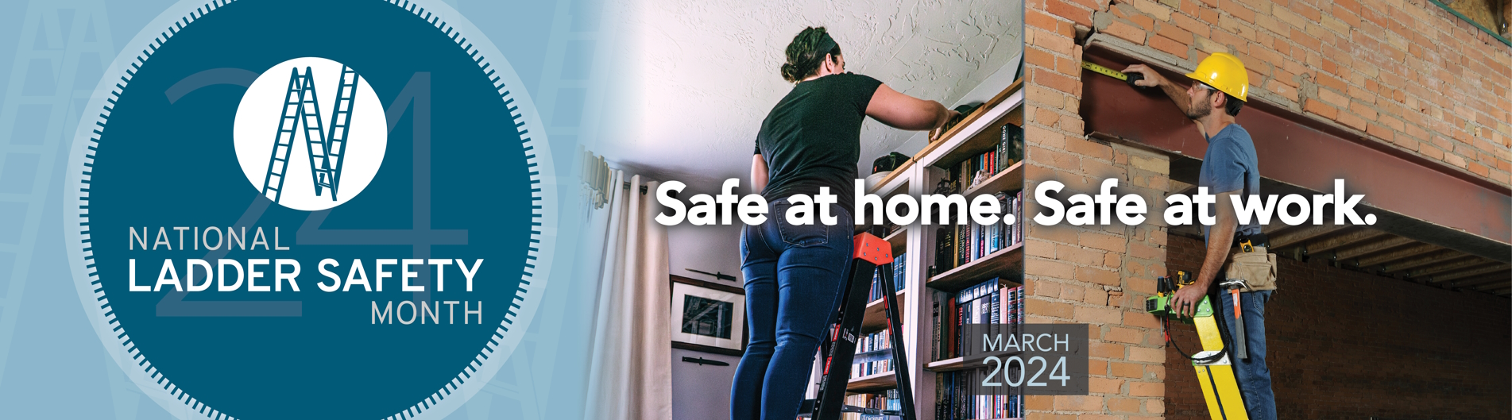

1,336

Claims

FY24 YTD

[Basic Ladder Safety](https://www.americanladderinstitute.org/page/BasicLadderSafety)

Workers Comp

Five Minutes for Safety:

334

291

Claims

FY23 YTD YTD

Lost Time

FY24 YTD

Lost Time

FY23 YTD

1,309

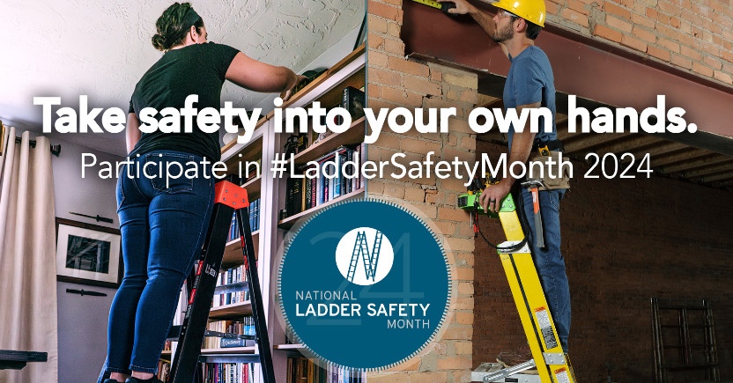

***2024 Ladder Safety Webinar Series***

[Louisville Ladder](https://louisvilleladder.com/) and [Werner Co.](https://www.wernerco.com/us) are sponsoring new ladder safety webinars each week during ladder safety month, focusing on the following topics:

[**Training & Awareness**](https://register.gotowebinar.com/register/208309512221876822)

**Tuesday, March 5, 2024**

**12:00 PM – 1:00 PM CST**

“An ounce of prevention is worth a pound of cure.” How can you make your jobsites more safety conscious and productive? Change the way we communicate about climbing safety! In this webinar presenter will cover the top ladder OSHA violations, leveraging iconography on safety labels to improve communication, review available safety training resources, and discuss how to properly conduct ladder safety inspections.

[**Ladder Inspection, Maintenance, and Proper Use**](https://register.gotowebinar.com/register/3187181181071244887)

**Thursday, March 14, 2024**

**1:00 PM – 2:00 PM CST**

[**Stabilization, Setup, and Accessories**](https://register.gotowebinar.com/register/2721649057295673433)

**Tuesday, March 19, 2024**

**12:00 PM – 1:00 PM CST**

Let’s talk about proper ladder set-up. How can ladder accessories improve safety and productivity? In this webinar presenter will demonstrate how to properly setup step and extension ladders.

[**Ladder Inspection, Maintenance, and Proper Use (Spanish Spoken)**](https://register.gotowebinar.com/register/87770052556776025)

**Thursday, March 28, 2024**

**1:00 PM – 2:00 PM CST**

[Learn more and register here!](https://www.laddersafetymonth.com/participate/scheduled-events/)

**Free Online Ladder Safety Training**

The non-for-profit American Ladder Institute (ALI) created a free Ladder Safety Training program and declared March as National Ladder Safety Month to inspire safer ladder use and reduce the rate of injuries. The [ALI online Ladder Safety Training certification program](https://www.laddersafetytraining.org/) is aimed at promoting safe ladder use, selection and care. The ALI Safety Training is a 100% free educational offering, so all employees can be required to complete the program without any training cost implications. The training is designed for both professionals and homeowners, and it teaches participants how to safely use and care for different types of ladders including:

* Stepladders
* Single and extension ladders
* Articulated ladders
* Mobile ladders

Participants that complete the Ladder Safety Training program will receive a certificate of completion, ensuring the most current and reputable ladder safety information is understood.

*\*For Trainers and Training Managers, The ALI has designed a Trainer’s Toolbox (simply check the “Trainer Toolbox” when signing up). Additional free tool available to register/assign to organization’s trainees.*

<https://www.laddersafetytraining.org/>

***Ladder Tips to Ensure Your Safety***

1. ***Choose the right ladder or equipment trained on for the task.***
   * Different types of ladders have different uses.
   * Determine the ladder’s load rating, the weight of the person climbing the ladder, and the weight of the tools being carried.
2. ***Check the ladder for noticeable signs of damage or issues before each use.***
   * Check for structural damage such as broken or loose rungs, screws, bolts, hinges, or bent side rails (dispose of old, damaged, or obsolete).
   * Check for grease, dirt, or other materials that can increase the chance of a slip and fall.
3. ***Set up the ladder on a flat and stable surface.***
   * The surface should be able support the weight of the ladder and the person using it. The surface should also be level.
4. ***Set the ladder up in a safe place.***
   * The surrounding area should be uncluttered and free of obstructions.
5. ***Always maintain three points of contact.***
   * When climbing or descending the ladder, three points of contact should always be maintained. This includes two hands and one foot, or two feet and one hand.
6. ***Only take secured small items up or down a ladder.***
   * Be conscious of the ladder’s load limit. Carrying anything larger or heavier than the load limit can make the ladder unstable.
7. ***Climb down the ladder cautiously.***
   * Remain facing the ladder and always maintain three points of contact. Descend slowly and avoid any sudden movements that affect the stability of the ladder.

Consumer Safety

[United States Consumer Product Safety Commission](http://www.cpsc.gov/)

Contact Us

<https://doa.wi.gov>

E-Mail

[Jake.Lowell@Wisconsin.gov](mailto:jake.lowell@wisconsin.gov)