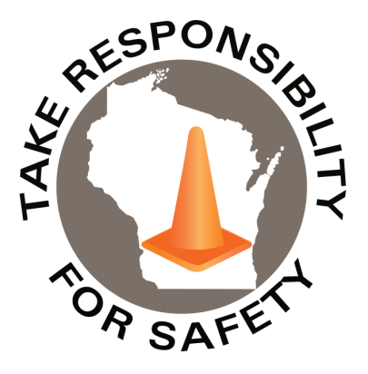

Volume 11, Number 1

January 2024

In This Issue:

**What You Didn’t Know About Carbon Monoxide Poisoning and Alarms**

|  |
| --- |
| Safety Net(work)  Produced by Department of Administration Bureau of State Risk Management  Produced by Department of Administration Bureau of State Risk Management |

Safety Spotlight:

[National Radon Action Month](https://www.epa.gov/radon/national-radon-action-month-information)

* **50,000 Annual ER Visits**
* **1,200 Annual Deaths**
* **Only 14% of families in the US have a properly functioning carbon monoxide alarm**

[Carbon Monoxide at a glance (NCOAA):](https://www.ncoaa.us/_files/ugd/025508_b2c700c54d9b4ae1ae1b24aa983cdb0f.pdf)

What You Didn’t Know About Carbon Monoxide Poisoning and Alarms

Highlighted in the National Fire Protection Association (NFPA) Network December 2023 edition, was the Learn Something New episode, on YouTube video number 15 of 34 titled, [“What You Didn’t Know About Carbon Monoxide Poisoning and Alarms](https://youtu.be/-rHTIY-49zw?si=_eQrYPm_WQfY8276). Carbon monoxide (CO) poisoning is a potentially fatal health hazard most associated in the winter. Did you know research suggests carbon monoxide is also dangerous when you are exposed to low levels over long periods of time, and a carbon monoxide alarm or detector might not alert you to these levels? Less is known about the harmful effects that lower levels of carbon monoxide exposure can have both acutely and over long periods of time but there is research out there to suggest it’s a problem:

*Excerpt From February 2021 Fire Protection Research Foundation Report*

*Excerpt From 1998 Campus Study Report*

*Excerpt From 1998 Campus Study Report*

969

Claims

FY24 YTD

[Hazardous Chemicals in the Workplace?](https://dsps.wi.gov/Documents/Programs/PublicSafety/SBD6894.pdf)

Workers Comp

Five Minutes for Safety:

249

210

Claims

FY23 YTD YTD

Lost Time

FY24 YTD

Lost Time

FY23 YTD

977

Addressing the issue of low-level exposure is quite complicated. The research foundations February 2021 report indicates that different organizations like OSHA (50 parts per million (ppm) parts of air as an 8-hour time-weighted average (TWA)), NIOSH, ACGIH, WHO, EPA (9 ppm over 8 hours), and ASHRAE all have different recommended safe thresholds for CO exposure:

According to manufacturer web sites, some CO alarms won’t sound at levels below 40 or 50 ppm and when they do, it requires those levels to persist for several hours before they do in fact sound. Home inspector Bryan Standley has become TikTok-famous for exposing hidden problems in houses. [Homeowners should always buy a low-level carbon monoxide detector, Standley reported](https://www.insider.com/low-level-carbon-monoxide-detector-home-safety-inspector-2021-3#:~:text=Home%20inspector%20Bryan%20Standley%20has,cause%20health%20problems%2C%20he%20said.). Standard detectors won’t alert homeowners to low gas levels that can cause health problems.

One organization that is very passionate about the issue of low-level and long-term CO exposure is called the [National Carbon Monoxide Awareness Association (NCOAA)](https://www.ncoaa.us/). From organizational web site:

So, what can you do? Prevention and knowledge are key. Know both the sources of CO and signs of CO poisoning. Please review NCOAA and NFPA web sites for more information:

[What You Didn't Know About Carbon Monoxide Poisoning and Alarms](https://youtu.be/-rHTIY-49zw?si=gIaKGUdAxzHRwDFk)

[Carbon Monoxide Detection and Alarm Requirements: Literature Review](https://www.nfpa.org/education-and-research/research/fire-protection-research-foundation/projects-and-reports/carbon-monoxide-detection-and-alarm-requirements-literature-review?l=48)

[NFPA Carbon Monoxide Alarm Information](https://www.nfpa.org/education-and-research/home-fire-safety/carbon-monoxide?l=33)

[The National Carbon Monoxide Awareness Association](https://www.ncoaa.us/)

[Learn Something New Series – NFPA](https://www.youtube.com/playlist?list=PL62RdU8F0s8ETOw-TrrwIPizDeRi1UhrC)

Consumer Safety

[United States Consumer Product Safety Commission](http://www.cpsc.gov/)

Contact Us

<https://doa.wi.gov>

E-Mail

[Jake.Lowell@Wisconsin. gov](mailto:jake.lowell@wisconsin.gov)

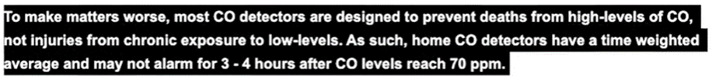](https://www.ncoaa.us/)