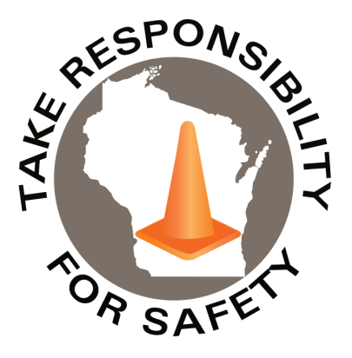

Volume 11, Number 2

In This Issue:

**Hazardous Materials Awareness**

**& Waste Disposal Training**

**Warning Serious Injuries are Still Occurring!**

**Free** for state, municipal, public school and tribal government employees

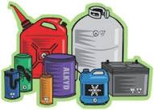

February 2024

|  |
| --- |
| Safety Net(work)  Produced by Department of Administration Bureau of State Risk Management  Produced by Department of Administration Bureau of State Risk Management |

Safety Spotlight:

[Heart Health Awareness Month](https://www.heart.org/)

**REGISTER online at** [**seminars.veoliaes.com/seminars**](http://seminars.veoliaes.com/seminars)

**2024 Wisconsin Hazardous Materials Awareness**

**& Waste Disposal Training**

Employees working at state-owned or operated facilities or employees of municipalities, tribal governments, public K-12 schools, technical colleges, and universities, need to be thoroughly familiar with proper waste handling and emergency procedures relevant to their facilities operations.

The Bureau of State Risk Management sponsors this **free** training to familiarize, refresh and engage the audience with material explaining the requirements and best management practices for waste handling, storage, disposal, and recycling. Some example products include: fluorescent lamps, batteries, laboratory chemicals, oils, antifreeze, paints, thinners, cleaners, corrosives & poisons.

During 2024, training options will be provided remotely through Microsoft Teams & five limited seating in-person options. For remote training, Microsoft Teams meeting invites with instructions will be sent to all registered email addresses in advance of the sessions. A phone call in option will be made available for those without computer access. For any potential scheduling conflicts or technical difficulty, recordings of the sessions will be available to review in the original Microsoft Teams calendar invites for a limited time.

**Who Should Attend?**

* Employees who work with hazardous chemicals
* Facility operations, maintenance, buildings and grounds management
* Employees involved with vehicle and equipment maintenance
* Employees who manage waste storage areas
* Laboratory workers who generate waste solvents or other chemical waste
* Stock/supply-area workers who order, receive or store chemical products
* **Supervisors who oversee personnel with the duties listed above**

**In-Person training dates and times:**

**Online training dates and times:**

1,159

Claims

FY24 YTD

[Understanding Heart Health](https://www.cdc.gov/heartdisease/index.htm)

Workers Comp

Quote of the Month:

Five Minutes for Safety:

283

259

Claims

FY23 YTD YTD

Lost Time

FY24 YTD

Lost Time

FY23 YTD

1,123

***WARNING***

***SERIOUS INJURIES ARE STILL OCCURRING***

The Department of Administration Bureau of Training and Development in collaboration with the Bureau of State Risk Management released a home grown 30 minute winter slip and fall prevention module available in both [Cornerstone](https://ess.wi.gov/psp/ess/EXTERNAL/HRMS/?cmd=login&languageCd=ENG&) (agencies) and [Canvas](https://www.wisconsin.edu/ehs/training2/) (universities) for all state employees last November. **Please be sure to take advantage of this educational opportunity in the coming days to help protect yourself and the team from one of the state’s leading causes of injury.** This course will help you recognize potential winter slip and fall hazards and identify important safety practices that can lower your risk of injury due to slips, trips, and falls.

Keyword search “Winter” in Leader (Cornerstone)

**Below depicts the total number of slip, trip and fall workers compensation claims, by month, since the Winter Slip and Fall Prevention Training was released:**



**AGENCY ENGAGEMENT - WINTER SLIP AND FALL PREVENTION TRAINING**

**\*\*\*Important message from Bureau of State Risk Management (BSRM) Director Jason Gates***:**

The Department of Administration Bureau of Training and Development created a dashboard with up to the minute tracking results by state agency for BSRM to monitor. The dashboard data demonstrates that despite our efforts in creating a customized learning focused directly at one of the two largest annual causes of injuries to state employees, State agencies are not taking advantage of this training. With a total of 116 agency-wide completed trainings *(Cornerstone data and does not include UWS)*; which, overall, is not corresponding well with the existing loss trends (shown above). There are still a couple winter months left this year to make an impact. We would greatly appreciate agency support and participation to continue to promote this training program; especially, or at a minimum with state job positions that are “high risk” involving work outdoors. At our 2023 risk management conference, we were able to recognize several individuals that made significant impacts to our state risk management program. It would be wonderful to recognize more, potentially including successful efforts in promoting important learning.

Consumer Safety

[United States Consumer Product Safety Commission](http://www.cpsc.gov/)

Contact Us

<https://doa.wi.gov>

E-Mail

[Jake.Lowell@Wisconsin.gov](mailto:jake.lowell@wisconsin.gov)