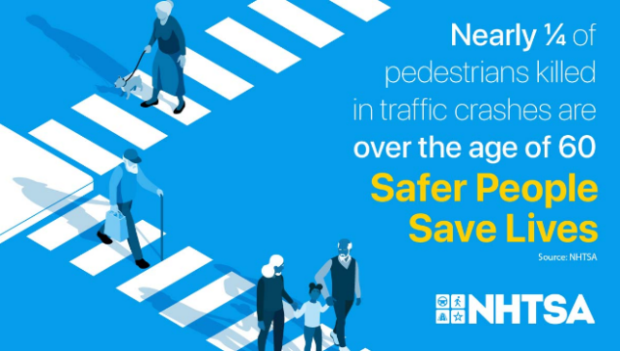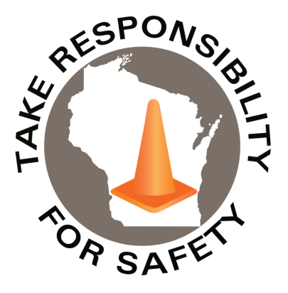

Volume 10, Number 10

October 2023

In This Issue:

**Pedestrian Safety Week**

**Slow Down!**

**State Risk Management Conference**

|  |
| --- |
| Safety Net(work)  Produced by Department of Administration Bureau of State Risk Management  Produced by Department of Administration Bureau of State Risk Management |

Safety Spotlight:

[Pedestrian Safety Month](https://www.trafficsafetymarketing.gov/get-materials/pedestrian-safety#:~:text=Every%20October%2C%20NHTSA%20celebrates%20National%20Pedestrian%20Safety%20Month.)

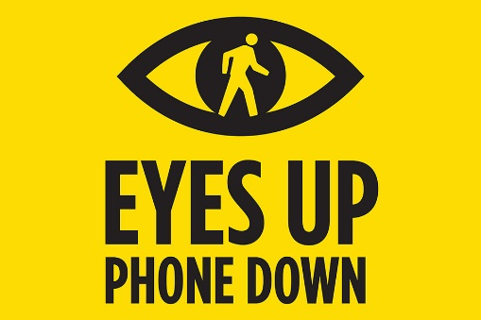[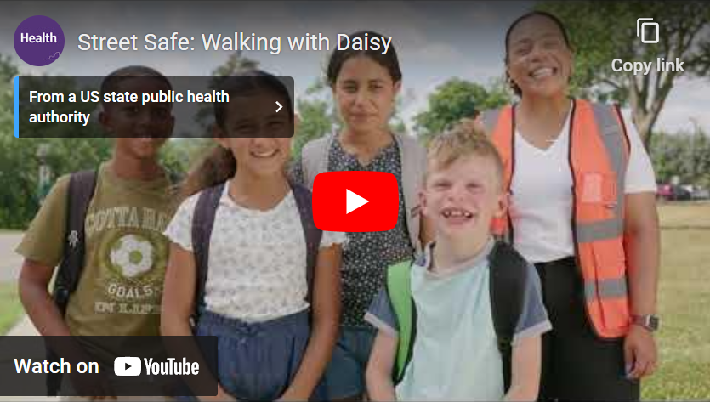

Workers Comp

488

Claims

FY24 YTD

[Fire Prevention Week](https://www.nfpa.org/fpw)

Motto of the Month:

Five Minutes for Safety:

145

111

Claims

FY23 YTD YTD

Every October, the National Highway Traffic Safety Administration (NHTSA) observes [National Pedestrian Safety Month](https://www.trafficsafetymarketing.gov/get-materials/pedestrian-safety/everyone-pedestrian). A recent [NHTSA Pedestrian publication](https://crashstats.nhtsa.dot.gov/Api/Public/ViewPublication/813458) shared some alarming statistics such as, in 2021, there were 7,388 pedestrians killed in traffic crashes, a 12.5% increase from the 6,565 pedestrian fatalities in 2020. This is the highest since 1981, when 7,837 pedestrians died in traffic crashes. Additionally, in 2021, there were an estimated 60,577 pedestrians injured in traffic crashes, an 11% increase from 54,771 pedestrians injured in 2020. On average, a pedestrian was killed every 71 minutes and injured every 9 minutes in traffic crashes in 2021.

NHTSA is strengthening its efforts to improve safety for pedestrians and other vulnerable road users by suggesting activities and providing [sample social media posts and messages, free infographics and other resources](https://www.trafficsafetymarketing.gov/get-materials/pedestrian-safety/everyone-pedestrian). Please use these materials to increase awareness about how we can combat pedestrian crashes in our communities.

Be sure to check out The New York State Department of Health, which also promotes some great [“Pedestrian Safety: It’s No Accident”](https://www.health.ny.gov/prevention/injury_prevention/pedestrians.htm) resources including but not limited to [“Street Safe: Walking With Daisy Video”](https://www.youtube.com/watch?v=T5Ml6DUPz6g) and [“See! Be Seen! Tip Card”](https://www.health.ny.gov/publications/3292.pdf).

Lost Time

FY24 YTD

Lost Time

FY23 YTD

559

Consumer Safety

[United States Consumer Product Safety Commission](http://www.cpsc.gov/)

Contact Us

<https://doa.wi.gov>

E-Mail

[Jake.Lowell@Wisconsin.gov](mailto:jake.lowell@wisconsin.gov)

Slow Down!

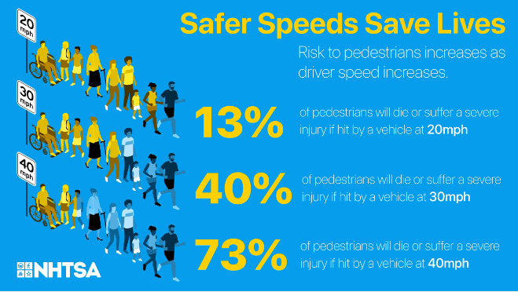

[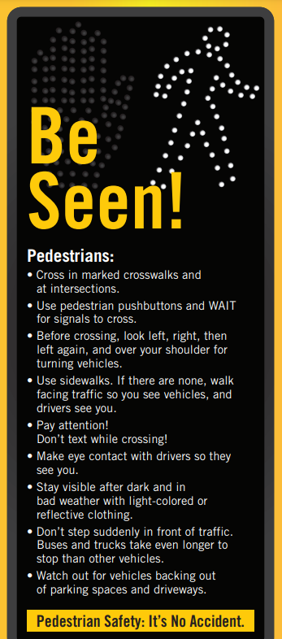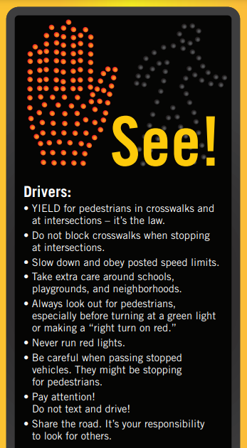](https://www.health.ny.gov/publications/3292.pdf)

|  |
| --- |
|  |

Last Call!

Risk Management would love to see you on November 2nd at the Monona Terrace! Please see [registration](https://doa.wi.gov/DEO/RegistrationInstructions.pdf) and [brochure](https://doa.wi.gov/DEO/Brochure%202023.pdf) information linked. Register by October 17th to avoid late fees!