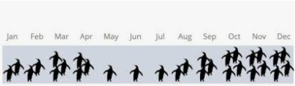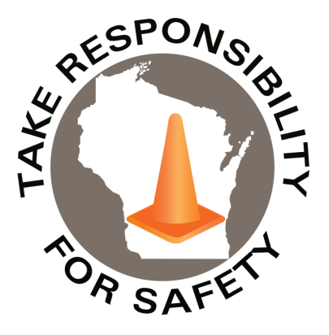

November 2023

Volume 10, Number 11

In This Issue:

**Walk Like a Penguin Time**

**NOW LIVE:**

**Winter Slip & Fall Prevention Module**

**Drive Safe Wisconsin**

|  |
| --- |
| Safety Net(work)  Produced by Department of Administration Bureau of State Risk Management  Produced by Department of Administration Bureau of State Risk Management |

Safety Spotlight:

[Mothers Against Drunk Driving](https://www.madd.org/)

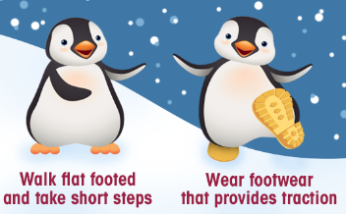

Penguin Tips:

WALK LIKE A PENGUIN TIME

Slips, trips and falls are one of the leading causes of injury each year for State of Wisconsin workers. Historically, the highest months of injury frequency tends to be during the winter season – November through April. Figure 1 shown below depicts the total number of slip, trip and fall workers compensation claims, by month, over the past five fiscal years. Figure 2 shown below illustrates the total number of slippery surface related workers compensation claims, which may include descriptions such as ice, water, or grease, by month, over the past five fiscal years.



Figure 1



Figure 2

677

Claims

FY24 YTD

[Get Smart About Antibiotics Week](https://www.cdc.gov/antibiotic-use/week/index.html)

Workers Comp

Five Minutes for Safety:

186

149

Claims

FY23 YTD YTD

Lost Time

FY24 YTD

Lost Time

FY23 YTD

719

NOW LIVE

***WARNING SERIOUS INJURIES HAVE PREVIOUSLY OCCURRED***

The Department of Administration Bureau of Training and Development in collaboration with the Bureau of State Risk Management just released a home grown 30 minute winter slip and fall prevention module available in both [Cornerstone](https://ess.wi.gov/psp/ess/EXTERNAL/HRMS/?cmd=login&languageCd=ENG&) (agencies) and [Canvas](https://www.wisconsin.edu/ehs/training2/) (universities) for all state employees. Please be sure to take advantage of this educational opportunity in the coming days to help protect yourself and the team from one of the state’s leading causes of injury. This course will help you recognize potential winter slip and fall hazards and identify important safety practices that can lower your risk of injury due to slips, trips, and falls.

Keyword search “Winter” in Leader (Cornerstone)

**Still Available: Drive Safe Wisconsin**

Released in 2021, the Bureau of State Risk Management partnered with the Department of Transportation in creating a “Drive Safe Wisconsin” training course to help mitigate injuries and loses involving motor-vehicles. The course provides information about driving risks and best practices to help reduce the chances of motor vehicle collision, injury, and loss by improving knowledge and behavior while on the road. The training series is focused on four important driver safety topics that are common contributing areas of risk & loss for the State of Wisconsin. The topics included share valuable information that can dramatically lower the risk of injury when behind the wheel:

* Using Safety Belts
* Seeing Well
* Avoiding Dangerous Driving Behaviors
* Adjusting to Road Conditions

The “Drive Safe Wisconsin” training course is available through [Employee Self Service](https://ess.wi.gov/psp/ess/EXTERNAL/HRMS/?cmd=login&languageCd=ENG&) (ESS) via the “My Learning” icon for agencies and via [UW System OSH Training](https://www.wisconsin.edu/ehs/training2/) web page for campuses. Keyword search “Drive Safe” in Leader (Cornerstone). The course is broken in four sessions, topically as outlined above, and total run time of entire program is approximately 40 minutes. It’s designed either to be taken in a single sitting or by topic to accommodate any time constraints **(Good time of year to refresh on Seeing Well & Adjusting to Road Conditions)**. This training is beneficial for both personal and work-related operation of vehicles and encourage anyone operating a vehicle to complete this training.

Consumer Safety

[United States Consumer Product Safety Commission](http://www.cpsc.gov/)

Contact Us

<https://doa.wi.gov>

E-Mail

[Jake.Lowell@Wisconsin.gov](mailto:jake.lowell@wisconsin.gov)

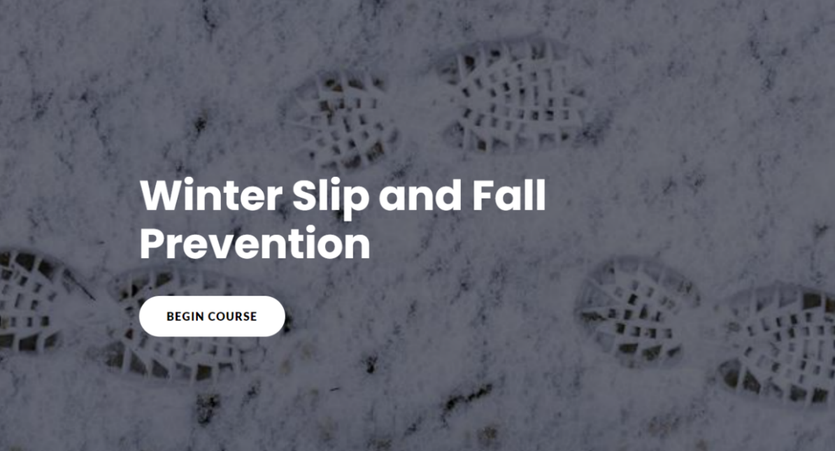

[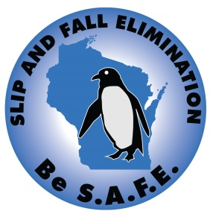](https://doa.wi.gov/DEO/Slip%2c%20Trip%20and%20Fall%20Prevention%20Manual.pdf)