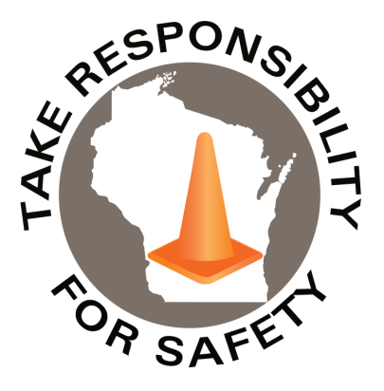

May 2023

Volume 10, Number 5

In This Issue:

**Through the Motions: Point & Call to Promote Safety**

**National Electrical Safety Month**

**Lockout/Tagout**

|  |
| --- |
| Safety Net(work)  Produced by Department of Administration Bureau of State Risk Management  Produced by Department of Administration Bureau of State Risk Management |

Safety Spotlight:

[National Electrical Safety Month](http://www.esfi.org/program/national-electrical-safety-month-314)

[Electrical Safety While Working from Home](https://www.esfi.org/electrical-safety-while-working-from-home/)



**Japanese Rail Workers Point & Call to Promote Safety**

Did you know that Japanese train conductors and railway staff point and call as they perform their work duties? This practice is known as pointing-and-calling and is an effective strategy to increase safety across the country’s transportation network. Check out the video link below to learn more about this innovative strategy!



[What’s the Point of Pointing in Japan, Anyway? | Atlas Obscura - YouTube](https://www.youtube.com/watch?v=RZun7IvqMvE)

This practice, known as pointing-and-calling, works on the principle of associating one’s tasks with physical movements and vocalizations to prevent errors by “raising the conscious levels of workers”-according to the National Institute of Occupational Safety and Health, Japan. ***This innovative industrial safety method reduces workplace errors by up to 85 percent!*** Rather than solely relying on a worker’s eyes or habit alone, each step in a given task is reinforced physically and audibly to ensure the step is both complete and accurate. For example, when train drivers wish to perform a required speed check, they do not simply glance at the display. Instead, they will physically point at the speedometer and call out “speed check, 80.” This confirms that the action is taking place and audibly confirms the correct speed.

***To learn more about the pointing-and-calling strategy, check out the link below!***

[Why Japan's Rail Workers Can't Stop Pointing at Things - Atlas Obscura](https://www.atlasobscura.com/articles/pointing-and-calling-japan-trains)

1,594

Claims

FY23 YTD

Workers Comp

Quote of the Month:

Five Minutes for Safety:

442

375

Claims

FY22 YTD YTD

Lost Time

FY23 YTD

Lost Time

FY22 YTD

1,806

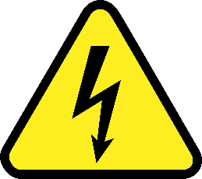

[**National Electrical Safety Month**](https://www.esfi.org/program/national-electrical-safety-month/)

The Electrical Safety Foundation International (ESFI) is a non-profit organization dedicated exclusively to promoting electrical safety in the home, school, and workplace. May is National Electrical Safety Month and ESFI spearheads an annual campaign to educate key audiences about the steps that can be taken to reduce the number of electrically related fires, fatalities, injuries, and property loss.  ESFI’s National Electrical Safety Month 2023 campaign features a comprehensive collection of new and updated resources to help facilitate an effective electrical safety awareness campaign for your community, organization, school, or family.  Included is an extensive collection of fact sheets and related safety tips, plus templates and tools you can use to promote electrical safety and National Electrical Safety Month in your home, school, community, or workplace.

**National Electrical Safety Month 2023 Campaign Overview**

ESFI is excited to announce the theme for our National Electrical Safety Month 2023 campaign: “Electrification: E-Mobility.” The materials for this year’s campaign examine how the rapid advancements made to emerging technology, including electric vehicles, require further electrification and safe, efficient devices that can support this increased energy demand.

**Related News and Safety Resources**

* ***Lithium-ion Battery Safety****:* [Lithium-ion Battery Safety - (esfi.org)](https://www.esfi.org/lithium-ion-battery-safety/)
* ***Workplace Safety****:* ***Avoid Common Electrical Hazards:*** [Workplace Safety: Avoid Common Electrical Hazards - (esfi.org)](https://www.esfi.org/workplace-safety-avoid-common-electrical-hazards/)
* ***Are you preparing your home or business for electrical vehicles?:*** [Prepare your Home or Business for Electric Vehicles - (esfi.org)](https://www.esfi.org/prepare-your-home-or-business-for-electric-vehicles/)
* ***National Fire Protection Association:*** [May is National Electrical Safety Month | NFPA | NFPA](https://www.nfpa.org/News-and-Research/Publications-and-media/Blogs-Landing-Page/Safety-Source/Blog-Posts/2022/05/06/May-is-National-Electrical-Safety-Month)

***For more information on National Electrical Safety Month, check out the link below!***

[National Electrical Safety Month - (esfi.org)](https://www.esfi.org/program/national-electrical-safety-month/)

Consumer Safety

[United States Consumer Product Safety Commission](http://www.cpsc.gov/)

Contact Us

<https://doa.wi.gov>

E-Mail

[Jake.Lowell@Wisconsin.gov](mailto:jake.lowell@wisconsin.gov)

[OSHA Lockout/Tagout Link](https://www.osha.gov/control-hazardous-energy)

Proper lockout/tagout (LOTO) of powered machinery safeguards workers from the release of hazardous energy during maintenance and servicing activities.

**Hazardous energy sources include:**

* Electrical energy
* Mechanical energy
* Hydraulic energy
* Pneumatic energy
* Chemical energy
* Thermal energy

Worker’s servicing or maintaining machines or equipment may be seriously injured or killed if hazardous energy is not properly controlled. Injuries resulting from the failure to control hazardous energy during maintenance activities can be serious or fatal! Injuries may include electrocution, burns, crushing, cutting, lacerating, amputating, or fracturing body parts, and others.

Failure to establish an energy control program is [#3 leading public sector safety violation](https://dsps.wi.gov/Documents/Programs/PublicSafety/TopViolations.pdf). Without a thorough and complete lockout/tagout (energy control) program, employees that maintain and service equipment are at risk for a serious injury!

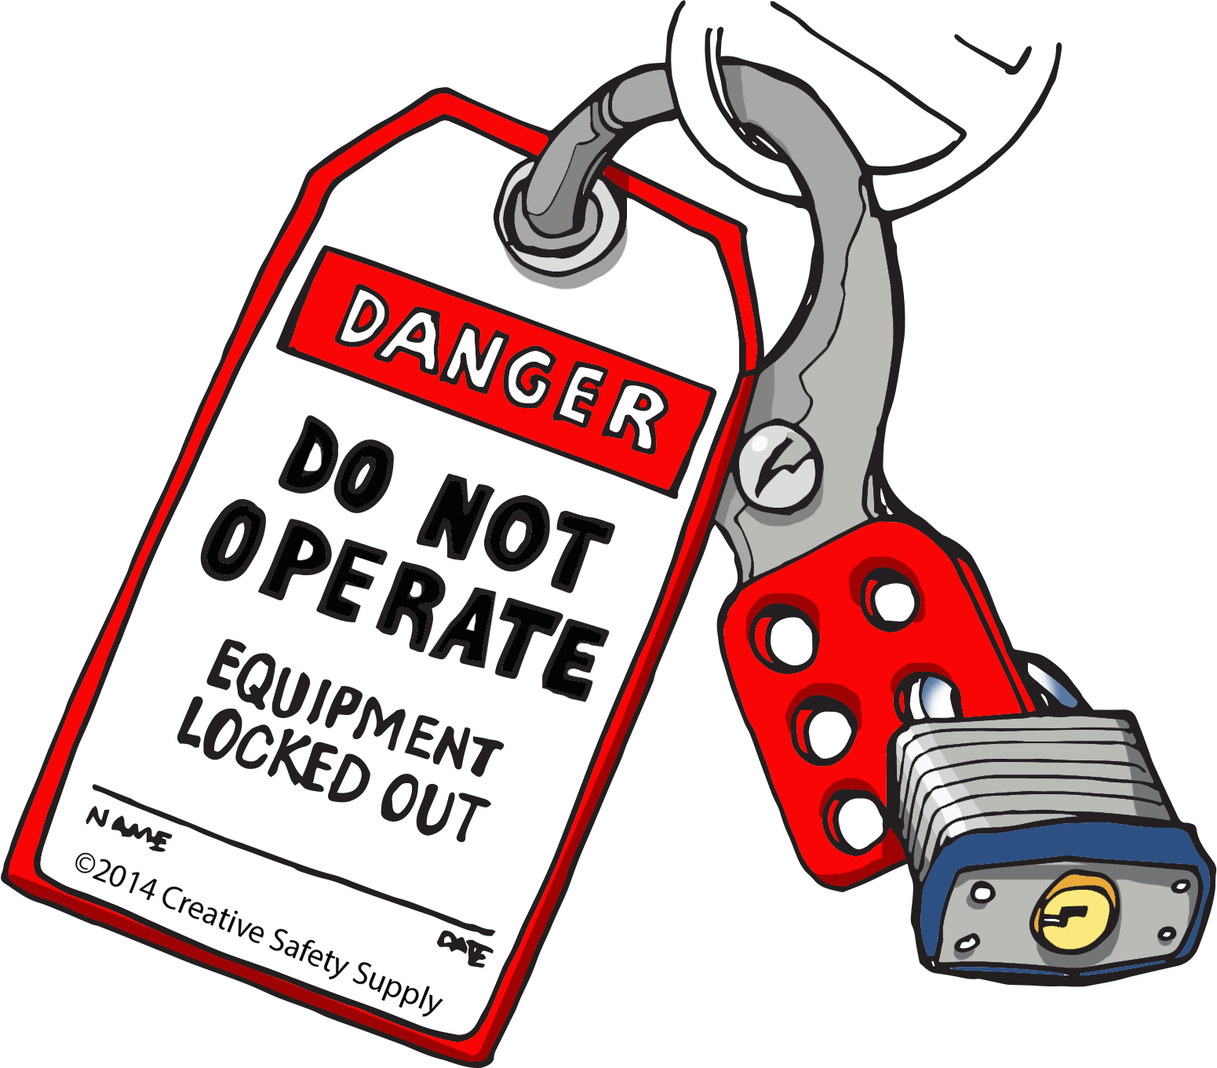

[Videos: Lockout Tagout Best Practices](https://www.masterlock.com/support/videos/safety-solutions/tagout)

[**Five Electrical Safety Tips for Homeowners**](https://chintglobal.com/blog/home-electrical-safety-tips/#:~:text=Electrical%20Safety%20at%20Home%3A%207%20Tips%20on%20Dealing,Follow%20Appliance%20Instructions%20for%20Improved%20Electrical%20Safety)

1. Repair or replace damaged, cracked, loose, or faulty power cords.
2. Keep electrical devices away from sources of water to avoid a potential shock hazard.
3. Avoid overloading outlets.
4. Unplug appliances when not in use to avoid the risk of overheating.
5. Use the proper wattage for lamps and lighting fixtures.