

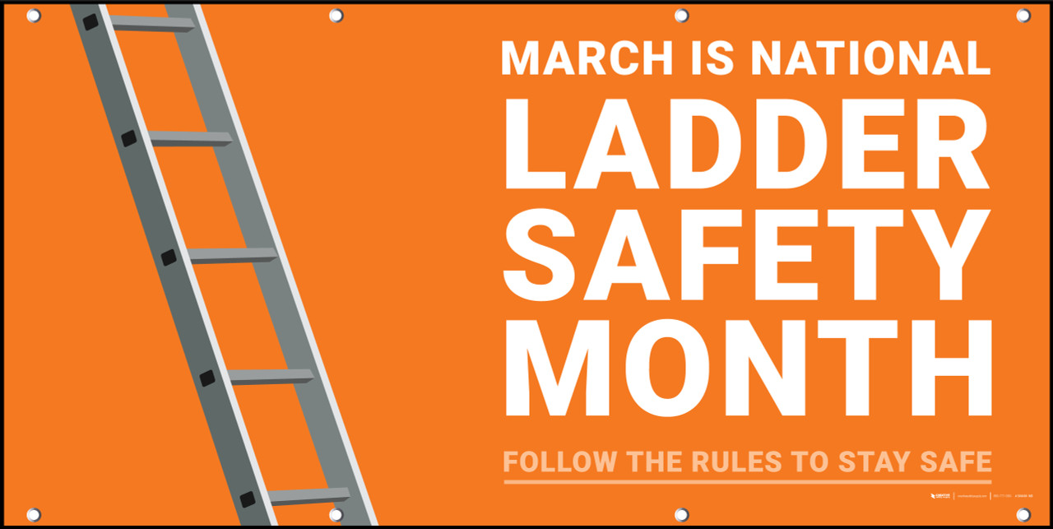

In This Issue:

**National Ladder Safety Month**

**Free Online Ladder Safety Training**

**Brain Injury and Awareness Month**

Volume 10, Number 3

March 2023

|  |
| --- |
| Safety Net(work)  Produced by Department of Administration Bureau of State Risk Management  Produced by Department of Administration Bureau of State Risk Management |

Safety Spotlight:

[National Ladder Safety Month](https://www.laddersafetymonth.com/About/National-Ladder-Safety-Month)

***5 Most Common Causes of Ladder Incidents***

According to the American Ladder Institute (ALI), missing the last step and overreaching were the two most cited causes of ladder incidents. Provided below are the five most common causes of ladder incidents.

1. ***Missing the last step when climbing down the ladder***
2. ***Overreaching while on the ladder.***
3. ***The ladder was not the right size for the job.***
4. ***The ladder was not on firm, level ground.***
5. ***Three points of contact were not used when climbing the ladder.***

[5 Most Common Causes of Ladder Incidents - ANSI Blog](https://blog.ansi.org/ali/common-causes-ladder-incidents/)

**National Ladder Safety Month | March 2023**

Every year over 100 people die in ladder-related incidents, and thousands suffer disabling injuries. National Ladder Safety Month was designed to raise awareness around ladder safety and to decrease the number of ladder-related injuries and fatalities that occur annually.

***Goals of National Ladder Safety Month:***

* Decrease the number of ladder-related incidents and fatalities.
* Increase ladder safety training.
* Reduce the number of ladder-related safety citations on OSHA’s yearly “Top 10 citation list.”
* Increase ladder inspections and awareness to dispose of old or damaged ladders.

For more information on National Ladder Safety Month, check out the link below!

***Click on the link for more information on National Ladder Safety Month:*** [National Ladder Safety Month](https://www.laddersafetymonth.com/About/National-Ladder-Safety-Month)

Make your life a masterpiece; imagine no limitations on what you can be, have, or do.

~ Brian Tracy

1,249

Claims

FY23 YTD

[Basic Ladder Safety](https://www.americanladderinstitute.org/page/BasicLadderSafety)

Workers Comp

Quote of the Month:

Five Minutes for Safety:

350

295

Claims

FY22 YTD YTD

Lost Time

FY23 YTD

Lost Time

FY22 YTD

1,450

***National Brain Injury & Awareness Month***

This month is Brain Injury Awareness Month! There are more than 5.3 million individuals in the United States who are living with a permanent brain injury-related disability. ***That is one in every 60 people.***

At least 2.8 million Americans sustain traumatic brain injuries in the United States every year. As a result, Brain Injury Awareness Month rallies a large community into raising awareness and advocating for causes they care about.

***About Brain Injury:***

-**Acquired Brain Injury**: An injury to the brain that is not hereditary, congenital, or induced by birth trauma. This type of brain injury occurs after birth. There are two types which include: traumatic and non-traumatic.

**Traumatic Brain Injury**: is defined as an alteration in brain function, or other evidence of brain pathology, caused by an external force or trauma. Traumatic impact injuries can be defined as closed (or non-penetrating) or open (penetrating).

**Source:** [Brain Injury Awareness Month - Brain Injury Association of America (biausa.org)](https://www.biausa.org/public-affairs/public-awareness/brain-injury-awareness)

**Free Online Ladder Safety Training**

The non-for-profit American Ladder Institute (ALI) created a free Ladder Safety Training program and declared March as National Ladder Safety Month to inspire safer ladder use and reduce the rate of injuries. The [ALI online Ladder Safety Training certification program](https://www.laddersafetytraining.org/) is aimed at promoting safe ladder use, selection and care. The ALI Safety Training is a 100% free educational offering, so all employees can be required to complete the program without any training cost implications. The training is designed for both professionals and homeowners, and it teaches participants how to safely use and care for different types of ladders including:

* Stepladders
* Single and extension ladders
* Articulated ladders
* Mobile ladders

Participants that complete the Ladder Safety Training program will receive a certificate of completion, ensuring the most current and reputable ladder safety information is understood.

*\*For Trainers and Training Managers, The ALI has designed a Trainer’s Toolbox (simply check the “Trainer Toolbox” when signing up). Additional free tool available to register/assign to organization’s trainees.*

<https://www.laddersafetytraining.org/>

<https://www.laddersafetymonth.com/Portals/0/NLSM%20Chimney%20Sweep%20News%202019.pdf>

***Ladder Tips to Ensure Your Safety***

1. ***Choose the right ladder.***
   * Different types of ladders have different uses.
   * Determine the ladder’s load rating, the weight of the person climbing the ladder, and the weight of the tools being carried.
2. ***Check the ladder for noticeable signs of damage or issues before each use.***
   * Check for structural damage such as broken or loose rungs, screws, bolts, hinges, or bent side rails.
   * Check for grease, dirt, or other materials that can increase the chance of a slip and fall.
3. ***Set up the ladder on a flat and stable surface.***
   * The surface should be able support the weight of the ladder and the person using it. The surface should also be level.
4. ***Set the ladder up in a safe place.***
   * The surrounding area should be uncluttered and free of obstructions.
5. ***Always maintain three points of contact.***
   * When climbing or descending the ladder, three points of contact should always be maintained. This includes two hands and one foot, or two feet and one hand.
6. ***Only take small items up or down a ladder.***
   * Be conscious of the ladder’s load limit. Carrying anything larger or heavier than the load limit can make the ladder unstable.
7. ***Climb down the ladder cautiously.***
   * Remain facing the ladder and always maintain three points of contact. Descend slowly and avoid any sudden movements that affect the stability of the ladder.

Consumer Safety

[United States Consumer Product Safety Commission](http://www.cpsc.gov/)

Contact Us

<https://doa.wi.gov>

E-Mail

[Jake.Lowell@Wisconsin.gov](mailto:jake.lowell@wisconsin.gov)