*[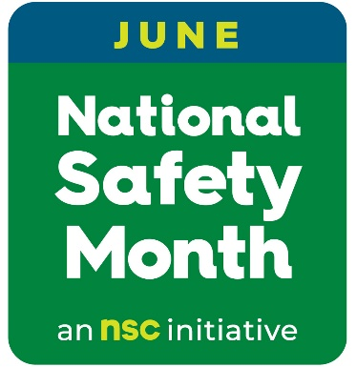](https://www.nsc.org/workplace/national-safety-month/nsm-public-materials)*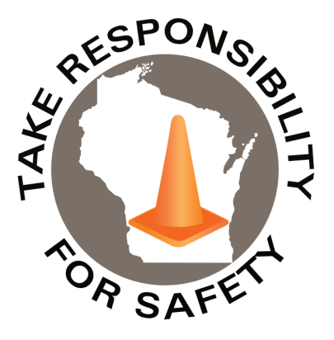

Volume 10, Number 6

June 2023

In This Issue:

**National Safety Month**

**Heat Stress Management Program**

|  |
| --- |
| Safety Net(work)  Produced by Department of Administration Bureau of State Risk Management  Produced by Department of Administration Bureau of State Risk Management |

Safety Spotlight:

[National CPR & AED Awareness Week](https://cpr.heart.org/en/training-programs/cpr-and-aed-awareness/cpr-and-aed-awareness-week)

](https://www.nsc.org/getmedia/c56cd091-5021-4a68-a794-8dcdf46bee1b/nsm_2022_poster_(engsp).pdf)

1,715

Claims

FY23 YTD

[Heat Illness Prevention Campaign](https://www.osha.gov/heat)

Workers Comp

Inspiration of the Month:

Five Minutes for Safety:

477

408

Claims

FY22 YTD YTD

Observed annually in June, we are prioritizing National Safety Month by joining the National Safety Council (NSC) in observing this important initiative. NSC offers free weekly resources to help keep workplaces safe as well as help families thrive off the job with topics covering emergency preparedness; slips, trips and falls; heat-related illnesses; and hazard recognition.

[(Hyperlink to access free downloadable resources)](https://www.nsc.org/workplace/national-safety-month/nsm-public-materials)

Download and share these materials provided by the National Safety Council (control click on Hyperlink above to access downloadable resources) to help keep each other safe this June and beyond, from the workplace to anyplace. Areas of focus:

* + - * Week 1 – Emergency Preparedness
      * Week 2 – Slips, Trips and Falls
      * Week 3 – Heat-Related Illness
      * Week 4 – Hazard Recognition

The Department of Administration – Bureau of State Risk Management secures annual statewide membership through the Wisconsin Safety Council. Membership includes exclusive National Safety Council (NSC) Safety Month materials such as: 5-minute safety talks, videos/virtual events, posters, checklists, and quizzes. Please contact [Jake.Lowell@Wisconsin.gov](mailto:Jake.Lowell@Wisconsin.gov) from the Bureau of State Risk Management – Safety & Loss Control for assistance accessing exclusive materials.

Lost Time

FY23 YTD

Lost Time

FY22 YTD

1,977

Heat Stress Management Program

Consumer Safety

[United States Consumer Product Safety Commission](http://www.cpsc.gov/)

Contact Us

<https://doa.wi.gov>

E-Mail

[Jake.Lowell@Wisconsin.gov](mailto:jake.lowell@wisconsin.gov)

|  |
| --- |
|  |

## NSC members, [click here](https://www.nsc.org/nsc-membership/national-safety-month-member-downloads) to get access to your member-exclusive National Safety Month materials.

**Special thank you to Mary Bauer, Compliance Assistance, Eau Claire OSHA for contributing the important message!** A heat wave has already hit the Chippewa Valley! The early summer season has more potential for heat stress and heat related illness than later in the summer. The body will physically acclimate to warmer temperatures over time.

OSHA does not have a [heat stress](https://www.osha.gov/SLTC/heatstress/) standard or limit; however, can use the General Duty Clause (Section 5a1) to issue citations when the hazard was recognized and a feasible abatement method exists. In 2022, OSHA introduced an Indoor/Outdoor Heat Stress [National Emphasis Program](https://www.osha.gov/sites/default/files/enforcement/directives/CPL_03-00-024.pdf) (NEP).

[‘Don’t Fry Friday’](https://skincancerprevention.org/get-involved/dont-fry-day/) – recognized on May 26, 2023: To help reduce rising rates of skin cancer from overexposure to the ultraviolet (UV) rays of the sun. The National Council on Skin Cancer Prevention has designated the Friday before Memorial Day as “Don’t Fry Day” to encourage sun safety awareness and to remind everyone to protect their skin while enjoying the outdoors.

Factors to consider are:

1. Processes often contribute to the heat and humidity in the work area.
2. There is a limit to how much a fan will help cool a worker before it adds to the problem.
3. PPE or some work uniforms limit the amount of heat that the body can radiate.
4. New workers need time to adjust to hot environments. Studies show 7-14 days.
5. Workers that are dehydrated and heat compromised will make poor decisions.

OSHA Recommends a [Heat Stress Management Program](https://www.osha.gov/otm/section-3-health-hazards/chapter-4) consisting of Acclimatization, Medical Monitoring, Training and Heat Alert Program. Managers and Supervisors need to be able to adjust work needs to implement an effective heat stress program. OSHA has a [Heat Stress App](https://www.cdc.gov/niosh/topics/heatstress/heatapp.html) that could help the management team decide work/rest cycles. Water and air cooled garments can be used.

HYDRATE, HYDRATE, HYDRATE! Availability of popsicles, water jugs with electrolyte replacement, and/or just plain water is extremely important. A good bathroom stall poster is the [Urine Color Chart](https://www.uwgb.edu/UWGBCMS/media/Health-Care-Task-Force/files/Pee-Poster-11x8-5-2.pdf) to remind employees if they have drank enough water!