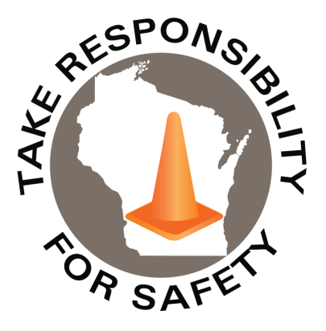

February 2023

**Recognize** the early warning signs and symptoms of musculoskeletal disorders.

In This Issue:

**Awareness and Prevention of Musculoskeletal Disorders**

**Heart Health Awareness**

Volume 10, Number 2

|  |
| --- |
| Safety Net(work)  Produced by Department of Administration Bureau of State Risk Management  Produced by Department of Administration Bureau of State Risk Management |

Safety Spotlight:

[Heart Health Awareness Month](https://www.heart.org/)

**Awareness and Prevention of Musculoskeletal Disorders (MSDs)**

Musculoskeletal Disorders or MSDs are injuries and disorders that affect movement of the human body or the musculoskeletal system. These disorders often compromise muscles, tendons, ligaments, nerves, discs, and blood vessels. Musculoskeletal disorders rarely result from a single event or accident, and often take weeks, months, or even years to develop.

**Common Musculoskeletal Disorders Include:**

* Carpal Tunnel Syndrome
* Tendinitis
* Tension Neck Syndrome
* Muscle, tendon, or ligament sprains
* Herniated or ruptured discs

Due to the prolonged development of MSDs, it is essential that early warning symptoms are recognized and mitigated. Some of the most common symptoms associated with the development of musculoskeletal disorders include joint pain, swelling, reduced range of motion, and muscle pain or weakness. If you develop any of these symptoms while at work, notify your employer **immediately**. Continuing to work through pain may exacerbate the issue and increase the likelihood of developing a work-related musculoskeletal disorder.

Identifying and mitigating ergonomic risk factors from the workplace is a vital step in maintaining good health. Eliminating ergonomic risk factors will also reduce the probability of employees developing a work-related musculoskeletal disorder.

**Common Ergonomic Risk Factors Include:**

* Awkward posture
* Contact stress and compression
* Repetitive motions
* Static posture
* Excessive force

Maintaining good ergonomics in jobs that require a high amount of physical force is critical. However, employees that work in an office setting will also benefit from maintaining good ergonomics. According to ErgoPlus, the average adult spends 50-70% of the day sitting at work. With remote work becoming more common, it is important to understand how you can maintain proper office ergonomics. The graphic below displays proper sitting posture and distances when working in an office setting.

“A river cuts through rock, not because of its power, but because of its persistence.”

-James N. Watkins

1,065

Claims

FY23 YTD

[Understanding Heart Health](https://www.cdc.gov/heartdisease/index.htm)

Workers Comp

Quote of the Month:

Five Minutes for Safety:

308

247

Claims

FY22 YTD YTD

Lost Time

FY23 YTD

Lost Time

FY22 YTD

1,297

**Reminder**

An office ergonomics self-assessment tool is available to all state employees via [Cornerstone](https://ess.wi.gov/psp/ess/EXTERNAL/HRMS/?cmd=login&languageCd=ENG&) and [Canvas](https://uws-td.instructure.com/enroll/GRC9EX).

* ***State Agencies-*** Login to Cornerstone through Employee Self Service (ESS) keyword search “ergonomics.”
* ***Universities-*** Found in Canvas.

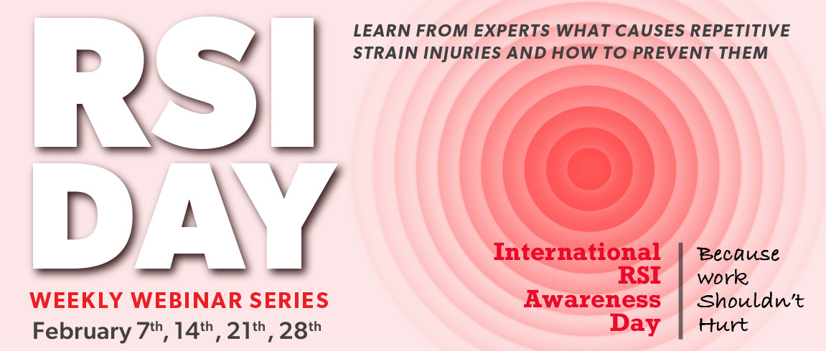

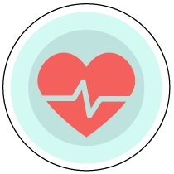

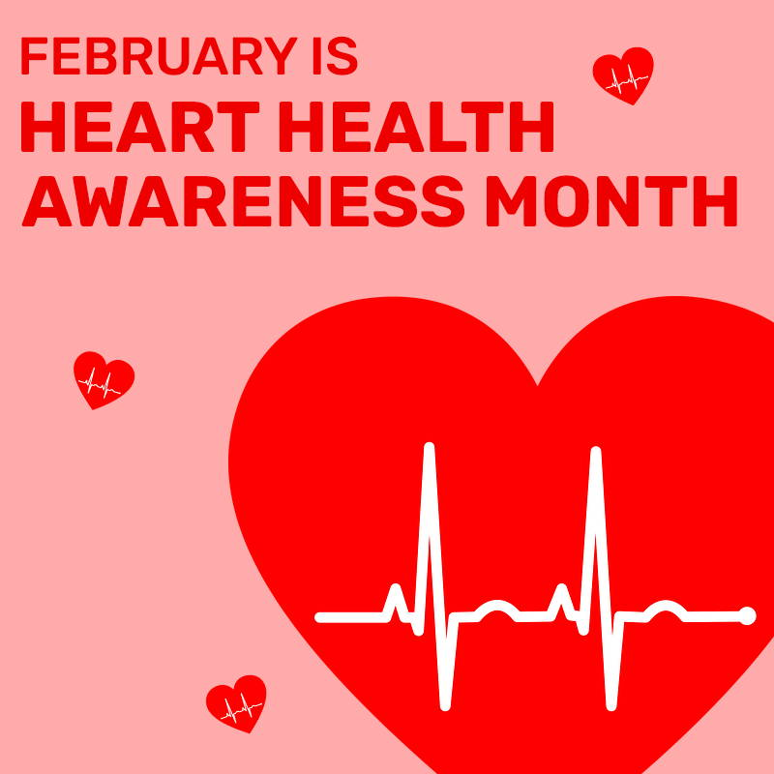

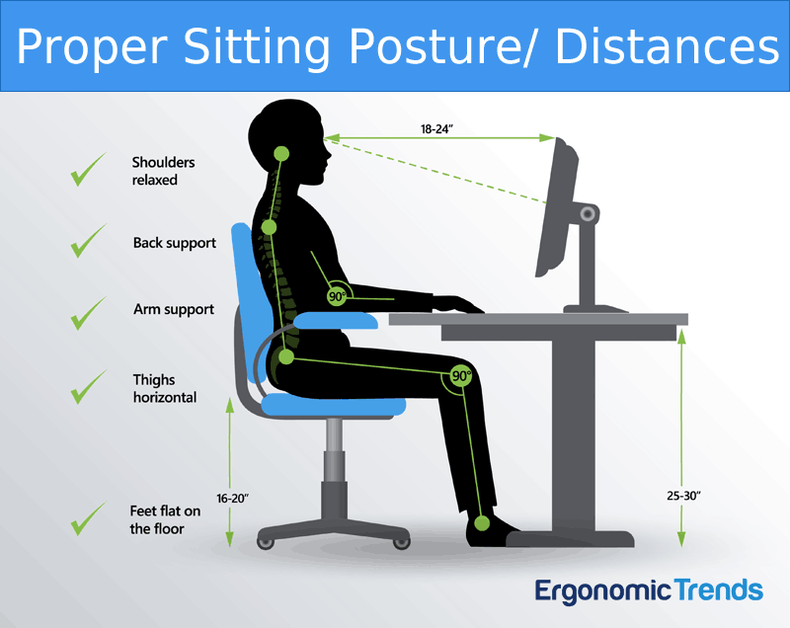

Image Source: *Ergonomic Trends, Office Ergonomics*

If you would like more information on repetitive strain injuries and how to prevent them, check out the link below.

***Webinar Series Link:*** [Repetitive Strain Injury Day (RSI - Day) (ohcow.on.ca)](https://www.ohcow.on.ca/ohcow-events/repetitive-strain-injury-rsi-day/)

The Occupational Health Clinics for Ontario Workers (OHCOW) is offering a free international virtual webinar series on increasing awareness and prevention of musculoskeletal disorders. This event is a weekly webinar series for the entire month of February. Session dates, times, and topics are listed below.

**Heart Health Awareness Month**

February is American Heart Month and the biggest push for cardiovascular health awareness in the United States. The human heart is the main organ of the cardiovascular system and pumps blood throughout the human body via the circulatory system. According to the Center of Disease Control and Prevention (CDC), heart disease is the leading cause of death for men and women in the United States. Below are seven strategies to live a heart-healthy lifestyle. These strategies were provided by the CDC.

**7 Strategies to Live a Heart-Healthy Lifestyle:**

1. ***Learn your health history-*** Be informed of your risks and consult your doctor for health history.
2. ***Eat a healthy diet-*** Eat less salt, saturated fat, and added sugar.
3. ***Move more, sit less-*** Get at least 150 minutes of moderate-intensity aerobic activity every week, plus muscle-strengthening activities at least two days a week.
4. ***Quit smoking-*** Call 1-800-QUIT-NOW for free help.
5. ***Take medicines as directed-*** Follow your doctors’ instructions and ask questions.
6. ***Choose your drinks wisely-*** Drink more water and limit alcohol consumption.
7. ***Monitor your blood pressure-*** self-measure blood pressure monitors are safe and easy to use.

**Week 2- February 14th, 2023**

*(10:00 a.m.-12:00 p.m. EST)*

* **Session 1-** Implications of indoor environment quality in an office setting.
* **Session 2**- Ergonomics and sleep.

**Week 4- February 28th, 2023**

*(10:00 a.m.-12:00 p.m. EST)*

* **Session 1-** ***Ergonomic Prevention Tools.*** Job demands: Physical and Cognitive.

**Week 3- February 21st, 2023**

*(10:00 a.m.-12:00 p.m. EST)*

* **Session 1-** Canadian Women’s experiences with Personal Protective Equipment in the workplace.
* **Session 2**- Review of and new directions for OHCOW’s PPD Handbook.

**Week 1- February 7th, 2023**

*(10:00 a.m.-12:00 p.m. EST)*

* **Session 1-** Four E’s of Shoulder Injuries.
* **Session 2**- Concussion: Post-concussion symptoms, underreporting, and prevention of workplace hazards.

Consumer Safety

[United States Consumer Product Safety Commission](http://www.cpsc.gov/)

Contact Us

<https://doa.wi.gov>

E-Mail

[Jake.Lowell@Wisconsin.gov](mailto:jake.lowell@wisconsin.gov)