[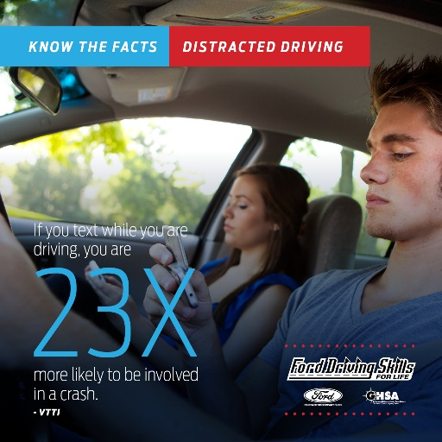](https://drivingskillsforlife.com/press-and-multimedia/latest-happenings/april-is-distracted-driving-awareness-month-resources-for-parents-of-teen-drivers)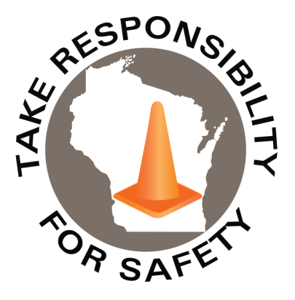

Volume 10, Number 12

December 2023

In This Issue:

**Smartphone Use Leading to More Distracted Driving Deaths**

**Drive Safe Wisconsin**

|  |
| --- |
| Safety Net(work)  Produced by Department of Administration Bureau of State Risk Management  Produced by Department of Administration Bureau of State Risk Management |

Safety Spotlight:

[National Handwashing Awareness Week](http://www.henrythehand.com/news-events/national-handwashing-awareness-week/)

](https://www.forbes.com/sites/edgarsten/2023/04/28/addictive-smartphone-use-leading-to-distracted-driving-deaths-safety-officials-say/?sh=5da12fe230b4)

Smartphone Use Leading to More Distracted Driving Deaths

On April 28, 2023, [Forbes](https://www.forbes.com/sites/edgarsten/2023/04/28/addictive-smartphone-use-leading-to-distracted-driving-deaths-safety-officials-say/?sh=5da12fe230b4) shared an alarming update on smartphone use leading to more distracted driving deaths. Telematics company Cambridge Mobile Telematics (CMT) revealed that drivers were 30% more distracted in February 2022 than they were in February 2020, making it the worst month for phone distraction in the U.S. since 2019. The increase in distracted driving resulted in a corresponding increase in deaths and economic losses. CMT estimates that the increase in distracted driving caused an additional 420,000 crashes, 1,000 fatalities, and $10 billion in damages to the U.S. economy in 2022.

CMT data shows drivers interacted with their phones on nearly 58% of trips in 2022, up from 54% in 2020. Screen interaction while driving reached two minutes and 12 seconds of every hour driving in 2022, a 23% increase over 2020.

**“The increase in crashes when drivers interact with their screens is stark: The worst offenders are 240% more likely to crash than the safest drivers.”**

**“If we pull up the number of distracted driving fatalities compared to aviation, we would be losing one airliner a week, one airliner a week that’s the losses that we have due to distracted driving.”**

**-Bruce Landsberg, National Transportation Safety Board**

841

Claims

FY24 YTD

[Make it a Home Safe Home for the Holidays](https://www.cpsc.gov/Newsroom/News-Releases/2024/Make-it-a-Home-Safe-Home-for-the-Holidays)

Workers Comp

Metaphor of the Month:

Five Minutes for Safety:

217

187

Claims

FY23 YTD YTD

Lost Time

FY24 YTD

Lost Time

FY23 YTD

853

Drive Safe Wisconsin

Released in 2021, the Bureau of State Risk Management partnered with the Department of Transportation in creating a “Drive Safe Wisconsin” training course to help mitigate injuries and loses involving motor-vehicles. The course provides information about driving risks and best practices to help reduce the chances of motor vehicle collision, injury, and loss by improving knowledge and behavior while on the road. The training series is focused on four important driver safety topics that are common contributing areas of risk & loss for the State of Wisconsin. The topics included share valuable information that can dramatically lower the risk of injury when behind the wheel:

* Using Safety Belts
* Seeing Well
* **Avoiding Dangerous Driving Behaviors** *(Excerpts Related to Distracted Driving Italicized Below)*
* Adjusting to Road Conditions

The “Drive Safe Wisconsin” training course is available through [Employee Self Service](https://ess.wi.gov/psp/ess/EXTERNAL/HRMS/?cmd=login&languageCd=ENG&) (ESS) via the “My Learning” icon for agencies and via [UW System OSH Training](https://www.wisconsin.edu/ehs/training2/) web page for campuses. Keyword search “Drive Safe” in Leader (Cornerstone). The course is broken in four sessions, topically as outlined above, and total run time of entire program is approximately 40 minutes. It’s designed either to be taken in a single sitting or by topic to accommodate any time constraints **(Good time to refresh on Avoiding Dangerous Driving Behaviors)**. This training is beneficial for both personal and work-related operation of vehicles and encourage anyone operating a vehicle to complete this training.

*Any lapse in attention to traffic or road conditions is a grave danger to you, your passengers and everyone else on the road. Your concentration should be completely on your driving and what is around and ahead of your vehicle.*

*All distractions can endanger safety. Wisconsin law states that no driver may engage in any activity other than driving that interferes or reasonably appears to interfere with safe driving.*

***Texting and making calls while driving***

*Texting is especially alarming because it takes your eyes off the road, your hands off the wheel and your mind off driving.****Texting while driving is against the law in Wisconsin****and it’s a primary enforcement law, which means law enforcement officers may stop motorists suspected of this offense alone.*

***Cell phones, driving, and the law***

* *Hand-held or hands-free cell phone use while driving is against the law in Wisconsin for any driver with a probationary license or instruction permit, except to report an emergency.*
* *No driver may use a hand-held, mobile device when driving through a road work zone, except to report an emergency. Violators will receive a ticket of $162.70 and four points added to the license.*
* *Texting while driving is against the law for ALL drivers in Wisconsin. Violators will receive a ticket of $187.90 and four points added to their license.*

***Avoid the risk and stay safe***

* *Turn off your phone or switch to silent mode every time you get behind the wheel.*
* *Record your voice mail message to tell callers that you are driving.*
* *Pull over and stop in a safe area if you must use your cell phone.*
* *Ask a passenger to call or text for you.*

Consumer Safety

[United States Consumer Product Safety Commission](http://www.cpsc.gov/)

Contact Us

<https://doa.wi.gov>

E-Mail

[Jake.Lowell@Wisconsin.gov](mailto:jake.lowell@wisconsin.gov)

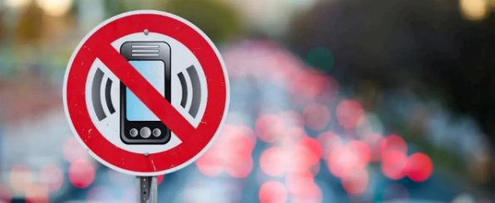

*\*Vehicle (600) codes may include truck, automobile, motorcycle, moped, bicycle, ATV, airplane, snowmobile, farm equipment, and other miscellaneous modes of transportation*

This is an average of more than **ONE** state employee getting injured **EVERY** **WEEK** from vehicles.

**274**

**State of Wisconsin Vehicle Coded Worker’s Compensation Claims FY2019-2023**