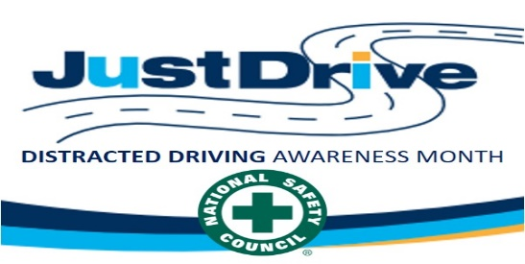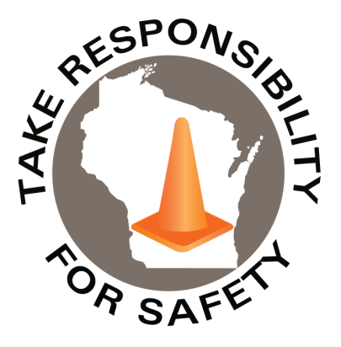

In This Issue:

**Distracted Driving Awareness Month**

**Tornado & Severe Weather Awareness Week**

**Vehicle Safety Recalls**

Volume 10, Number 4

April 2023

|  |
| --- |
| Safety Net(work)  Produced by Department of Administration Bureau of State Risk Management  Produced by Department of Administration Bureau of State Risk Management |

Safety Spotlight:

[Distracted Driving Awareness Month](https://www.nsc.org/pages/ddam/ddam-materials)

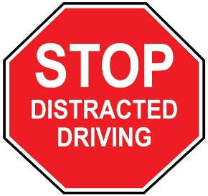

***Three Main Types of Distracted Driving***

1. **Visual:** Taking your eyes off the road.
2. **Manual:** Taking your hands off the wheel.
3. **Cognitive:** Taking your mind off driving.

[Severe Weather and Tornado Safety](https://readywisconsin.wi.gov/be-informed/tornadoes/)

**Distracted Driving Awareness Month**

Survivor, Carlos Rosario, Florida State Trooper asks you to **PLEASE put your phone away while driving** (Ctrl Click Image to Play Video):

<https://www.youtube.com/watch?v=vg7ljIalbhU>

**Nine people** in the United States are killed every day in crashes that are reported to involve a distracted driver. In 2020, **3,142** people were killed in motor vehicle crashes involving distracted drivers.

***What happens when we're driving, and that text or email alert comes in****?* According to the [National Highway Traffic Safety Administration (NHTSA)](https://r20.rs6.net/tn.jsp?f=001lA_Er2Vph8VPaAZuoqGAxPb_3UWw0hhlk7nO0OXxPVJ-wOTxi_ihQJXn6uI41sTiKR30mpjgnEMVhHsDBnKeAhr58ll-fNFh7HqHLh5-1pqjRUdrE5jOiK_nQW7CJzD7ZAx_G44zoqw5SxMMbDVBIbVLrxOfezprYRuUglzU91xX4FqNtP6X4z4lp-ta-LVi&c=Ukexv6-BX6jsQUdC44KLCBGdTjjHTRBJVnct4U4YGu8W_m18lBJr4Q==&ch=xqa9LndACibAAxZlQwe0JCqOXqVjuimVnTObUwzmlwOrgDuANXgjcA==), "Sending or reading a text takes your eyes off the road for 5 seconds and at 55 mph, that's like driving the length of an entire football field with your eyes closed." The [World Health Organization](https://r20.rs6.net/tn.jsp?f=001lA_Er2Vph8VPaAZuoqGAxPb_3UWw0hhlk7nO0OXxPVJ-wOTxi_ihQJXn6uI41sTiKUz2Fkom5PeNi3iXjgARlVSVHzXGRwL77bhqJafcAF_igYA0YRV3nrCM36XW5EtvcIYIX9UxOWVEIqHAQZ2KLJx0YUOMjhrscHDGsisP5WDH1WCEfEuHtVE3cnvFX7Sq&c=Ukexv6-BX6jsQUdC44KLCBGdTjjHTRBJVnct4U4YGu8W_m18lBJr4Q==&ch=xqa9LndACibAAxZlQwe0JCqOXqVjuimVnTObUwzmlwOrgDuANXgjcA==) states that "Telephone use while driving (whether hand-held or hands-free) increases the likelihood of being involved in a crash by a factor of four, while texting increases crash risk by around 23 percent." In addition, there are other distractions besides electronic device use including: eating and drinking, adjusting navigation, climate, or infotainment systems; or reaching down to pick something up.

This month, and any month, please make use of the many distracted driving prevention resources available such as [NETS Distracted Driving Module](https://r20.rs6.net/tn.jsp?f=001lA_Er2Vph8VPaAZuoqGAxPb_3UWw0hhlk7nO0OXxPVJ-wOTxi_ihQJXn6uI41sTi8GTp_g3vHyYAeBA0gdK4MTQXt4AR8uxDLLPfe5o94xBY3C5HdS68_t_JFgJxs4GF_9p1FoX1rYVRMTcqR5wkFt27qZMmmuK2Nk0wnTo0khVJx8eVNnPoNlzbhZ73nRM7xOfo11spwP8Eyfm_w7zsBg==&c=Ukexv6-BX6jsQUdC44KLCBGdTjjHTRBJVnct4U4YGu8W_m18lBJr4Q==&ch=xqa9LndACibAAxZlQwe0JCqOXqVjuimVnTObUwzmlwOrgDuANXgjcA==) or the other resources shared below from the National Safety Council.

**For more information on distracted driving check out the link below!**

<https://www.nsc.org/road/safety-topics/distracted-driving/distracted-driving-home>

Success is not final; Failure is not fatal. It is the courage to continue that counts.

-Winston S. Churchill

403

1,445

Claims

FY23 YTD

Workers Comp

Quote of the Month:

Five Minutes for Safety:

337

Claims

FY22 YTD YTD

Lost Time

FY23 YTD

Lost Time

FY22 YTD

1,641

**Tornado & Severe Weather Awareness Week**

Our partners at Wisconsin Emergency Management would like to announce that Tornado and Severe Weather Awareness Week in Wisconsin will take place April 17-21 this year. This annual campaign encourages everyone in Wisconsin to prepare for the tornadoes and severe storms in the state that may develop during the spring and summer months. This is also a good opportunity for all to review their severe weather safety procedures by participating in statewide tornado drills at 1:45 p.m. and 6:45 p.m. on Thursday, April 20th. For more information regarding the 2023 Wisconsin statewide tornado drill, click on the link below!

***Click on the link for more information on the 2023 Wisconsin statewide tornado drill!*** <https://wem.wi.gov/ready230303/>

***Tornado and Severe Weather Safety: How can you be prepared?***

Wisconsin averages 23 tornadoes a year. Peak tornado season in Wisconsin is April through August, but it is important to understand that a tornado can occur at any time of the year. Tornadoes can lead to fatalities and devastate communities in a matter of seconds. This violent force of nature can occur at any time of day or night and may not always be visible.

***By preparing, planning, and practicing how and where you will take shelter could save your life!***

***Important Terms Used During a Tornado: Tornado Watch vs. Warning***

* **Tornado Watch: Be Prepared!** An alert issued when weather conditions in the area favor the formation of tornadoes-often during thunderstorms. Be ready to act quickly if a warning is issued or you suspect a tornado is approaching.
* **Tornado Warning: Take Action!** A tornado has been sighted or indicated by weather radar. This is imminent danger to life and property. Move to an interior room on the lowest floor of a sturdy building. AVOID WINDOWS.

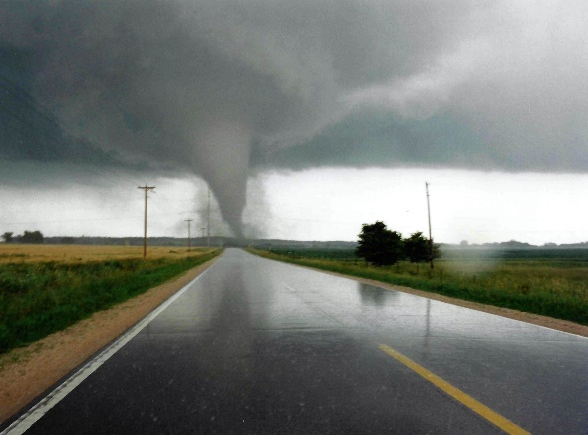

***Check to Protect! Vehicle Safety Recalls***

Does your car or truck have a safety recall? If you are unsure, it is time to check!

According to the National Safety Council, nearly 50 million vehicles on the road today - or roughly 1 out of 4 - have unrepaired safety recalls. Many recalls involve defective parts that can pose life-threatening risks to the operator of the vehicle and everyone else on the road.

***How can you check if your vehicle has a recall?*** Just visit [CheckToProtect.org](http://checktoprotect.org/) and enter a photo of your license plate, or the license plate number and state. The National Highway Traffic Safety Administration recommends checking for recalls ***every three months***.

For more information on vehicle safety recalls check out this link! [Does your car or truck have a safety recall? It’s easy to check | Safety+Health (safetyandhealthmagazine.com)](https://www.safetyandhealthmagazine.com/articles/23670-does-your-car-or-truck-have-a-safety-recall-its-easy-to-check?utm_source=sfmc&utm_medium=email&utm_campaign=mbrnewsalertmar10&utm_content=)

***Severe Weather Safety Tips: Thunderstorms and Tornadoes***

* Listen to the radio, television, or weather alert radios for updates.
* When a thunderstorm threatens, go inside a home or large building.
* During a thunderstorm, avoid using telephones, except for emergencies.
* During a tornado warning, TAKE ACTION IMMEDIATELY. Stay away from windows, doors, and outside walls.
* Seek shelter in the basement or an interior part on the lowest level.

Consumer Safety

[United States Consumer Product Safety Commission](http://www.cpsc.gov/)

Contact Us

<https://doa.wi.gov>

E-Mail

[Jake.Lowell@Wisconsin.gov](mailto:jake.lowell@wisconsin.gov)