*[](https://www.ready.gov/september)*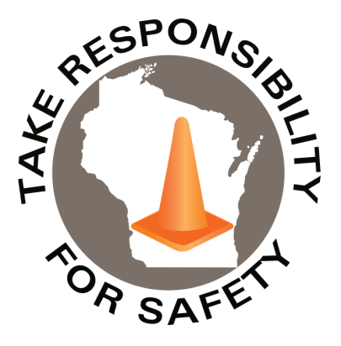

Volume 9, Number 9

September 2022

In This Issue:

**National Preparedness Month**

**Fire Prevention**

**State Risk Management Conference**

|  |
| --- |
| Safety Net(work)  Produced by Department of Administration Bureau of State Risk Management  Produced by Department of Administration Bureau of State Risk Management |

Safety Spotlight:

[Respiratory Protection Week](https://www.cdc.gov/niosh/npptl/Respiratory-Protection-Week-2022.html)

Workers Comp

335

Claims

FY23 YTD

[National Child Passenger Safety Week](https://www.trafficsafetymarketing.gov/get-materials/child-safety/child-passenger-safety-week)

“Leadership is the art of getting someone else to do something you want done because they want to do it.”

-Dwight D. Eisenhower

Quote of the Month:

Five Minutes for Safety:

103

76

Claims

FY22 YTD YTD

Launched in February 2003, [Ready](https://www.ready.gov/about-us) is a National public service campaign designed to educate and empower the American people to prepare for, respond to and mitigate emergencies, including natural and man-made disasters. National Preparedness Month (NPM) is recognized each September to raise awareness about the importance of preparing for disasters and emergencies that could happen at any time.

The 2022 theme is: “**A Lasting Legacy.”** The life you’ve built is worth protecting. Prepare for disasters to create a lasting legacy for you and your family.

**Kids**

Build a Lasting Legacy: Prepare your kids for disasters and emergencies. Take time to make a plan and have conversations about preparedness. Help them know how to stay safe and navigate potentially scary situations. [Ready.gov/kids](http://www.ready.gov/kids)

Disasters can leave children and teens feeling frightened, confused and insecure. Their responses can be quite varied. It's important to not only recognize these reactions, but also help children cope with their emotions. <https://www.ready.gov/helping-children-cope>

**Emergency Kit**

An emergency kit should have everything you need to survive for several days. Keeping your kit stocked with necessities like food, water, and medical care can make the difference in the face of a disaster. [Ready.gov/kit](http://www.ready.gov/kit)

**Make a Plan**

Disasters can happen anywhere, any time. That’s why it’s important you’re prepared. Do you have a plan for yourself, your pets, and your family? Consider the specific needs you might have in an emergency. [Ready.gov/plan](http://www.ready.gov/plan)

More: <https://www.ready.gov/september>

Lost Time

FY23 YTD

Lost Time

FY22 YTD

414

****[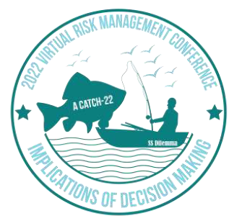](https://doa.wi.gov/DEO/2022%20DOA-RISK%20MANAGEMENT%20CONF%20BROCHURE_.pdf)[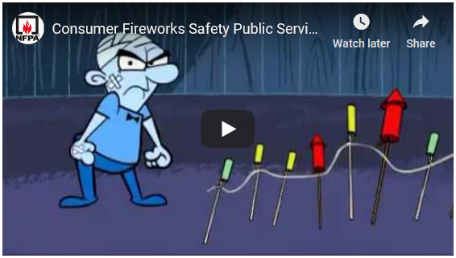](https://youtu.be/PcFuIEwbITA)

Consumer Safety

[United States Consumer Product Safety Commission](http://www.cpsc.gov/)

Contact Us

<https://doa.wi.gov>

E-Mail

[Jake.Lowell@Wisconsin.gov](mailto:jake.lowell@wisconsin.gov)

|  |
| --- |
|  |

Do you know what elements are needed for a fire? What combustible materials are around you? Fires occur when three elements are brought together: Air, Fuel, and Heat (or Source of Ignition). When these three elements are present at the same time, in the same place, a ﬁre is in the making. Conversely, if you remove one of the three elements, the ﬁre will not start, or will be extinguished if it is already in progress.

According to Liberty Mutual, overheating of electrical wiring and equipment is the leading cause of industrial ﬁres. To prevent electrical fires be sure to regularly check for: overloading of circuits & equipment, worn out or damaged wiring or equipment, improper use, and defective installations.

Another fire cause called, spontaneous combustion, occurs when certain materials and combinations of materials react chemically and produce heat. When this chemical reaction occurs in an area without good ventilation to dissipate the heat, it accumulates. If the heat buildup reaches the ignition temperature, a ﬁre is the result. One [recent news story](https://www.channel3000.com/automatic-sprinkler-puts-out-fire-at-memorial-union/) is an example of this (Society Insurance provides [5 Tips for Handling Greasy Rags in Your Commercial Kitchen](https://societyinsurance.com/blog/handling-greasy-rags-to-prevent-spontaneous-combustion/)). Some of the other materials that commonly produce this reaction are: oily rags – especially linseed oil, paint-soaked clothing, organic materials such as grains, ﬂour, sawdust, paper dust; fertilizers, and oil or solvent-soaked production wastes such as cloth, plastic, or wood. Fires from this source can by controlled by providing: adequate ventilation to dissipate the heat, heat-detection devices, dry storage areas, since moisture will often speed up the chemical interaction, safety-type containers for temporary storage of waste materials susceptible to spontaneous heating and prompt/daily removal to outside of the building. In some cases, storage of waste in water filled containers may be advisable. Very often, ﬁres that ignite spontaneously become destructive only because of accumulations of other combustibles in the same area. It is evident, then, that good housekeeping and ﬁre prevention go hand in hand.

*A portion excerpted from Liberty Mutual Safety Leadership Training program – A series of 22 individual safety modules designed to help managers and supervisors gain knowledge and develop skills to reduce or eliminate losses in the workplace.*

## State Risk Management Conference

## *Implications of Decision Making*

## November 2022

## [Conference Brochure](https://doa.wi.gov/DEO/2022%20DOA-RISK%20MANAGEMENT%20CONF%20BROCHURE_.pdf)

Fire Prevention