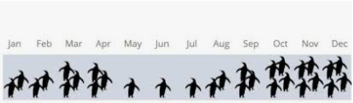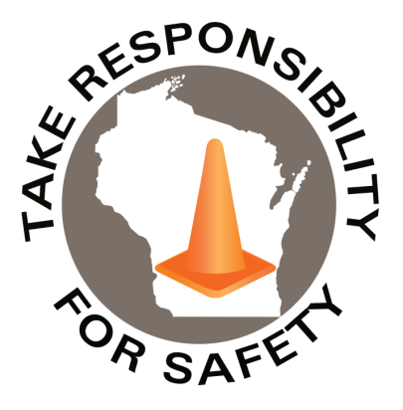

November 2022

Volume 9, Number 11

In This Issue:

**Walk Like a Penguin Time**

**Last Chance: Walking in Winter**

**DOA Wellness Committee Event: Creating a Stigma Free Culture**

|  |
| --- |
| Safety Net(work)  Produced by Department of Administration Bureau of State Risk Management  Produced by Department of Administration Bureau of State Risk Management |

Safety Spotlight:

[Mothers Against Drunk Driving](https://www.madd.org/)

WALK LIKE A PENGUIN TIME

Slips, trips and falls are one of the leading causes of injury each year for State of Wisconsin workers. Historically, the highest months of injury frequency tends to be during the winter season – November through April. Figure 1 shown below depicts the total number of slip, trip and fall workers compensation claims, by month, over the past five fiscal years. Figure 2 shown below illustrates the total number of slippery surface related workers compensation claims, which may include descriptions such as ice, water, or grease, by month, over the past five fiscal years.



Figure 1



Figure 2

**“He who wants to persuade, should put his trust not in the right argument, but the right word.”**

**-Joseph Conrad**

660

Claims

FY23 YTD

[Get Smart About Antibiotics Week](https://www.cdc.gov/antibiotic-use/week/index.html)

Workers Comp

Quote of the Month:

Five Minutes for Safety:

205

150

Claims

FY22 YTD YTD

Lost Time

FY23 YTD

Lost Time

FY22 YTD

828

LAST CHANCE

***WARNING SERIOUS INJURIES HAVE PREVIOUSLY OCCURRED***

The ten-minute slip and fall prevention program “Walking in Winter” video agreement is **due to expire on 12/1/22**! The course has been live in [Cornerstone](https://ess.wi.gov/psp/ess/EXTERNAL/HRMS/?cmd=login&languageCd=ENG&) (agencies) and [Canvas](https://uws-td.instructure.com/enroll/GRC9EX) (universities) for all state employees since 12/1/21. Please be sure to take advantage of this educational opportunity to help protect the team from one of the state’s leading causes of injury. Who’s going to be the agency/campus with the highest participation rate?

Leaderboard as of 10/10/22:

**% Completed of Equivalent Fulltime Workers**

**Coming Soon: An Interactive DOA Wellness Committee Event**

Do you know how to help support the mental wellbeing of others? The National Alliance on Mental Illness (2019) states that although one in five Americans lives with mental illness, only 43% seek support. Additionally, 50% of Americans experience mental health issues during their lifetime and the average person waits eight to ten years after the onset of initial symptoms before seeking treatment. To improve well-being, distractions, missed days, compromised safety, turnover, or worst of all suicide and drug overdoses, it is essential to provide education on identifying potential mental health problems and play a constructive role with use of appropriate resources. Please join the DOA Wellness Committee and Bruce Morton, Senior Loss Control Consultant, Marsh & McLennan Agency for 90 minutes, on December 1st, via Microsoft Teams to make a real difference of mental well-being for yourself, family and coworkers. *Please note this is a special one-time live opportunity and will not be available for later viewing.* Sign up for the event today in [LEADER](https://ess.wi.gov/psc/ess/EXTERNAL/HRMS/s/WEBLIB_WI_CS.ISCRIPT1.FieldFormula.Iscript_CSLogin_Default?DestURL=%252fDeepLink%252fProcessRedirect.aspx%253fmodule%253dloRegisterAndLaunch%2526lo%253df2cb63cf-00cd-4f47-81e2-002a264538ce). If you are a state agency or campus employee and do not have access to Cornerstone for registration, please email [Jake.Lowell@Wisconsin.gov](mailto:Jake.Lowell@Wisconsin.gov) for assistance.

Consumer Safety

[United States Consumer Product Safety Commission](http://www.cpsc.gov/)

Contact Us

<https://doa.wi.gov>

E-Mail

[Jake.Lowell@Wisconsin.gov](mailto:jake.lowell@wisconsin.gov)

[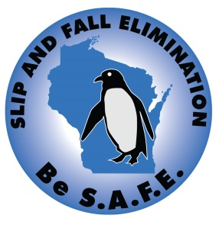](https://doa.wi.gov/DEO/Slip%2c%20Trip%20and%20Fall%20Prevention%20Manual.pdf)

