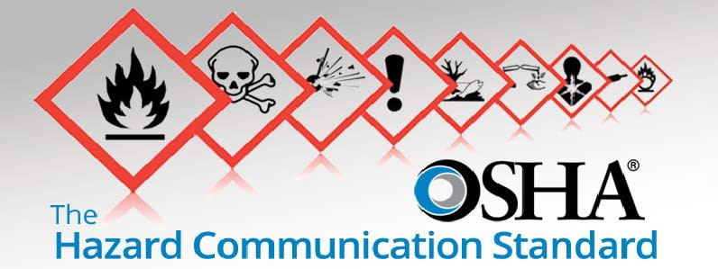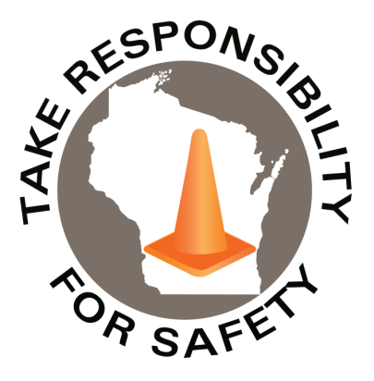

May 2022

Volume 9, Number 5

In This Issue:

**Hazard Communication Standard 1910.1200**

|  |
| --- |
| Safety Net(work)  Produced by Department of Administration Bureau of State Risk Management  Produced by Department of Administration Bureau of State Risk Management |

Safety Spotlight:

[National Electrical Safety Month](http://www.esfi.org/program/national-electrical-safety-month-314)

Hazard Communication Standard 1910.1200

Did you know the OSHA [Hazard Communication](https://www.osha.gov/hazcom) Standard [1910.1200](https://www.osha.gov/laws-regs/regulations/standardnumber/1910/1910.1200) was the #5 most cited violation for FY2021 (1,939 Total Violations)? This standard addresses chemical hazards – both chemicals produced in the workplace and those imported into the workplace. It also governs the communication of those hazards to workers. The top sections of 1910.1200 cited with suggested compliance considerations:

1. 1910.1200(e)(1): Employers shall develop, implement, and maintain at each workplace, a written hazard communication program which at least describes how the criteria specified in paragraphs (f), (g), and (h) of this section for labels and other forms of warning, safety data sheets, and employee information and training will be met. – 568 violations (29%) [**\*\*\*#1 DSPS Public Sector Safety Top Violation!!!**](https://dsps.wi.gov/Documents/Programs/PublicSafety/TopViolations.pdf)

* <https://www.osha.gov/sites/default/files/publications/OSHA3695.pdf> (Page 30: Appendix A Sample Written Hazard Communication Program)
* <https://doa.wi.gov/Pages/AboutDOA/DEO_Safety-and-Loss-Control.aspx> (Safety Categories: Hazard Communication Program Template)
* <https://dsps.wi.gov/Documents/Programs/PublicSafety/HazardCommunication.pdf> (DSPS Hazard Communication Program Sample)

1. 1910.1200(h)(1): Employers shall provide employees with effective information and training on hazardous chemicals in their work area at the time of their initial assignment, and whenever a new chemical hazard the employees have not previously been trained about is introduced into their work area. Information and training may be designed to cover categories of hazards (e.g., flammability, carcinogenicity) or specific chemicals. Chemical-specific information must always be available through labels and safety data sheets. – 516 violations (27%)

* Training courses available for Agencies in [Cornerstone](https://ess.wi.gov/psp/ess/EXTERNAL/HRMS/?cmd=login&languageCd=ENG&) (keyword search: “Right to Know” (Bizlibrary Four Part Series) or “Hazard Communication” (Martech Two Part Series):

“We can’t help everyone, but everyone can help someone.”

-Ronald Reagan

1,743

Claims

FY22 YTD

[National Physical Fitness & Sports Month](https://www.hhs.gov/fitness/index.html)

Workers Comp

Quote of the Month:

Five Minutes for Safety:

424

405

Claims

FY21 YTD YTD

Lost Time

FY22 YTD

Lost Time

FY21 YTD

1,648

<https://www.osha.gov/sites/default/files/publications/OSHA3514.pdf>

1. 1910.1200(g)(8): The employer shall maintain in the workplace copies of the required safety data sheets for each hazardous chemical, and shall ensure that they are readily accessible during each work shift to employees when they are in their work area(s). – 210 violations (11%)

* See Form 3 “Hazardous Chemical Inventory List” from [DSPS Hazard Communication Program Sample](https://dsps.wi.gov/Documents/Programs/PublicSafety/HazardCommunication.pdf) & link/attach all safety data sheets
* See Form 1 “Hazardous Substance Inventory” example from [DOA Hazard Communication Template](https://doa.wi.gov/Pages/AboutDOA/DEO_Safety-and-Loss-Control.aspx) & link/attach all safety data sheets

1. 1910.1200(f)(6): Workplace labeling. Except as provided in paragraphs (f)(7) and (f)(8) of this section, the employer shall ensure that each container of hazardous chemicals in the workplace is labeled, tagged or marked. – 174 violations (9%)

* <https://www.osha.gov/sites/default/files/publications/OSHA3636.pdf>
* Right-to-Know: Container Labels Training Course Shown Above

Consumer Safety

[United States Consumer Product Safety Commission](http://www.cpsc.gov/)

Contact Us

<https://doa.wi.gov>

E-Mail

[Jake.Lowell@Wisconsin.gov](mailto:jake.lowell@wisconsin.gov)

](https://www.osha.gov/sites/default/files/publications/OSHA3492QuickCardLabel.pdf)

***Warning Graphics May Be Disturbing***:

[Google “Chemical Injury” & click on “Images”.](https://www.google.com/search?q=chemical+injury+&tbm=isch&ved=2ahUKEwisp4jc-7T3AhUHOc0KHfmZAPoQ2-cCegQIABAA&oq=chemical+injury+&gs_lcp=CgNpbWcQAzIFCAAQgAQyBQgAEIAEMgUIABCABDIFCAAQgAQyBQgAEIAEMgUIABCABDIFCAAQgAQyBQgAEIAEMgUIABCABDIFCAAQgAQ6BAgAEBhQwQdYwQdgtwloAHAAeACAAViIAasBkgEBMpgBAKABAaoBC2d3cy13aXotaW1nwAEB&sclient=img&ei=_pdpYqywKofytAb5s4LQDw&bih=552&biw=1280&rlz=1C1GCEB_enUS980US981)

[CSB Releases New Safety Video Incompatible Chemicals:   
Explosion at AB Specialty Silicones](https://www.youtube.com/watch?v=8j8EprZP4IE)