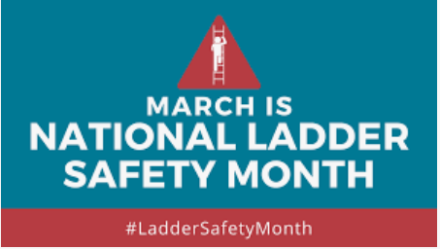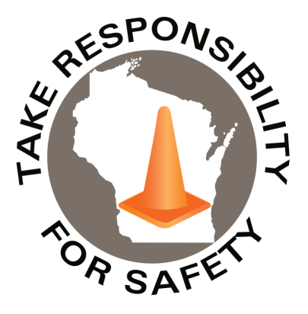

In This Issue:

**Ladder Safety Affects Everyone**

**Free Online Ladder Safety Training**

Volume 9, Number 3

March 2022

|  |
| --- |
| Safety Net(work)  Produced by Department of Administration Bureau of State Risk Management  Produced by Department of Administration Bureau of State Risk Management |

Safety Spotlight:

[National Ladder Safety Month](https://www.laddersafetymonth.com/About/National-Ladder-Safety-Month)

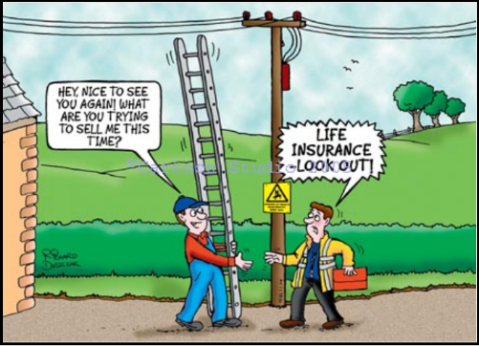

**Ladder Safety Affects Everyone**

Ladder injuries are serious, more than 100 people die from ladder related injuries each year and thousands more suffer from crippling pain:



<https://www.laddersafetymonth.com/Portals/0/NLSM%202020/ALI_320583-18_19NLSM_flyer1.pdf?ver=2019-10-30-150324-250>

1,398

Claims

FY22 YTD

[Basic Ladder Safety](https://www.americanladderinstitute.org/page/BasicLadderSafety)

Workers Comp

Quote of the Month:

Five Minutes for Safety:

350

317

Claims

FY21 YTD YTD

Lost Time

FY22 YTD

Lost Time

FY21 YTD

1,307

**Free Online Ladder Safety Training**

The non-for-profit American Ladder Institute (ALI) created a free Ladder Safety Training program and declared March as National Ladder Safety Month to inspire safer ladder use and reduce the rate of injuries. The [ALI online Ladder Safety Training certification program](https://www.laddersafetytraining.org/) is aimed at promoting safe ladder use, selection and care. The ALI Safety Training is a 100% free educational offering, so all employees can be required to complete the program without any training cost implications. The training is designed for both professionals and homeowners, and it teaches participants how to safely use and care for different types of ladders including:

* Stepladders
* Single and extension ladders
* Articulated ladders
* Mobile ladders

Participants that complete the Ladder Safety Training program will receive a certificate of completion, ensuring the most current and reputable ladder safety information is understood.

*\*For Trainers and Training Managers, The ALI has designed a Trainer’s Toolbox (simply check the “Trainer Toolbox” when signing up). Additional free tool available to register/assign to organization’s trainees.*

<https://www.laddersafetytraining.org/>

<https://www.laddersafetymonth.com/Portals/0/NLSM%20Chimney%20Sweep%20News%202019.pdf>

[**Five Ways to Prevent Common Injuries Resulting from Ladder Misuse**](https://youtu.be/jmDVzXHpnzg)

(Ctrl Click to Review Video)

Consumer Safety

[United States Consumer Product Safety Commission](http://www.cpsc.gov/)

Contact Us

<https://doa.wi.gov>

E-Mail

[Jake.Lowell@Wisconsin.gov](mailto:jake.lowell@wisconsin.gov)