*[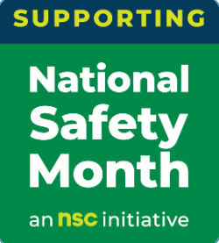](https://www.nsc.org/workplace/national-safety-month/nsm-public-materials)*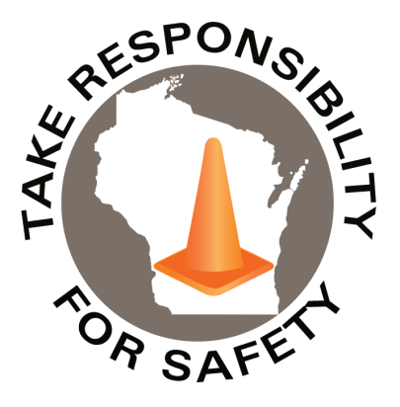

Volume 9, Number 6

June 2022

In This Issue:

**National Safety Month**

**The Accidental Safety Pro Podcast**

|  |
| --- |
| Safety Net(work)  Produced by Department of Administration Bureau of State Risk Management  Produced by Department of Administration Bureau of State Risk Management |

Safety Spotlight:

[National CPR & AED Awareness Week](https://cpr.heart.org/en/training-programs/cpr-and-aed-awareness/cpr-and-aed-awareness-week)

](https://www.nsc.org/getmedia/d6d935e8-7af1-4d73-ad65-62b996b9955b/nsm_2022_poster_engsp.pdf)

1,902

Claims

FY22 YTD

[Heat Illness Prevention Campaign](https://www.osha.gov/heat)

Workers Comp

Fear is the foundation of safety.

-Tertullian

Quote of the Month:

Five Minutes for Safety:

483

443

Claims

FY21 YTD YTD

Observed annually in June, National Safety Month focuses on reducing leading causes of injury and death at work, on the roads and in our homes and communities.

[(Hyperlink to access free downloadable resources)](https://www.nsc.org/workplace/national-safety-month/nsm-public-materials)

Download and share these materials provided by the National Safety Council (control click on Hyperlink above to access downloadable resources) to help keep each other safe this June and beyond, from the workplace to anyplace. Areas of focus:

* + - * Week 1 – Musculoskeletal Disorders (MSDs)
      * Week 2 – Workplace Impairment
      * Week 3 – Injury Prevention
      * Week 4 – Slips, Trips and Falls

The Department of Administration – Bureau of State Risk Management secures annual statewide membership through the Wisconsin Safety Council. Membership includes exclusive National Safety Council (NSC) Safety Month materials such as: 5-minute safety talks, videos/virtual events, posters, checklists, and quizzes. Please contact [Jake.Lowell@Wisconsin.gov](mailto:Jake.Lowell@Wisconsin.gov) from the Bureau of State Risk Management – Safety & Loss Control for assistance accessing exclusive materials.

Lost Time

FY22 YTD

Lost Time

FY21 YTD

1,835

](https://hsi.com/podcast/accidentalSafetyPro?utm_campaign=podcast&utm_medium=email&_hsmi=214247104&_hsenc=p2ANqtz--XwBVdPcrAq33RJjUsUij_oynJXmezrXoH_Kkuk8-LASTcDzcMSTJ-t_FZwR9ngE1_OWZ4qCIJCQ9ndMI5ByteM28PpQ&utm_content=214247104&utm_source=hs_email)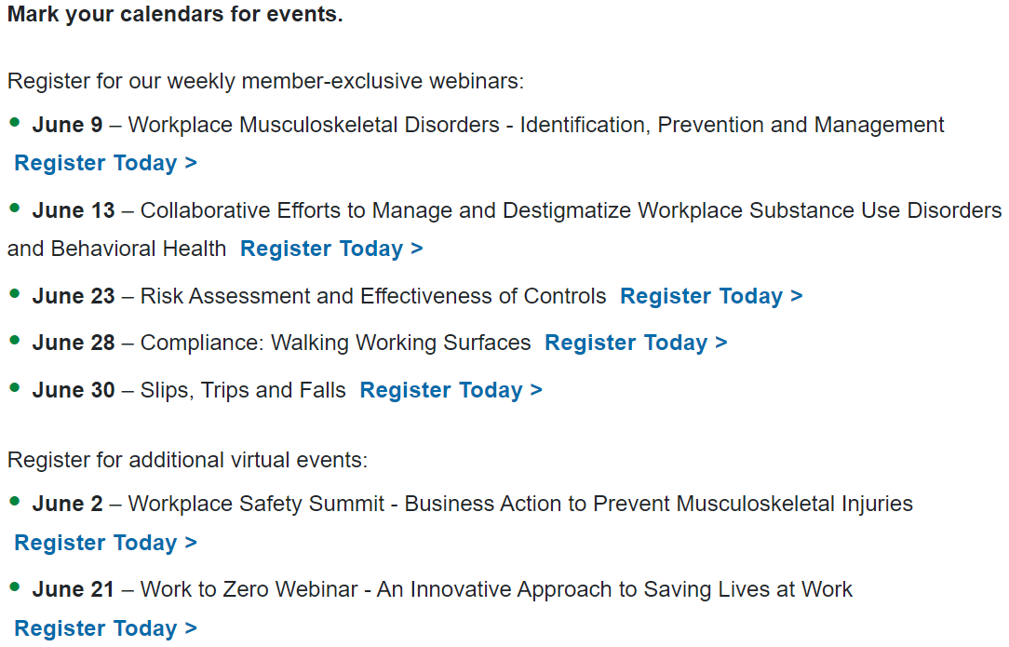

[The birth of a safety movement in America – the inside look at what Triangle Shirtwaist women went through before absolute disaster.](https://www.dailymotion.com/video/x1itk1p)

The Accidental Safety Pro Podcast

Consumer Safety

[United States Consumer Product Safety Commission](http://www.cpsc.gov/)

Contact Us

<https://doa.wi.gov>

E-Mail

[Jake.Lowell@Wisconsin.gov](mailto:jake.lowell@wisconsin.gov)

|  |
| --- |
|  |

Did you know Jill James, HSI’s Chief Safety Officer hosts a series of safety podcast conversations with safety professionals about how they came into their role, what they’ve learned along the way, as well as some of the highs and lows that come with the job? There was a very [special episode #91](https://hsi.com/podcast/accidentalSafetyPro/91-a-very-special-4th-anniversary-episode) on May 11th recognizing the 4th Anniversary. Recognized University of Wisconsin-Whitewater’s own safety guru Dr. Todd Loushine was the guest host! It was a great conversation reminiscing of past stories and some of the most memorable interviews! Hope you check it out and more!

Some of Jill’s most memorable must listen episodes:

* Dr. Todd Loushine, episodes [#7](https://hsi.com/podcast/accidentalSafetyPro/7-im-letting-everybody-know-our-secrets) & [#49](https://hsi.com/podcast/accidentalSafetyPro/49-the-power-of-reflection).
* Mark Catlin Appearing Four Times including [#11](https://hsi.com/podcast/accidentalSafetyPro/11-crab-asthma) & [#71](https://hsi.com/podcast/accidentalSafetyPro/71-osha-is-considering-an-emergency-temporary-standard)
* [NSC Live: “Eliminating preventable deaths in our lifetime” with Debbie Hersman](https://hsi.com/podcast/accidentalSafetyPro/nsc-live-eliminating-preventable-deaths-in-our-lifetime-with-nsc-president-debbie-hersman)
* [#29 Charlie Morecraft](https://hsi.com/podcast/accidentalSafetyPro/29-charlie-morecraft)
* [#30 "Hardcore one-on-one safety stuff” with Eric Kloss](https://hsi.com/podcast/accidentalSafetyPro/30-hardcore-one-on-one-safety-stuff)
* [#13 The real test is, “Can we change other people’s minds about this?” with Dave DeSario](https://hsi.com/podcast/accidentalSafetyPro/13-the-real-test-is-can-we-change-other-peoples-minds-about-this)
* [#53 “Equity for all” with Katica Roy](https://hsi.com/podcast/accidentalSafetyPro/53-equity-for-all)
* [#54 “What happens the day before the disaster” with Chip Hughes](https://hsi.com/podcast/accidentalSafetyPro/54-what-happens-the-day-before-the-disaster)
* [#34 Dr. Scott Geller at NSC 2019](https://hsi.com/podcast/accidentalSafetyPro/34-dr-scott-geller-at-nsc-2019)

Top Five Downloads

* [#78 “Do I Want to Stay in Safety?”](https://hsi.com/podcast/accidentalSafetyPro/78-do-i-want-to-stay-in-safety)
* [#50 “What Employers Need to Know About Coronavirus”](https://hsi.com/podcast/accidentalSafetyPro/50-what-employers-need-to-know-about-coronavirus-covid-19)
* [#75 “Finding the Best Way to Protect Your Workers”](https://hsi.com/podcast/accidentalSafetyPro/75-finding-the-best-way-to-protect-your-workers)
* [#69 “Safety from every perspective”](https://hsi.com/podcast/accidentalSafetyPro/69-safety-from-every-perspective)
* [#70 “From firefighting to ammonia”](https://hsi.com/podcast/accidentalSafetyPro/70-from-firefighting-to-ammonia)

Additional episodes may also be referenced on [The Accidental Safety Pro Podcast](https://hsi.com/podcast/accidentalSafetyPro?utm_campaign=podcast&utm_medium=email&_hsmi=214247104&_hsenc=p2ANqtz--XwBVdPcrAq33RJjUsUij_oynJXmezrXoH_Kkuk8-LASTcDzcMSTJ-t_FZwR9ngE1_OWZ4qCIJCQ9ndMI5ByteM28PpQ&utm_content=214247104&utm_source=hs_email) HSI webpage.