**

Volume 9, Number 7

July 2022

In This Issue:

**The Blueprint for Safety**

**NSC Job Safety Analysis Template**

|  |
| --- |
| Safety Net(work)  Produced by Department of Administration Bureau of State Risk Management  Produced by Department of Administration Bureau of State Risk Management |

Safety Spotlight:

[Fireworks Safety](https://blogs.cdc.gov/yourhealthyourenvironment/2021/07/01/fireworks-safety-month-2/)

](https://patents.google.com/patent/US2300364A/en)

Workers Comp

2,116

Claims

FY22 YTD

[Child Safety - Heatstroke Prevention](https://www.trafficsafetymarketing.gov/get-materials/child-safety/heatstroke-prevention)

“Someone is sitting in the shade today because someone planted a tree a long time ago.”

-Warren Buffett

Quote of the Month:

Five Minutes for Safety:

531

493

Claims

FY21 YTD YTD

Here’s to a safe beginning of Fiscal Year 2023! During National Safety Month, the National Safety Council (NSC) focused on “Injury Prevention” and some great tips were discussed. We are all experts of our own jobs, workstations, individual routines, and tools. If we notice something out of the ordinary, it’s our responsibility to do something about it; to not only protect ourselves, but others too.

Hazards (any existing or potential condition that, by itself or by interacting with other variables, can result in death, injury, property damage or other loss) can take shape in many different forms. Hence, we always need to keep our “Safety Hat” on. If we can identify the potential hazards early, we can address/fix them and prevent injury. Collaboratively working together with supervisors, maintenance, safety committees or any other designated safety representatives are the best things to do as soon as potential hazards are noticed.

One excellent proactive tool the NSC highlighted that we all can use is called a “Job Safety Analysis (JSA)”. The process will help us determine what the potential hazards are in our jobs and what we can do to control them. Think of it as a more detailed job description with safety steps/precautions included. By documenting the steps of each task, with the potential hazards to each step and the safety solutions, everyone benefits including new employees and people who don’t do the task every day.

What are the tasks that have the highest risk for hazard that you do? The first phase is creating this list of highest risk hazards to work on (not every task may need this process at first). This is also a great time to think about not only how each task is currently done but whether the process could be improved more efficiently or safer. Ultimately, the JSA program creates a “blueprint” for safer work processes!

[Identifying & Addressing Safety Hazards](https://www.nsc.org/getmedia/42f8e6c9-a1af-4958-8642-95b9f897c0ab/hazard-st-combo.pdf)

[Talking Points to Introduce the JSA Process](https://www.nsc.org/getmedia/bd1497bc-6d97-4267-8da5-7123208d582a/jsa-st-combo.pdf)

Lost Time

FY22 YTD

Lost Time

FY21 YTD

2,031

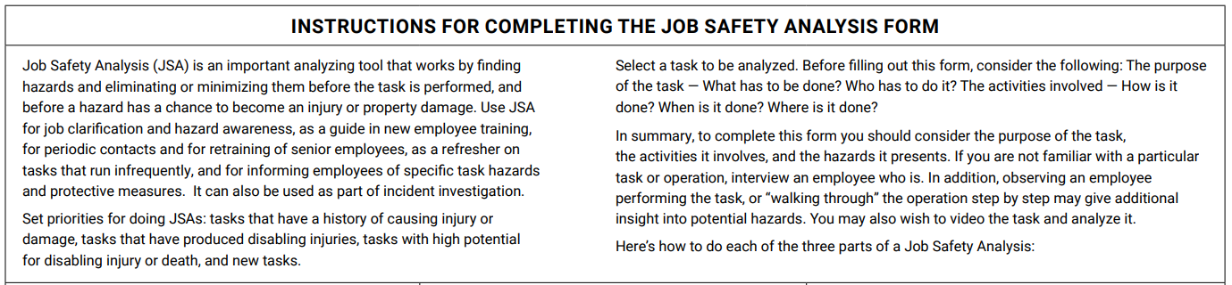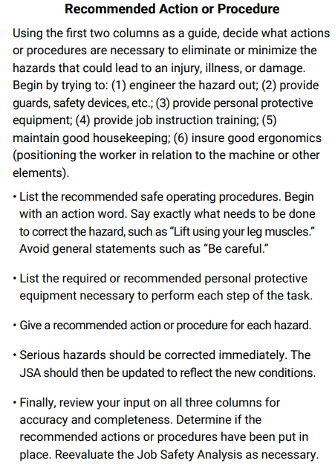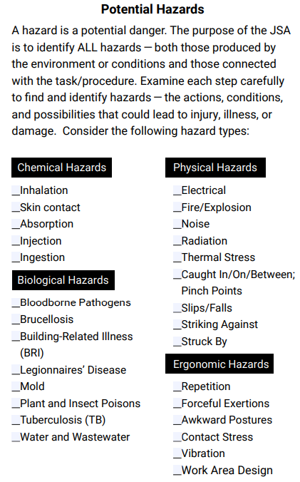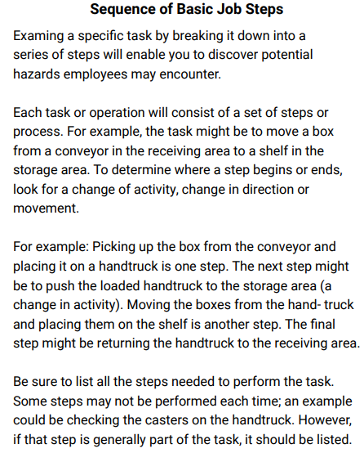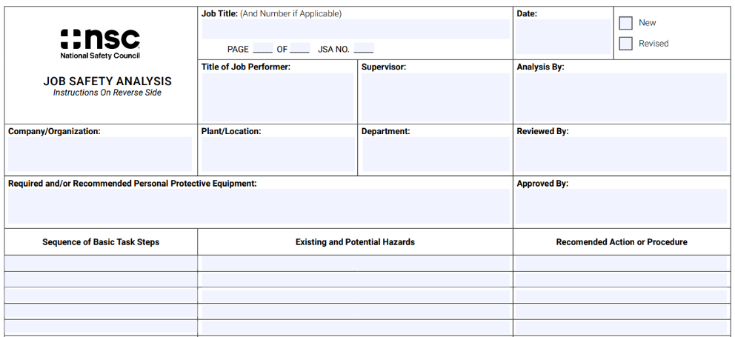[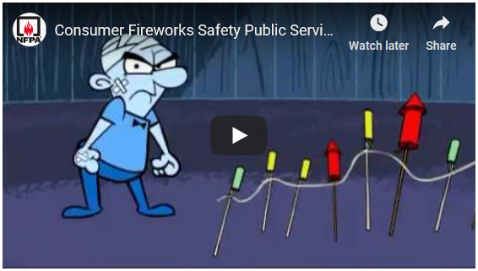](https://youtu.be/PcFuIEwbITA)

Consumer Safety

[United States Consumer Product Safety Commission](http://www.cpsc.gov/)

Contact Us

<https://doa.wi.gov>

E-Mail

[Jake.Lowell@Wisconsin.gov](mailto:jake.lowell@wisconsin.gov)

|  |
| --- |
|  |

The [NSC Job Safety Analysis Template](https://www.nsc.org/getmedia/43f2a16f-fb71-4fa0-8fdf-979581c4a3b3/jsa-form-template.pdf) shown below is one best practice example of how to complete a JSA. As mentioned below in the instructions for assistance in setting priorities, a good starting point for historical tasks causing injury may be to work with designated safety representatives who can trend columns C, E & F of the required annual OSHA 300 Injury Recordkeeping forms (column C requires job title, column E requires where the event occurred and column F requires a description of injury/illness, body parts affected, and object/substance that directly injured or made person ill).