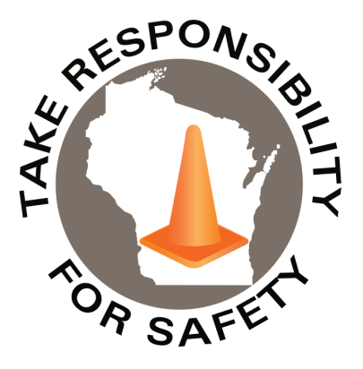

January 2022

Volume 9, Number 1

In This Issue:

**Slip, Trip and Fall Milestone!**

**Now Live: Walking in Winter**

|  |
| --- |
| Safety Net(work)  Produced by Department of Administration Bureau of State Risk Management  Produced by Department of Administration Bureau of State Risk Management |

Safety Spotlight:

[National Radon Action Month](https://www.epa.gov/radon/national-radon-action-month-information)

Slip, Trip and Fall Milestone!

As challenging as what Fiscal Year 2021 may have been, did you know the State of Wisconsin made an extraordinary milestone, **not seen in over 30 years**, by not having **ANY** month in Fiscal Year 2021 reach 50 slip, trip and fall coded claims?! We had to look all the way back to Fiscal Year 1988 to see the last time that happened! And even in one Fiscal Year like 1993, every single month of the year had in excess of 50 slip, trip and fall coded claims!



*Highlighted in YELLOW indicates the typical high hazard Wisconsin winter slip and fall period, particularly led by the month of January.

*Highlighted in GREEN indicates months in excess of 50 slip, trip and fall coded claims.

We have come such a long way and a special **THANK YOU** goes to every state employee, as safety starts with personal responsibility, and every single person plays an extremely important role in making sure we all go home safely each and every day.

**“When you improve a little each day, eventually big things occur…Don’t look for the big, quick improvement. Seek the small improvement one day at a time. That’s the only way it happens – and when it happens, it lasts.”**

**-John Wooden**

1,107

Claims

FY22 YTD

[Hazardous Chemicals in the Workplace?](https://dsps.wi.gov/Documents/Programs/PublicSafety/SBD6894.pdf)

Workers Comp

Quote of the Month:

Five Minutes for Safety:

258

251

Claims

FY21 YTD YTD

Lost Time

FY22 YTD

Lost Time

FY21 YTD

964

Now Live: Walking in Winter

Welcome to 2022! Have you watched the ten-minute slip and fall prevention program “Walking in Winter” yet? The course is now live in [Cornerstone](https://ess.wi.gov/psp/ess/EXTERNAL/HRMS/?cmd=login&languageCd=ENG&) (agencies) and [Canvas](https://uws-td.instructure.com/enroll/GRC9EX) (universities) for all state employees for a limited time! Please be sure to take advantage of this educational opportunity to help protect yourself from one of the state’s leading causes of injury. Who’s going to be the agency/campus with the highest participation rate?

For agencies, to access Cornerstone, login to ESS (where time is entered):

<https://ess.wi.gov/psp/ess/EXTERNAL/HRMS/?cmd=login&languageCd=ENG&>

Click on the My Learning Icon:

Keyword search “Walking in Winter”

Select “Launch” program:

Consumer Safety

[United States Consumer Product Safety Commission](http://www.cpsc.gov/)

Contact Us

<https://doa.wi.gov>

E-Mail

[Jake.Lowell@Wisconsin.gov](mailto:jake.lowell@wisconsin.gov)

](https://images.propertycasualty360.com/propertycasualty360/article/2015/01/30/chalkboard-page-001.jpg)

**Click infographic to expand**

[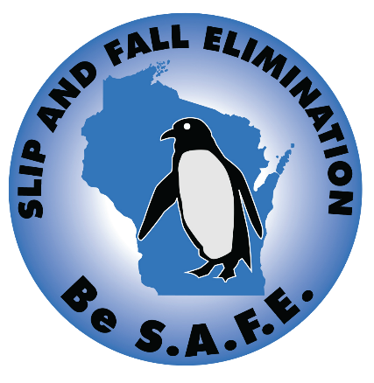](https://doa.wi.gov/DEO/WalkLikeAPenguinPoster.pdf)

**Click infographic to expand**