**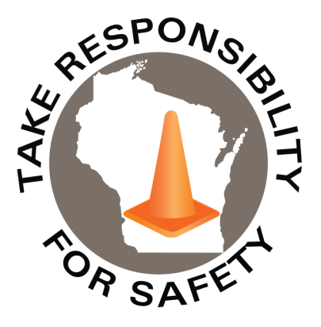

Volume 9, Number 8

August 2022

In This Issue:

**Liberty Mutual SafetyNet**

**Slip, Trip & Fall Toolkit**

**Speeding Wrecks Lives**

|  |
| --- |
| Safety Net(work)  Produced by Department of Administration Bureau of State Risk Management  Produced by Department of Administration Bureau of State Risk Management |

Safety Spotlight:

[Drive Sober or Get Pulled Over](http://www.trafficsafetymarketing.gov/LaborDayWeekend)

Workers Comp

127

Claims

FY23 YTD

[National Stop on Red Week](http://ncsrsafety.org/stop-on-red/)

“It’s easier to act your way into a new way of thinking, than think your way into a new way of acting.”

-Jerry Sternin

Quote of the Month:

Five Minutes for Safety:

57

19

Claims

FY22 YTD YTD

Did you know the Bureau of State Risk Management procures a Boiler and Machinery policy through Liberty Mutual Insurance? As an added benefit Liberty performs jurisdictional boiler inspection which provides State of Wisconsin Agency’s and Campuses extremely important recommendations assisting efforts in loss control; however, in addition to that service being a policy holder gives us full access to the Liberty SafetyNet platform. There is a plethora of great resources found within the Liberty SafetyNet platform ranging from: industry specific, OSHA, model safety plans, newsletters, toolkits, program specific, research tools to a variety of risk management topics including safety, property & liability. Even some training and unique vendor partnership opportunities. Honestly too much to even list! If there is something of specific interest, please feel free to reach out to [Jake.Lowell@Wisconsin.gov](mailto:Jake.Lowell@Wisconsin.gov).

The annual Liberty Mutual Workplace Safety Index report is one example of an attention grabber (please note #2, #4, & #7 in total impact of Slip & Falls, over 30% of total):

Lost Time

FY23 YTD

Lost Time

FY22 YTD

216

[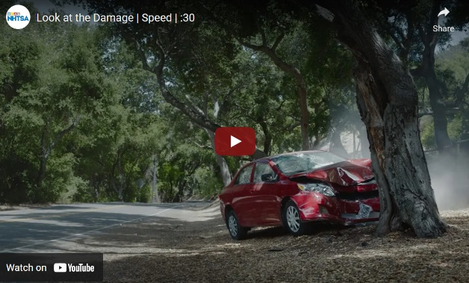](https://www.youtube.com/embed/nAwn_p6u2dI)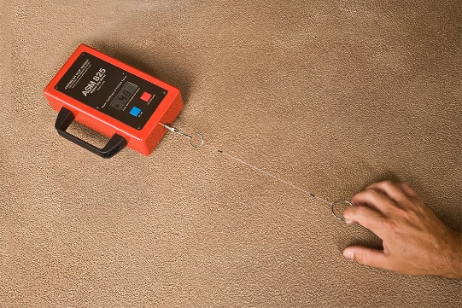[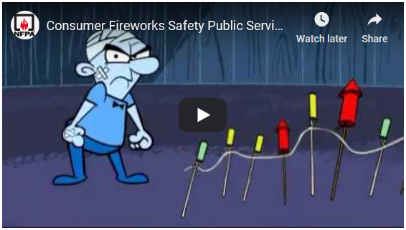](https://youtu.be/PcFuIEwbITA)

Consumer Safety

[United States Consumer Product Safety Commission](http://www.cpsc.gov/)

Contact Us

<https://doa.wi.gov>

E-Mail

[Jake.Lowell@Wisconsin.gov](mailto:jake.lowell@wisconsin.gov)

|  |
| --- |
|  |

The Liberty SafeyNet slip, trip and fall prevention toolkit has a set of guidelines intended to help organizations and major stakeholders understand their role in preventing slips, trips, and falls; including understanding causes, identifying hazards, and implementing solutions. The two highlighted resources shared below are included in the email as some of the examples available:

* **RC183 -Preventing Indoor Slips, Trips, and Falls**: This reference note looks at the causes of slips and falls and offers prevention solutions. It provides information on performing walkway slipperiness assessments and the coefficient of friction.
* **RC5751 – STF Prevention Process Evaluation**: This evaluation tool/checklist is designed to assist an organization in reviewing components of a comprehensive slip, trip, and fall prevention process.

The Bureau of State Risk Management also has a relationship via our Broker of Record contract with Sentry Insurance, which provides the state access to “Safety Services”. Generally, this involves a negotiated hourly rate for a complex variety of safety assistance needs. Some examples of activities are provided in Parker Services email attachment. We did proactively reach out to our Sentry representative to see what services might be available for tribology (an objective way to perform a walkway slipperiness assessment via a coefficient of friction measurement device). Sentry does have the ASM 825A Digital Slip Meter available for loan, as needed (operating instructions attached). Please feel free again to reach out to [Jake.Lowell@Wisconsin.gov](mailto:Jake.Lowell@Wisconsin.gov) for any possible assistance with Sentry services.

Additional informational videos on the ASM 825A Digital Slip Meter:

<https://www.youtube.com/watch?v=OMZ_hQbPapQ>

<https://www.youtube.com/watch?v=_EM4E5SQnyY>

<https://www.youtube.com/watch?v=lIXjrQ9rbgs>

<https://www.youtube.com/watch?v=Hws80FC9Kcc>

Possible limitations with “Adhesion” when testing wet…

<https://www.youtube.com/watch?v=magxcZmmWZo>

Speeding Wrecks Lives

Federal data showed, in 2020, 11,258 people were killed in speeding-related crashes – a 17% spike from the previous year. [Speeding](https://injuryfacts.nsc.org/motor-vehicle/motor-vehicle-safety-issues/speeding/) deaths also accounted for 29% of all traffic deaths in 2020. Additionally:

* 87% of speeding-related traffic deaths occurred on non-interstate roads.
* Speeding was a factor in 37% of deadly work zone crashes.
* 37% of drivers involved in deadly speeding-related crashes had a [blood-alcohol concentration](https://www.cdc.gov/motorvehiclesafety/pdf/bac-a.pdf)equal to or higher than the .08 legal limit.

The National Highway Traffic Safety Administration (NHTSA) is reminding drivers to slow down and be more careful because “speeding wrecks lives” in [new ad campaign](https://www.youtube.com/embed/nAwn_p6u2dI). NHTSA has also developed a [social media toolkit](https://www.trafficsafetymarketing.gov/get-materials/speed-prevention/speeding-wrecks-lives/speeding-catches-you) with resources such as fact sheets, graphics and a sample press release.

Slip, Trip & Fall Toolkit