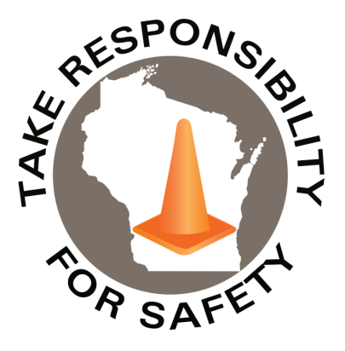

In This Issue:

**Distracted Driving Awareness Month**

**Tornado & Severe Weather Awareness Week**

**[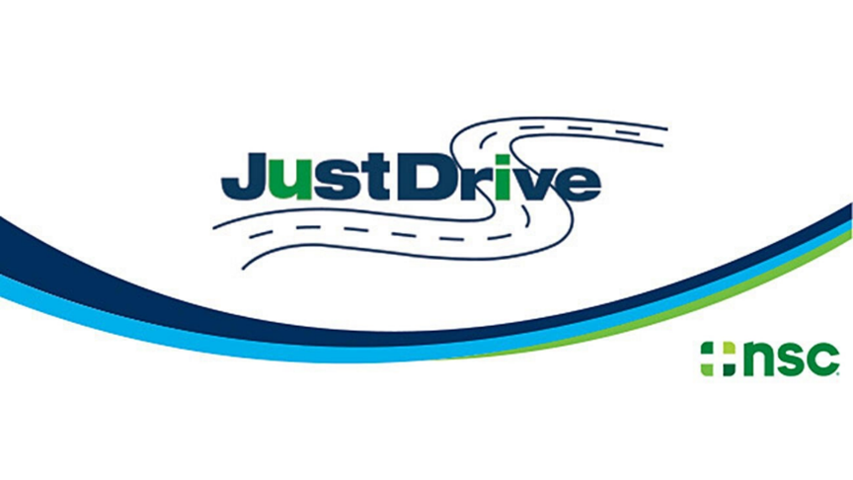](https://www.nsc.org/pages/ddam/ddam-materials)**

Volume 9, Number 4

April 2022

|  |
| --- |
| Safety Net(work)  Produced by Department of Administration Bureau of State Risk Management  Produced by Department of Administration Bureau of State Risk Management |

Safety Spotlight:

[Distracted Driving Awareness Month](https://www.nsc.org/pages/ddam/ddam-materials)

**Distracted Driving Awareness Month**

Survivor, Carlos Rosario, Florida State Trooper asks you to **PLEASE put your phone away while driving** (Ctrl Click Image to Play Video):

<https://www.youtube.com/watch?v=vg7ljIalbhU>

NHTSA reports that **3,142** people were killed in the U.S. in 2020 in distracted driving crashes (that is **at least 8.6 people every day**).

What happens when we're driving and that text or email alert comes in? According to the [National Highway Traffic Safety Administration (NHTSA)](https://r20.rs6.net/tn.jsp?f=001lA_Er2Vph8VPaAZuoqGAxPb_3UWw0hhlk7nO0OXxPVJ-wOTxi_ihQJXn6uI41sTiKR30mpjgnEMVhHsDBnKeAhr58ll-fNFh7HqHLh5-1pqjRUdrE5jOiK_nQW7CJzD7ZAx_G44zoqw5SxMMbDVBIbVLrxOfezprYRuUglzU91xX4FqNtP6X4z4lp-ta-LVi&c=Ukexv6-BX6jsQUdC44KLCBGdTjjHTRBJVnct4U4YGu8W_m18lBJr4Q==&ch=xqa9LndACibAAxZlQwe0JCqOXqVjuimVnTObUwzmlwOrgDuANXgjcA==), "Sending or reading a text takes your eyes off the road for 5 seconds and at 55 mph, that's like driving the length of an entire football field with your eyes closed." The [World Health Organization](https://r20.rs6.net/tn.jsp?f=001lA_Er2Vph8VPaAZuoqGAxPb_3UWw0hhlk7nO0OXxPVJ-wOTxi_ihQJXn6uI41sTiKUz2Fkom5PeNi3iXjgARlVSVHzXGRwL77bhqJafcAF_igYA0YRV3nrCM36XW5EtvcIYIX9UxOWVEIqHAQZ2KLJx0YUOMjhrscHDGsisP5WDH1WCEfEuHtVE3cnvFX7Sq&c=Ukexv6-BX6jsQUdC44KLCBGdTjjHTRBJVnct4U4YGu8W_m18lBJr4Q==&ch=xqa9LndACibAAxZlQwe0JCqOXqVjuimVnTObUwzmlwOrgDuANXgjcA==) states that "Telephone use while driving (whether hand-held or hands-free) increases the likelihood of being involved in a crash by a factor of four, while texting increases crash risk by around 23 percent." And there are other distractions besides electronic device use: eating and drinking; adjusting navigation, climate, or infotainment systems; or reaching down to pick something up.

This month, and any month, please make use of the many distracted driving prevention resources available such as [NETS Distracted Driving Module](https://r20.rs6.net/tn.jsp?f=001lA_Er2Vph8VPaAZuoqGAxPb_3UWw0hhlk7nO0OXxPVJ-wOTxi_ihQJXn6uI41sTi8GTp_g3vHyYAeBA0gdK4MTQXt4AR8uxDLLPfe5o94xBY3C5HdS68_t_JFgJxs4GF_9p1FoX1rYVRMTcqR5wkFt27qZMmmuK2Nk0wnTo0khVJx8eVNnPoNlzbhZ73nRM7xOfo11spwP8Eyfm_w7zsBg==&c=Ukexv6-BX6jsQUdC44KLCBGdTjjHTRBJVnct4U4YGu8W_m18lBJr4Q==&ch=xqa9LndACibAAxZlQwe0JCqOXqVjuimVnTObUwzmlwOrgDuANXgjcA==) or the other resources shared below from the National Safety Council.

The NSC annually produces resources to help create or enhance a distracted driving program to engage the workforce, share safe driving messages, and help keep the roadways and people safer.

<https://www.nsc.org/pages/ddam/ddam-materials>

*Please note the State of Wisconsin does have member exclusive access to the additional materials available (April 26th member exclusive webinar on combating distraction for those who drive for work, 20% discount on online defensive driving courses, digital slides for internal monitors or newsletters).

“Passion is too important to be without, but too fickle to be guided by. Which is why I’m more inclined to say, Don’t Follow Your Passion, But Always Bring it With You”

-Mike Rowe

388

1,595

Claims

FY22 YTD

[Tornado & Severe Weather Awareness Week](https://dpi.wi.gov/sped/tornado-and-severe-weather-awareness-week)

Workers Comp

Quote of the Month:

Five Minutes for Safety:

369

Claims

FY21 YTD YTD

Lost Time

FY22 YTD

Lost Time

FY21 YTD

1,483

**Tornado & Severe Weather Awareness Week**

Our partners at Wisconsin Emergency Management would like to announce Tornado and Severe Weather Awareness Week in Wisconsin will take place April 4-8 this year. This annual campaign encourages everyone in Wisconsin to prepare for the tornadoes and severe storms in the state that may develop during the spring and summer months. This is also a good opportunity for all to review their severe weather safety procedures by participating in statewide tornado drills at 1:45 p.m. and 6:45 p.m. on April 7. [Please view this PDF on Tornado and Severe Weather Awareness Week for more information](https://dpi.wi.gov/sites/default/files/imce/sspw/2022_TSAW_school_packet.pdf).

**Ctrl + Click the hyperlink to read further:** <https://dpi.wi.gov/sped/tornado-and-severe-weather-awareness-week>

* All thunderstorms produce lightning and are dangerous. Since 2006, lightning has killed an average of 28 people in the U.S. each year. During that time period, it also has killed ten people and injured at least 41 in Wisconsin.
* There were 148 deaths nationwide in 2021 due to flooding. There were none in Wisconsin last year.

[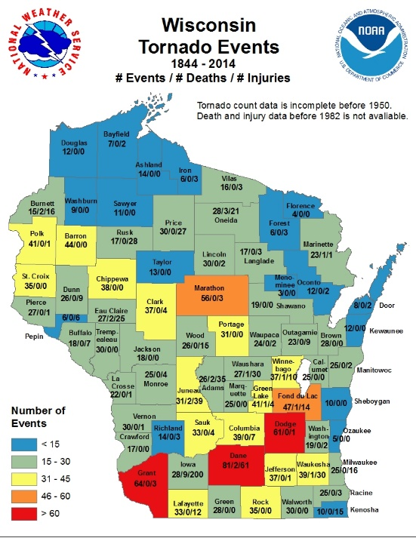

[Wisconsin Tornado & Severe Weather Statistics](https://www.weather.gov/grb/WI_tornado_stats)

*Annually Wisconsin averages 23 tornadoes*

Consumer Safety

[United States Consumer Product Safety Commission](http://www.cpsc.gov/)

Contact Us

<https://doa.wi.gov>

E-Mail

[Jake.Lowell@Wisconsin.gov](mailto:jake.lowell@wisconsin.gov)